Barry G. Johnson, Sr. / www.barrygjohnsonsr.com
Natural Evangelism / Evangelism / Luke 10:10–12
Christians must do the work necessary to tell the world the good news about Jesus.
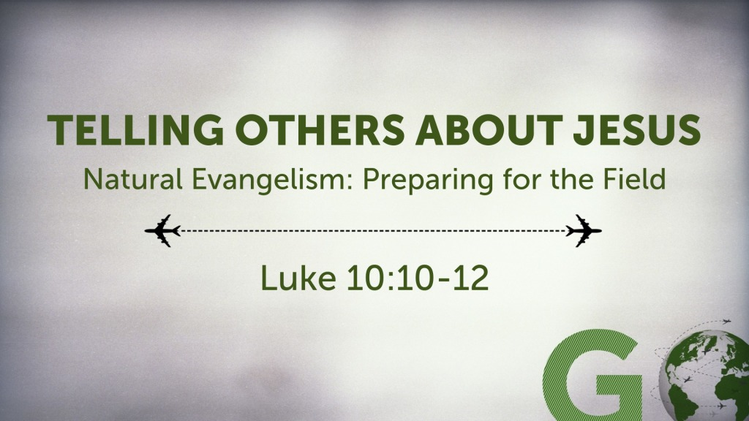
Luke 10:10–12 ESV
¹⁰ But whenever you enter a town and they do not receive you, go into its streets and say, ¹¹ ‘Even the dust of your town that clings to our feet we wipe off against you. Nevertheless know this, that the kingdom of God has come near.’ ¹² I tell you, it will be more bearable on that day for Sodom than for that town.

There are not many people to tell the story
Luke 10:1–2 ESV
¹ After this the Lord appointed seventy-two others and sent them on ahead of him, two by two, into every town and place where he himself was about to go. ² And he said to them, “The harvest is plentiful, but the laborers are few. Therefore pray earnestly to the Lord of the harvest to send out laborers into his harvest.

We are sent out as Lambs before Wolves
Luke 10:3 ESV
³ Go your way; behold, I am sending you out as lambs in the midst of wolves.

We proclaim that the Kingdom of God is here
Luke 10:9 ESV
⁹ Heal the sick in it and say to them, ‘The kingdom of God has come near to you.’
Things that get in the way of Telling Others about Jesus
1. Our 2. Our 3. Our 4. Our
Luke 4:43 ESV
⁴³ but he said to them, “I must preach the good news of the kingdom of God to the other towns as well; for I was sent for this purpose.”

Argument 1: Christianity is Full of

Argument 2: Christians are

Argument 3: Being a is Enough

Top Reasons People Have Against Jesus

God’s Message of Salvation

Hear – Believe - Confess – Repent - Be Baptized - Remain Steadfast
Study: Rom 10:17; Jn 1:7; Heb 4:14; Lk 13:3; Acts 2:38; Rev 2:10 ‌

