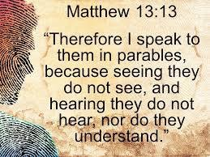
Central Idea / Synopsis:
An inability or unwillingness to perceive the truth of the gospel.
Objectives:
- Unbelievers are spiritually blind
- Spiritual blindness is a result of sin
- The consequences of spiritual blindness
- The removal of spiritual blindness
- Examples of spiritual blindness
Introduction:
Jesus taught in parables because of the spiritual blindness of His audiences. Those without the Spirit cannot comprehend the things of God. Due to sin our ability to understand God’s Word has been corrupted. The world is a powerful weapon against those who might become born again. There are consequences to the blindness that we walk in daily. Hatred and darkness become the rule of human existence. If we are going to receive the gift of God and walk in His ways, we must have the spiritual blindness removed. Israel had spiritual blindness and did not keep the covenant of God. Generation after generation of leaders display spiritual blindness, they lead their memberships into the ditch. Ordinary believers walk in spiritual blindness and are in danger of the judgement and destruction. Whole churches and denominations are guilty of spiritual blindness and will find themselves lost unless they hear, believe confess, repent and become born again according to the commands of God.

Sermon Outline:
- Unbelievers are spiritually blind
1 Corinthians 2:14 (NIV) — 14 The person without the Spirit does not accept the things that come from the Spirit of God but considers them foolishness, and cannot understand them because they are discerned only through the Spirit.
- The blindness both of idols and those who worship them:
Isaiah 44:9 (NIV) — 9 All who make idols are nothing, and the things they treasure are worthless. Those who would speak up for them are blind; they are ignorant, to their own shame.
Isaiah 44:18–19 (NIV) — 18 They know nothing, they understand nothing; their eyes are plastered over so they cannot see, and their minds closed so they cannot understand. 19 No one stops to think, no one has the knowledge or understanding to say, “Half of it I used for fuel; I even baked bread over its coals, I roasted meat and I ate. Shall I make a detestable thing from what is left? Shall I bow down to a block of wood?”
- Jesus Christ speaks in parables because of the spiritual dullness of the people:
Matthew 13:13–15 (NIV) — 13 This is why I speak to them in parables: “Though seeing, they do not see; though hearing, they do not hear or understand. 14 In them is fulfilled the prophecy of Isaiah: “ ‘You will be ever hearing but never understanding; you will be ever seeing but never perceiving. 15 For this people’s heart has become calloused; they hardly hear with their ears, and they have closed their eyes. Otherwise they might see with their eyes, hear with their ears, understand with their hearts and turn, and I would heal them.’
Isaiah 6:9–10 (NIV) — 9 He said, “Go and tell this people: “ ‘Be ever hearing, but never understanding; be ever seeing, but never perceiving.’ 10 Make the heart of this people calloused; make their ears dull and close their eyes. Otherwise they might see with their eyes, hear with their ears, understand with their hearts, and turn and be healed.”
- Spiritual blindness is a result of sin
Lamentations 4:14 (NIV) — 14 Now they grope through the streets as if they were blind. They are so defiled with blood that no one dares to touch their garments.
Zephaniah 1:17 (NIV) — 17 “I will bring such distress on all people that they will grope about like those who are blind, because they have sinned against the Lord. Their blood will be poured out like dust and their entrails like dung.
2 Corinthians 4:4 (NIV) — 4 The god of this age has blinded the minds of unbelievers, so that they cannot see the light of the gospel that displays the glory of Christ, who is the image of God.
- The consequences of spiritual blindness
Romans 1:18–23 (NIV) — 18 The wrath of God is being revealed from heaven against all the godlessness and wickedness of people, who suppress the truth by their wickedness, 19 since what may be known about God is plain to them, because God has made it plain to them. 20 For since the creation of the world God’s invisible qualities—his eternal power and divine nature—have been clearly seen, being understood from what has been made, so that people are without excuse. 21 For although they knew God, they neither glorified him as God nor gave thanks to him, but their thinking became futile and their foolish hearts were darkened. 22 Although they claimed to be wise, they became fools 23 and exchanged the glory of the immortal God for images made to look like a mortal human being and birds and animals and reptiles.
- Hatred and darkness:
1 John 2:11 (NIV) — 11 But anyone who hates a brother or sister is in the darkness and walks around in the darkness. They do not know where they are going, because the darkness has blinded them.
- The removal of spiritual blindness
2 Corinthians 4:6 (NIV) — 6 For God, who said, “Let light shine out of darkness,” made his light shine in our hearts to give us the light of the knowledge of God’s glory displayed in the face of Christ.
- Examples of spiritual blindness
  - The spiritual blindness of Israel
Isaiah 1:3 (NIV) — 3 The ox knows its master, the donkey its owner’s manger, but Israel does not know, my people do not understand.”
  - The spiritual blindness of leaders
Matthew 15:14 (NIV) — 14 Leave them; they are blind guides. If the blind lead the blind, both will fall into a pit.”
  - The spiritual blindness of believers
John 14:9 (NIV) — 9 Jesus answered: “Don’t you know me, Philip, even after I have been among you such a long time? Anyone who has seen me has seen the Father. How can you say, ‘Show us the Father’?
  - The spiritual blindness of a church
Revelation 3:17–18 (NIV) — 17 You say, ‘I am rich; I have acquired wealth and do not need a thing.’ But you do not realize that you are wretched, pitiful, poor, blind and naked. 18 I counsel you to buy from me gold refined in the fire, so you can become rich; and white clothes to wear, so you can cover your shameful nakedness; and salve to put on your eyes, so you can see.

Conclusion:
How long will we remained blind? How long will our spiritual blindness continue? If you have ears, then let them hear. Our sins work against us receiving the promises and blessings of God. Yet there is a remedy to our sins, where by they can be washed away. Don’t continue to suffer from the consequences of sin. Those sins are working in us death, which will result in an eternal separation from God. Do not be the example of spiritual blindness, hear believe and obey His commands.
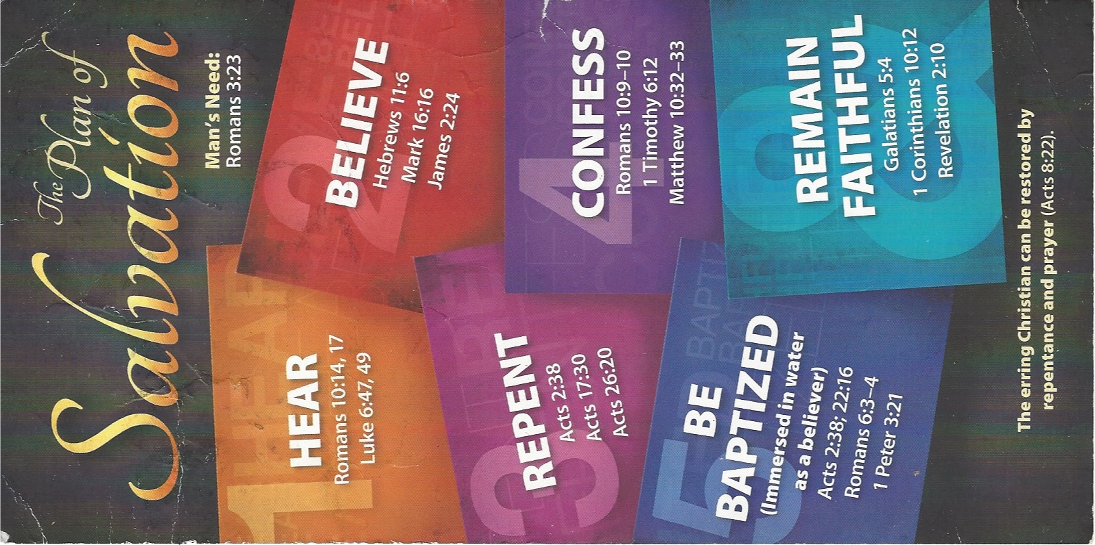
Invitation
HEAR
Luke 6:47–49 (ESV)
⁴⁷ Everyone who comes to me and hears my words and does them, I will show you what he is like: ⁴⁸ he is like a man building a house, who dug deep and laid the foundation on the rock. And when a flood arose, the stream broke against that house and could not shake it, because it had been well built. ⁴⁹ But the one who hears and does not do them is like a man who built a house on the ground without a foundation. When the stream broke against it, immediately it fell, and the ruin of that house was great.”

BELIEVE
Hebrews 11:6 (ESV)
⁶ And without faith it is impossible to please him, for whoever would draw near to God must believe that he exists and that he rewards those who seek him.

REPENT
Luke 13:3 (ESV)
³ No, I tell you; but unless you repent, you will all likewise perish.
Acts 17:30 (ESV)
³⁰ The times of ignorance God overlooked, but now he commands all people everywhere to repent,

CONFESS
Matthew 10:32–33 (ESV)
³² So everyone who acknowledges me before men, I also will acknowledge before my Father who is in heaven, ³³ but whoever denies me before men, I also will deny before my Father who is in heaven.
Romans 10:9–10 (ESV)
⁹ because, if you confess with your mouth that Jesus is Lord and believe in your heart that God raised him from the dead, you will be saved. ¹⁰ For with the heart one believes and is justified, and with the mouth one confesses and is saved.

BE BAPTIZED
Romans 6:3–4 (ESV)
³ Do you not know that all of us who have been baptized into Christ Jesus were baptized into his death? ⁴ We were buried therefore with him by baptism into death, in order that, just as Christ was raised from the dead by the glory of the Father, we too might walk in newness of life.
1 Peter 3:21 (ESV)
²¹ Baptism, which corresponds to this, now saves you, not as a removal of dirt from the body but as an appeal to God for a good conscience, through the resurrection of Jesus Christ,

REMAIN STEADFAST
Galatians 5:4 (ESV)
⁴ You are severed from Christ, you who would be justified by the law; you have fallen away from grace.
1 Corinthians 10:12 (ESV)
¹² Therefore let anyone who thinks that he stands take heed lest he fall.

