Speaking Boldly for the Lord
Barry G. Johnson, Sr. / General
Discovering the Church / Boldness; Courage; Confidence; Persistent / Acts 14:1–7

Courage and confidence in approaching God and other people.
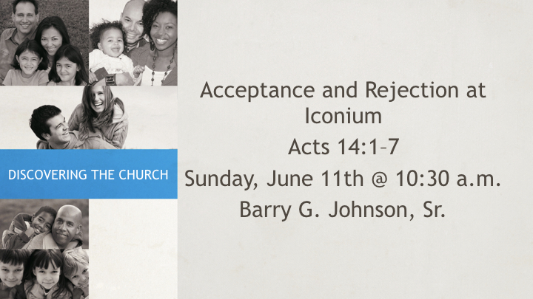

I. Boldness in Approaching God
Hebrews 10:19–22 ESV
¹⁹ Therefore, brothers, since we have confidence to enter the holy places by the blood of Jesus, ²⁰ by the new and living way that he opened for us through the curtain, that is, through his flesh, ²¹ and since we have a great priest over the house of God, ²² let us draw near with a true heart in full assurance of faith, with our hearts sprinkled clean from an evil conscience and our bodies washed with pure water.
Genesis 18:27 ESV
²⁷ Abraham answered and said, “Behold, I have undertaken to speak to the Lord, I who am but dust and ashes.
Genesis 18:31 ESV
³¹ He said, “Behold, I have undertaken to speak to the Lord. Suppose twenty are found there.” He answered, “For the sake of twenty I will not destroy it.”

II. Boldness in Proclaiming the Gospel to Others
Acts 4:29 ESV
²⁹ And now, Lord, look upon their threats and grant to your servants to continue to speak your word with all boldness,
Additional scriptures: Ac 4:13; Ac 4:31; Ac 9:28; Ac 13:46; Ac 14:3; Ac 18:26; Ac 19:8; Ac 28:31

III. Boldness in Dealing with Others

A. Inner Confidence
Psalm 138:3 ESV
³ On the day I called, you answered me; my strength of soul you increased.
Additional scriptures: 1 Sa 17:34–50
Proverbs 28:1 ESV
¹ The wicked flee when no one pursues, but the righteous are bold as a lion.
2 Corinthians 3:12 ESV
¹² Since we have such a hope, we are very bold,

B. Confident Authority
Philemon 8–9 ESV
⁸ Accordingly, though I am bold enough in Christ to command you to do what is required, ⁹ yet for love’s sake I prefer to appeal to you—I, Paul, an old man and now a prisoner also for Christ Jesus—
Romans 15:15 ESV
¹⁵ But on some points I have written to you very boldly by way of reminder, because of the grace given me by God
2 Corinthians 10:1–2 ESV
¹ I, Paul, myself entreat you, by the meekness and gentleness of Christ—I who am humble when face to face with you, but bold toward you when I am away!— ² I beg of you that when I am present I may not have to show boldness with such confidence as I count on showing against some who suspect us of walking according to the flesh.

C. Courage
Mark 15:43 ESV
⁴³ Joseph of Arimathea, a respected member of the council, who was also himself looking for the kingdom of God, took courage and went to Pilate and asked for the body of Jesus.
Additional scriptures: Ex 14:8; Nu 33:3

D. Persistence
Luke 11:8 ESV
⁸ I tell you, though he will not get up and give him anything because he is his friend, yet because of his impudence he will rise and give him whatever he needs.

IV. Misplaced Boldness
2 Peter 2:10 ESV
¹⁰ and especially those who indulge in the lust of defiling passion and despise authority. Bold and willful, they do not tremble as they blaspheme the glorious ones,
1 Corinthians 8:10 ESV
¹⁰ For if anyone sees you who have knowledge eating in an idol’s temple, will he not be encouraged, if his conscience is weak, to eat food offered to idols?

Invitation God’s Plan of Salvation
