Barry G. Johnson, Sr. / General
Discovering the Church / Self-control; Fruit of the Spirit / Acts 24:24–27
Physical and emotional self-mastery, particularly in situations of intense provocation or temptation.
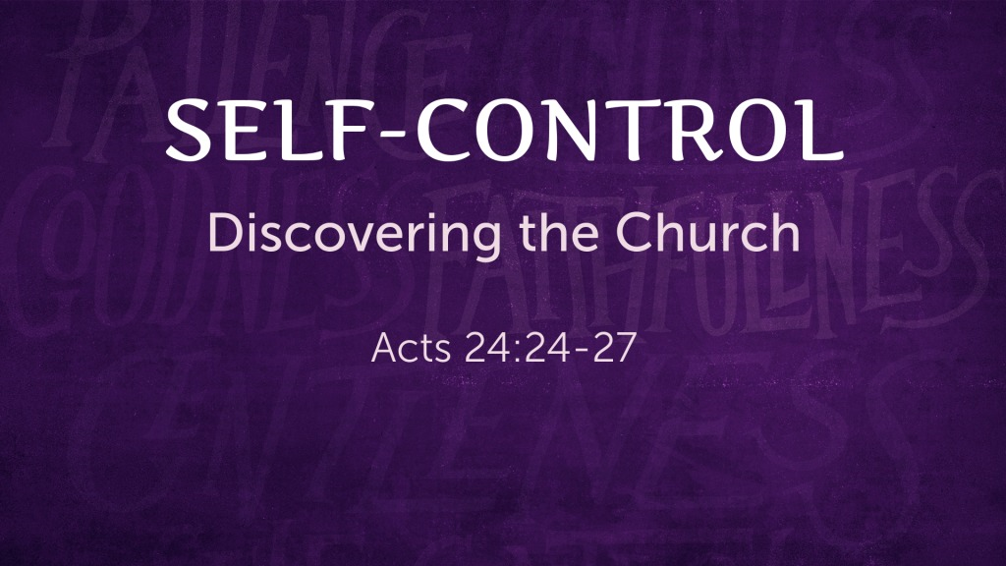
Acts 24:24–27 ESV
²⁴ After some days Felix came with his wife Drusilla, who was Jewish, and he sent for Paul and heard him speak about faith in Christ Jesus. ²⁵ And as he reasoned about righteousness and self-control and the coming judgment, Felix was alarmed and said, “Go away for the present. When I get an opportunity I will summon you.” ²⁶ At the same time he hoped that money would be given him by Paul. So he sent for him often and conversed with him. ²⁷ When two years had elapsed, Felix was succeeded by Porcius Festus. And desiring to do the Jews a favor, Felix left Paul in prison.

I. Self-control is the mark of a wise person
Proverbs 29:11 ESV
¹¹ A fool gives full vent to his spirit, but a wise man quietly holds it back.

II. Self-control is an aspect of Christian character
Galatians 5:22–23 ESV
²² But the fruit of the Spirit is love, joy, peace, patience, kindness, goodness, faithfulness, ²³ gentleness, self-control; against such things there is no law.
Titus 2:11–12 ESV
¹¹ For the grace of God has appeared, bringing salvation for all people, ¹² training us to renounce ungodliness and worldly passions, and to live self-controlled, upright, and godly lives in the present age,

III. Self-control affects the whole person

A. Physical self-control
1 Corinthians 9:26–27 ESV
²⁶ So I do not run aimlessly; I do not box as one beating the air. ²⁷ But I discipline my body and keep it under control, lest after preaching to others I myself should be disqualified.

B. A mental discipline
1 Peter 1:13 ESV
¹³ Therefore, preparing your minds for action, and being sober-minded, set your hope fully on the grace that will be brought to you at the revelation of Jesus Christ.

C. Controlled speech
Psalm 141:3 ESV
³ Set a guard, O Lord, over my mouth; keep watch over the door of my lips!
James 1:19 ESV
¹⁹ Know this, my beloved brothers: let every person be quick to hear, slow to speak, slow to anger;

IV. Self-control in response to persecution
Matthew 5:39–40 ESV
³⁹ But I say to you, Do not resist the one who is evil. But if anyone slaps you on the right cheek, turn to him the other also. ⁴⁰ And if anyone would sue you and take your tunic, let him have your cloak as well.

V. The dangers of a loss of self-control
Proverbs 18:7 ESV
⁷ A fool’s mouth is his ruin, and his lips are a snare to his soul.
Jeremiah 14:10 ESV
¹⁰ Thus says the Lord concerning this people: “They have loved to wander thus; they have not restrained their feet; therefore the Lord does not accept them; now he will remember their iniquity and punish their sins.”

- False teaching was leading to the throwing off of restraints in the name of the gospel:
2 Peter 2:12–14 ESV
¹² But these, like irrational animals, creatures of instinct, born to be caught and destroyed, blaspheming about matters of which they are ignorant, will also be destroyed in their destruction, ¹³ suffering wrong as the wage for their wrongdoing. They count it pleasure to revel in the daytime. They are blots and blemishes, reveling in their deceptions, while they feast with you. ¹⁴ They have eyes full of adultery, insatiable for sin. They entice unsteady souls. They have hearts trained in greed. Accursed children!
2 Peter 2:18–19 ESV
¹⁸ For, speaking loud boasts of folly, they entice by sensual passions of the flesh those who are barely escaping from those who live in error. ¹⁹ They promise them freedom, but they themselves are slaves of corruption. For whatever overcomes a person, to that he is enslaved.
Jude 4 ESV
⁴ For certain people have crept in unnoticed who long ago were designated for this condemnation, ungodly people, who pervert the grace of our God into sensuality and deny our only Master and Lord, Jesus Christ.

God’s Plan of Salvation

Hear the Word of God
Matthew 7:24–27 ESV
²⁴ “Everyone then who hears these words of mine and does them will be like a wise man who built his house on the rock. ²⁵ And the rain fell, and the floods came, and the winds blew and beat on that house, but it did not fall, because it had been founded on the rock. ²⁶ And everyone who hears these words of mine and does not do them will be like a foolish man who built his house on the sand. ²⁷ And the rain fell, and the floods came, and the winds blew and beat against that house, and it fell, and great was the fall of it.”

Believe the Word of God
James 2:24 ESV
²⁴ You see that a person is justified by works and not by faith alone.

Repent of Your Past Enmity
Acts 17:30 ESV
³⁰ The times of ignorance God overlooked, but now he commands all people everywhere to repent,

Confess the Son of God
1 Timothy 6:12 ESV
¹² Fight the good fight of the faith. Take hold of the eternal life to which you were called and about which you made the good confession in the presence of many witnesses.

Be Baptized for the Remission of Your Sins
1 Peter 3:21 ESV
²¹ Baptism, which corresponds to this, now saves you, not as a removal of dirt from the body but as an appeal to God for a good conscience, through the resurrection of Jesus Christ,

Remain Steadfast in New Life
1 Corinthians 10:12 ESV
¹² Therefore let anyone who thinks that he stands take heed lest he fall.

