Barry G. Johnson, Sr. / www.barrygjohnsonsr.com
Romans: The Just Shall Live by Faith / Neighbors; Edify; Edification; Submission / Romans 15:1–3
God calls His disciples to build one another up by putting others first.
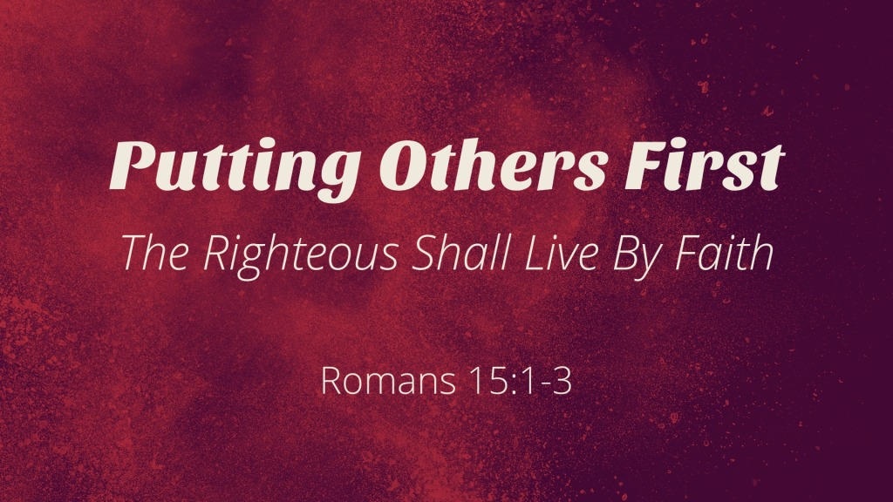
Romans 15:1–3 ESV
¹ We who are strong have an obligation to bear with the failings of the weak, and not to please ourselves. ² Let each of us please his neighbor for his good, to build him up. ³ For Christ did not please himself, but as it is written, “The reproaches of those who reproached you fell on me.”

I. Not to please ourselves
Romans 14:1 ESV
¹ As for the one who is weak in faith, welcome him, but not to quarrel over opinions.
1 Corinthians 9:22 ESV
²² To the weak I became weak, that I might win the weak. I have become all things to all people, that by all means I might save some.
1 Corinthians 10:24 ESV
²⁴ Let no one seek his own good, but the good of his neighbor.
1 Corinthians 10:33 ESV
³³ just as I try to please everyone in everything I do, not seeking my own advantage, but that of many, that they may be saved.
1 Corinthians 13:5 ESV
⁵ or rude. It does not insist on its own way; it is not irritable or resentful;
Philippians 2:4–5 ESV
⁴ Let each of you look not only to his own interests, but also to the interests of others. ⁵ Have this mind among yourselves, which is yours in Christ Jesus,

II. Build each other up
Galatians 6:1–2 ESV
¹ Brothers, if anyone is caught in any transgression, you who are spiritual should restore him in a spirit of gentleness. Keep watch on yourself, lest you too be tempted. ² Bear one another’s burdens, and so fulfill the law of Christ.
1 Thessalonians 5:14 ESV
¹⁴ And we urge you, brothers, admonish the idle, encourage the fainthearted, help the weak, be patient with them all.
Romans 14:19 ESV
¹⁹ So then let us pursue what makes for peace and for mutual upbuilding.
1 Corinthians 9:19–22 ESV
¹⁹ For though I am free from all, I have made myself a servant to all, that I might win more of them. ²⁰ To the Jews I became as a Jew, in order to win Jews. To those under the law I became as one under the law (though not being myself under the law) that I might win those under the law. ²¹ To those outside the law I became as one outside the law (not being outside the law of God but under the law of Christ) that I might win those outside the law. ²² To the weak I became weak, that I might win the weak. I have become all things to all people, that by all means I might save some.

III. Jesus our example
Matthew 26:39 ESV
³⁹ And going a little farther he fell on his face and prayed, saying, “My Father, if it be possible, let this cup pass from me; nevertheless, not as I will, but as you will.”
Matthew 26:42 ESV
⁴² Again, for the second time, he went away and prayed, “My Father, if this cannot pass unless I drink it, your will be done.”
John 4:34 ESV
³⁴ Jesus said to them, “My food is to do the will of him who sent me and to accomplish his work.
John 5:30 ESV
³⁰ “I can do nothing on my own. As I hear, I judge, and my judgment is just, because I seek not my own will but the will of him who sent me.
John 15:10 ESV
¹⁰ If you keep my commandments, you will abide in my love, just as I have kept my Father’s commandments and abide in his love.
John 6:38 ESV
³⁸ For I have come down from heaven, not to do my own will but the will of him who sent me.
Matthew 10:25 ESV
²⁵ It is enough for the disciple to be like his teacher, and the servant like his master. If they have called the master of the house Beelzebul, how much more will they malign those of his household.

Putting Others First Leads Men to Salvation
Romans 10:17 ESV
¹⁷ So faith comes from hearing, and hearing through the word of Christ.
Hebrews 11:6 ESV
⁶ And without faith it is impossible to please him, for whoever would draw near to God must believe that he exists and that he rewards those who seek him.
1 Timothy 6:12 ESV
¹² Fight the good fight of the faith. Take hold of the eternal life to which you were called and about which you made the good confession in the presence of many witnesses.
Luke 13:3 ESV
³ No, I tell you; but unless you repent, you will all likewise perish.
Colossians 2:12 ESV
¹² having been buried with him in baptism, in which you were also raised with him through faith in the powerful working of God, who raised him from the dead.
Revelation 2:10 ESV
¹⁰ Do not fear what you are about to suffer. Behold, the devil is about to throw some of you into prison, that you may be tested, and for ten days you will have tribulation. Be faithful unto death, and I will give you the crown of life.

