Barry G. Johnson, Sr. / www.barrygjohnsonsr.com
Evangelism: Biblical Authority / Doctrine; Doctrine of Man; Doctrine of God; Evangelism; Scripture / 2 Timothy 3:16–17
Sound doctrine is intended to shape and mold the people of God for life and service in the world.
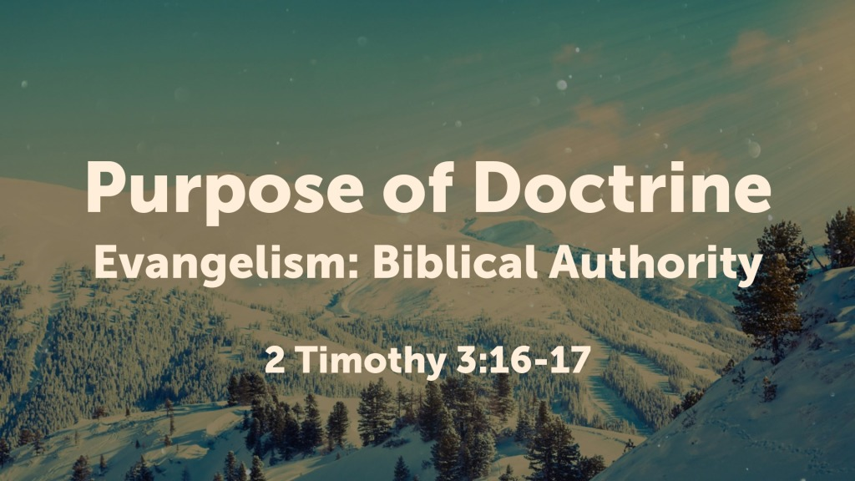
2 Timothy 3:16–17 (ESV)
¹⁶ All Scripture is breathed out by God and profitable for teaching, for reproof, for correction, and for training in righteousness, ¹⁷ that the man of God may be complete, equipped for every good work.

I. The purpose of doctrine for the individual

A. It leads to repentance
2 Timothy 2:25 ESV
²⁵ correcting his opponents with gentleness. God may perhaps grant them repentance leading to a knowledge of the truth,

B. It leads to salvation
1 Timothy 4:16 ESV
¹⁶ Keep a close watch on yourself and on the teaching. Persist in this, for by so doing you will save both yourself and your hearers.

C. It is necessary for Christian maturity and effective service
2 Timothy 3:16–17 ESV
¹⁶ All Scripture is breathed out by God and profitable for teaching, for reproof, for correction, and for training in righteousness, ¹⁷ that the man of God may be complete, equipped for every good work.

D. It makes possible a defense of the faith
1 Peter 3:15–16 ESV
¹⁵ but in your hearts honor Christ the Lord as holy, always being prepared to make a defense to anyone who asks you for a reason for the hope that is in you; yet do it with gentleness and respect, ¹⁶ having a good conscience, so that, when you are slandered, those who revile your good behavior in Christ may be put to shame.

E. It leads to enrichment and blessing
Deuteronomy 32:1–4 ESV
¹ “Give ear, O heavens, and I will speak,
and let the earth hear the words of my mouth.
² May my teaching drop as the rain,
my speech distill as the dew,
like gentle rain upon the tender grass,
and like showers upon the herb.
³ For I will proclaim the name of the Lord;
ascribe greatness to our God!
⁴ “The Rock, his work is perfect,
for all his ways are justice.
A God of faithfulness and without iniquity,
just and upright is he.

F. It leads to perfection
Colossians 1:28 ESV
²⁸ Him we proclaim, warning everyone and teaching everyone with all wisdom, that we may present everyone mature in Christ.

II. Doctrine as the basis of faithful ministry in the church
Titus 1:9 ESV
⁹ He must hold firm to the trustworthy word as taught, so that he may be able to give instruction in sound doctrine and also to rebuke those who contradict it.
1 Timothy 4:6–8 ESV
⁶ If you put these things before the brothers, you will be a good servant of Christ Jesus, being trained in the words of the faith and of the good doctrine that you have followed. ⁷ Have nothing to do with irreverent, silly myths. Rather train yourself for godliness; ⁸ for while bodily training is of some value, godliness is of value in every way, as it holds promise for the present life and also for the life to come.
God’s Invitation

Hear - Romans 10:17
Believe - John 1:7
Confess - Hebrews 4:14
Repent - Luke 13:3
Be Baptized - Acts 2:38
Remain Faithful - Revelation 2:10‌

New to the Faith?
• First Principles
Have you fallen away from Faith?
• Need to be Restored
My Decision Today
• I would like to be baptized today
• I would like to renew my life to Christ
• I would like to learn more about Jesus and the Bible
Questions: What are my next steps?
• Come forward to be baptized
• Request a Bible Study to learn more
• Attend Bible Class to grow and mature
• Find a place to serve others
• Apply today’s lesson to my life

