Barry G. Johnson, Sr. / www.barrygjohnsonsr.com
Power of the Bible / Jesus; Power; Concept of Great Power; God: Power; Word of God / Acts 13:38–41
The historical and ongoing effective authority of Jesus Christ over natural elements, over human life and ultimately over sin, forces of evil, Satan and death.
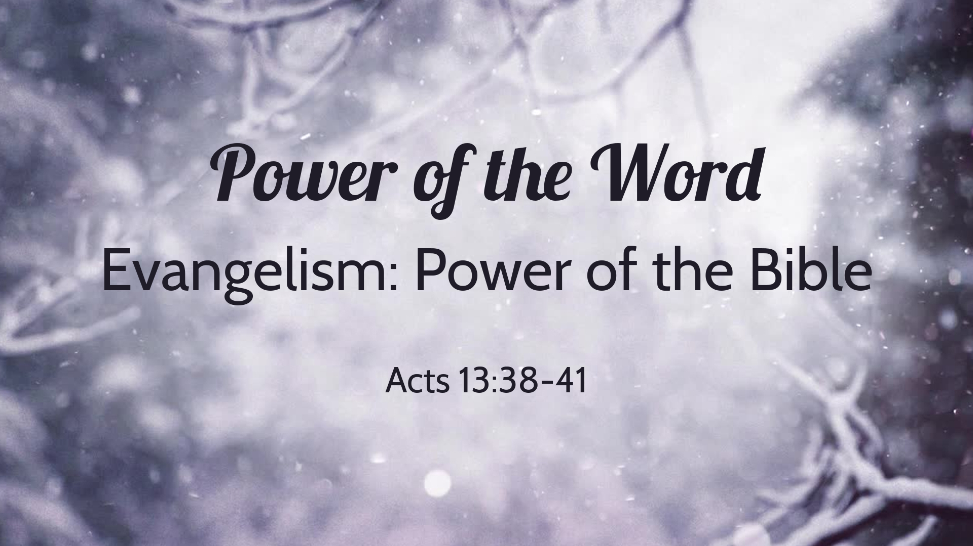 Acts 13:38–41 ESV
³⁸ Let it be known to you therefore, brothers, that through this man forgiveness of sins is proclaimed to you, ³⁹ and by him everyone who believes is freed from everything from which you could not be freed by the law of Moses. ⁴⁰ Beware, therefore, lest what is said in the Prophets should come about:
⁴¹ “ ‘Look, you scoffers,
be astounded and perish;
for I am doing a work in your days,
a work that you will not believe, even if one tells it to you.’ ”

I. The Word’s power is of God
Acts 10:38 ESV
³⁸ how God anointed Jesus of Nazareth with the Holy Spirit and with power. He went about doing good and healing all who were oppressed by the devil, for God was with him.

A. God’s creative power is exercised through the Word
John 1:3 ESV
³ All things were made through him, and without him was not any thing made that was made.

B. God’s infinite power is given by the Word
Matthew 28:18 ESV
¹⁸ And Jesus came and said to them, “All authority in heaven and on earth has been given to me.

II. The Word’s power is revealed on earth

A. The Word’s power over human life
Matthew 11:5 ESV
⁵ the blind receive their sight and the lame walk, lepers are cleansed and the deaf hear, and the dead are raised up, and the poor have good news preached to them.

B. The Word’s power over human behaviour
Matthew 4:20 ESV
²⁰ Immediately they left their nets and followed him.

C. The Word’s power over forces of evil
Matthew 8:16 ESV
¹⁶ That evening they brought to him many who were oppressed by demons, and he cast out the spirits with a word and healed all who were sick.

III. The Word has power over sin and death

A. The Gospel’s crucifixion defeats the power of sin
Romans 6:6 ESV
⁶ We know that our old self was crucified with him in order that the body of sin might be brought to nothing, so that we would no longer be enslaved to sin.

B. The Word’s resurrection defeats the power of death
Romans 6:9 ESV
⁹ We know that Christ, being raised from the dead, will never die again; death no longer has dominion over him.

C. The Word’s power over sin and death remains effective
Hebrews 7:25 ESV
²⁵ Consequently, he is able to save to the uttermost those who draw near to God through him, since he always lives to make intercession for them.

IV. The Word’s power remains available in human experience

A. The Word’s forgiving power is effective today
Acts 13:38–39 ESV
³⁸ Let it be known to you therefore, brothers, that through this man forgiveness of sins is proclaimed to you, ³⁹ and by him everyone who believes is freed from everything from which you could not be freed by the law of Moses.

B. The Word’s enabling power is effective today
1 Corinthians 12:4–6 ESV
⁴ Now there are varieties of gifts, but the same Spirit; ⁵ and there are varieties of service, but the same Lord; ⁶ and there are varieties of activities, but it is the same God who empowers them all in everyone.
God’s Invitation of Salvation
Hear - Believe - Confess - Repent Be Baptized - Remain Steadfast
‌Romans 10:17 ESV 17 So faith comes from hearing, and hearing through the word of Christ.
‌John 1:7 ESV 7 He came as a witness, to bear witness about the light, that all might believe through him.
‌Hebrews 4:14 ESV 14 Since then we have a great high priest who has passed through the heavens, Jesus, the Son of God, let us hold fast our confession.
‌Luke 13:3 ESV 3 No, I tell you; but unless you repent, you will all likewise perish.
‌Acts 2:38 ESV 38 And Peter said to them, “Repent and be baptized every one of you in the name of Jesus Christ for the forgiveness of your sins, and you will receive the gift of the Holy Spirit.
‌Revelation 2:10 ESV 10 Do not fear what you are about to suffer. Behold, the devil is about to throw some of you into prison, that you may be tested, and for ten days you will have tribulation. Be faithful unto death, and I will give you the crown of life.

