Barry G. Johnson, Sr. / www.barrygjohnsonsr.com
Power of the Bible / Power; God: Power / Luke 6:19
God has power to save and protect and through His power He will defeat those who oppose Him.
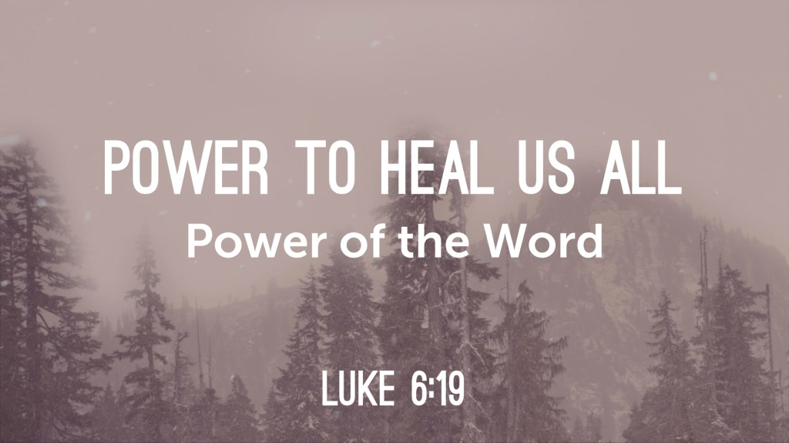
Luke 6:19 ESV
¹⁹ And all the crowd sought to touch him, for power came out from him and healed them all.

I. God’s power to save
Psalm 20:6 ESV
⁶ Now I know that the Lord saves his anointed;
he will answer him from his holy heaven
with the saving might of his right hand.
2 Peter 1:3–4 ESV
³ His divine power has granted to us all things that pertain to life and godliness, through the knowledge of him who called us to his own glory and excellence, ⁴ by which he has granted to us his precious and very great promises, so that through them you may become partakers of the divine nature, having escaped from the corruption that is in the world because of sinful desire.

II. God’s power and provision
1 Peter 1:3–5 ESV
³ Blessed be the God and Father of our Lord Jesus Christ! According to his great mercy, he has caused us to be born again to a living hope through the resurrection of Jesus Christ from the dead, ⁴ to an inheritance that is imperishable, undefiled, and unfading, kept in heaven for you, ⁵ who by God’s power are being guarded through faith for a salvation ready to be revealed in the last time.
Romans 8:38–39 ESV
³⁸ For I am sure that neither death nor life, nor angels nor rulers, nor things present nor things to come, nor powers, ³⁹ nor height nor depth, nor anything else in all creation, will be able to separate us from the love of God in Christ Jesus our Lord.

III. The power of the gospel
Romans 1:16 ESV
¹⁶ For I am not ashamed of the gospel, for it is the power of God for salvation to everyone who believes, to the Jew first and also to the Greek.
1 Corinthians 1:18 ESV
¹⁸ For the word of the cross is folly to those who are perishing, but to us who are being saved it is the power of God.

IV. The power of God’s kingdom
1 Corinthians 4:19–20 ESV
¹⁹ But I will come to you soon, if the Lord wills, and I will find out not the talk of these arrogant people but their power. ²⁰ For the kingdom of God does not consist in talk but in power.

V. Power in Preaching
1 Corinthians 2:4–5 ESV
⁴ and my speech and my message were not in plausible words of wisdom, but in demonstration of the Spirit and of power, ⁵ so that your faith might not rest in the wisdom of men but in the power of God.

VI. The powers that oppose God will be defeated
1 Corinthians 15:24 ESV
²⁴ Then comes the end, when he delivers the kingdom to God the Father after destroying every rule and every authority and power.
Colossians 2:15 ESV
¹⁵ He disarmed the rulers and authorities and put them to open shame, by triumphing over them in him.

VII. The power of God over death
Psalm 89:48 ESV
⁴⁸ What man can live and never see death?
Who can deliver his soul from the power of Sheol? Selah
Isaiah 25:8 ESV
⁸ He will swallow up death forever;
and the Lord God will wipe away tears from all faces,
and the reproach of his people he will take away from all the earth,
for the Lord has spoken.
1 Corinthians 6:14 ESV
¹⁴ And God raised the Lord and will also raise us up by his power.
1 Corinthians 15:54–57 ESV
⁵⁴ When the perishable puts on the imperishable, and the mortal puts on immortality, then shall come to pass the saying that is written:
“Death is swallowed up in victory.”
⁵⁵ “O death, where is your victory?
O death, where is your sting?”
⁵⁶ The sting of death is sin, and the power of sin is the law. ⁵⁷ But thanks be to God, who gives us the victory through our Lord Jesus Christ.
Hebrews 2:14–15 ESV
¹⁴ Since therefore the children share in flesh and blood, he himself likewise partook of the same things, that through death he might destroy the one who has the power of death, that is, the devil, ¹⁵ and deliver all those who through fear of death were subject to lifelong slavery.
God’s Invitation of Salvation
Hear - Believe - Confess - Repent Be Baptized - Remain Steadfast
‌Romans 10:17
ESV 17 So faith comes from hearing, and hearing through the word of Christ.
‌John 1:7
ESV 7 He came as a witness, to bear witness about the light, that all might believe through him.
‌Hebrews 4:14
ESV 14 Since then we have a great high priest who has passed through the heavens, Jesus, the Son of God, let us hold fast our confession.
‌Luke 13:3
ESV 3 No, I tell you; but unless you repent, you will all likewise perish.
‌Acts 2:38
ESV 38 And Peter said to them, “Repent and be baptized every one of you in the name of Jesus Christ for the forgiveness of your sins, and you will receive the gift of the Holy Spirit.
‌Revelation 2:10
ESV 10 Do not fear what you are about to suffer. Behold, the devil is about to throw some of you into prison, that you may be tested, and for ten days you will have tribulation. Be faithful unto death, and I will give you the crown of life.

