Discovering the Church / Peace; Peace of the Church; Mature; Increase; Labor; Work; Evangelism; Mission / Acts 12:24–25

Whether good times or bad we must work to promote the Gospel of Jesus Christ.
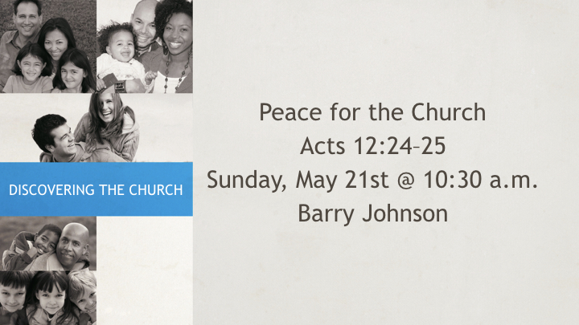

The Word of God Increased

Increase when times are good
Acts 6:7 ESV
⁷ And the word of God continued to increase, and the number of the disciples multiplied greatly in Jerusalem, and a great many of the priests became obedient to the faith.
Hebrews 4:12 ESV
¹² For the word of God is living and active, sharper than any two-edged sword, piercing to the division of soul and of spirit, of joints and of marrow, and discerning the thoughts and intentions of the heart.

Increase when things are bad
Acts 19:20 ESV
²⁰ So the word of the Lord continued to increase and prevail mightily.
Acts 8:4 ESV
⁴ Now those who were scattered went about preaching the word.

Completing our Service

Remaining Faithfully will give Strength
Acts 18:23 ESV
²³ After spending some time there, he departed and went from one place to the next through the region of Galatia and Phrygia, strengthening all the disciples.
Acts 14:21–23 ESV
²¹ When they had preached the gospel to that city and had made many disciples, they returned to Lystra and to Iconium and to Antioch,
²² strengthening the souls of the disciples, encouraging them to continue in the faith, and saying that through many tribulations we must enter the kingdom of God.
²³ And when they had appointed elders for them in every church, with prayer and fasting they committed them to the Lord in whom they had believed.

Our Service Must be Added to for Completion
Luke 8:14 ESV
¹⁴ And as for what fell among the thorns, they are those who hear, but as they go on their way they are choked by the cares and riches and pleasures of life, and their fruit does not mature.
Hebrews 5:14 ESV
¹⁴ But solid food is for the mature, for those who have their powers of discernment trained by constant practice to distinguish good from evil.
2 Peter 1:5–8 ESV
⁵ For this very reason, make every effort to supplement your faith with virtue, and virtue with knowledge,
⁶ and knowledge with self-control, and self-control with steadfastness, and steadfastness with godliness,
⁷ and godliness with brotherly affection, and brotherly affection with love.
⁸ For if these qualities are yours and are increasing, they keep you from being ineffective or unfruitful in the knowledge of our Lord Jesus Christ.

Adding Others to the Work

Recognize and Encourage those who Serve
1 Corinthians 16:15–18 ESV
¹⁵ Now I urge you, brothers—you know that the household of Stephanas were the first converts in Achaia, and that they have devoted themselves to the service of the saints—
¹⁶ be subject to such as these, and to every fellow worker and laborer.
¹⁷ I rejoice at the coming of Stephanas and Fortunatus and Achaicus, because they have made up for your absence,
¹⁸ for they refreshed my spirit as well as yours. Give recognition to such people.

Many Talents Needed in Building the Church
Romans 12:4–8 ESV
⁴ For as in one body we have many members, and the members do not all have the same function,
⁵ so we, though many, are one body in Christ, and individually members one of another.
⁶ Having gifts that differ according to the grace given to us, let us use them: if prophecy, in proportion to our faith;
⁷ if service, in our serving; the one who teaches, in his teaching;
⁸ the one who exhorts, in his exhortation; the one who contributes, in generosity; the one who leads, with zeal; the one who does acts of mercy, with cheerfulness.

Add to the Laborers because they are Few
Luke 10:2 ESV
² And he said to them, “The harvest is plentiful, but the laborers are few. Therefore pray earnestly to the Lord of the harvest to send out laborers into his harvest.
2 Corinthians 10:15–16 ESV
¹⁵ We do not boast beyond limit in the labors of others. But our hope is that as your faith increases, our area of influence among you may be greatly enlarged,
¹⁶ so that we may preach the gospel in lands beyond you, without boasting of work already done in another’s area of influence.

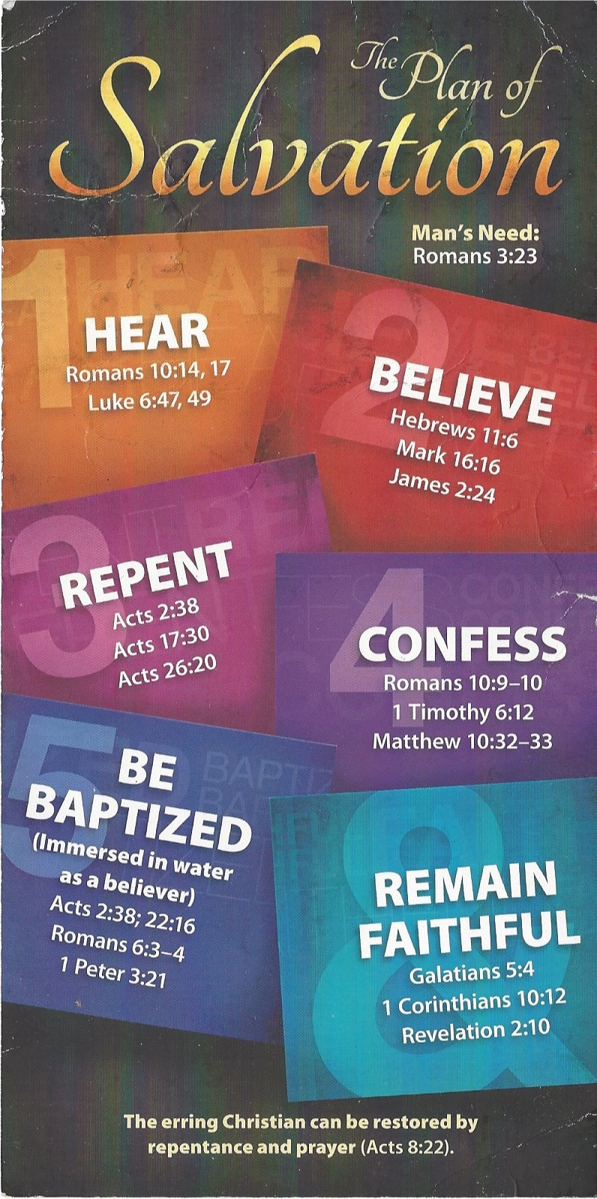
Hear - Romans 10:17 (NIV)
¹⁷ Consequently, faith comes from hearing the message, and the message is heard through the word about Christ.
Believe - Hebrews 11:6 (NIV)
⁶ And without faith it is impossible to please God, because anyone who comes to him must believe that he exists and that he rewards those who earnestly seek him.
Repent - Acts 17:30 (NIV)
³⁰ In the past God overlooked such ignorance, but now he commands all people everywhere to repent.
Confess - 1 Timothy 6:12 (NIV)
¹² Fight the good fight of the faith. Take hold of the eternal life to which you were called when you made your good confession in the presence of many witnesses.
Be Baptized - Acts 2:38 (ESV)
³⁸ And Peter said to them, “Repent and be baptized every one of you in the name of Jesus Christ for the forgiveness of your sins, and you will receive the gift of the Holy Spirit.
Remain Steadfast - Revelation 2:10 (NIV)
¹⁰ Do not be afraid of what you are about to suffer. I tell you, the devil will put some of you in prison to test you, and you will suffer persecution for ten days. Be faithful, even to the point of death, and I will give you life as your victor’s crown.

