Barry G. Johnson, Sr. / www.barrygjohnsonsr.com
Christian Character: Boldness / Boldness; Courage; Fear; Courageous; Faithfulness; Preaching; Evangelism / Acts 4:13–20
Christians should mature in a way in which they demonstrate the character of boldness.
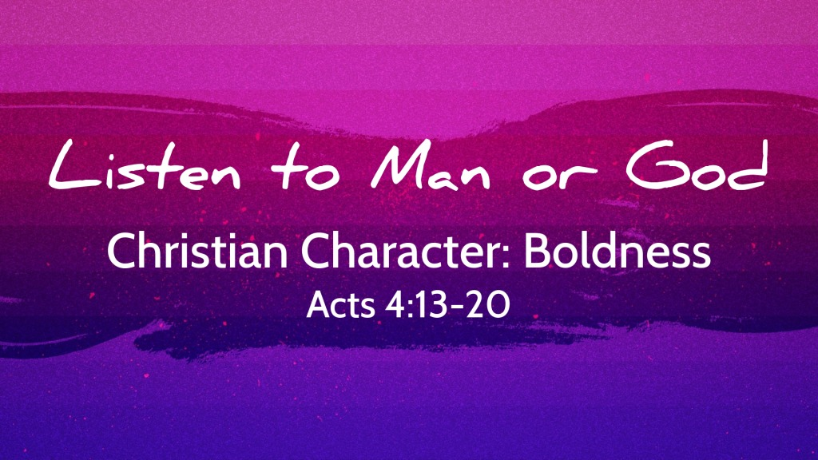
Acts 4:13–20 ESV
¹³ Now when they saw the boldness of Peter and John, and perceived that they were uneducated, common men, they were astonished. And they recognized that they had been with Jesus. ¹⁴ But seeing the man who was healed standing beside them, they had nothing to say in opposition. ¹⁵ But when they had commanded them to leave the council, they conferred with one another, ¹⁶ saying, “What shall we do with these men? For that a notable sign has been performed through them is evident to all the inhabitants of Jerusalem, and we cannot deny it. ¹⁷ But in order that it may spread no further among the people, let us warn them to speak no more to anyone in this name.” ¹⁸ So they called them and charged them not to speak or teach at all in the name of Jesus. ¹⁹ But Peter and John answered them, “Whether it is right in the sight of God to listen to you rather than to God, you must judge, ²⁰ for we cannot but speak of what we have seen and heard.”

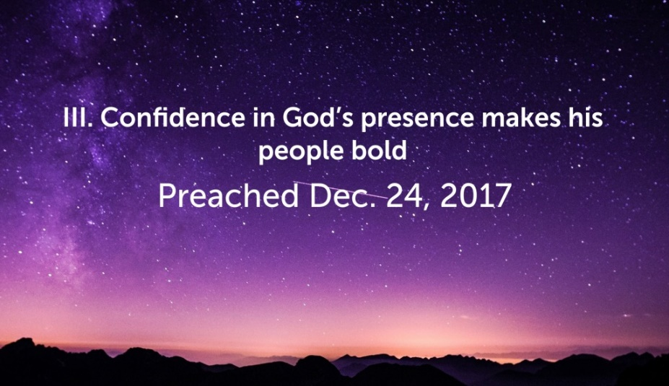
I. Ways Boldness is produced
click graphic for presentation of sermon from December 24, 2017

A. By trusting God
Isaiah 50:7 ESV
⁷ But the Lord God helps me;
therefore I have not been disgraced;
therefore I have set my face like a flint,
and I know that I shall not be put to shame.

B. Fear of God
Acts 5:29 ESV
²⁹ But Peter and the apostles answered, “We must obey God rather than men.

C. Faithfulness to God
1 Timothy 3:13 ESV
¹³ For those who serve well as deacons gain a good standing for themselves and also great confidence in the faith that is in Christ Jesus.

II. Ways Boldness is Sought

A. Prayer
Acts 4:29 ESV
²⁹ And now, Lord, look upon their threats and grant to your servants to continue to speak your word with all boldness,
Ephesians 6:19–20 ESV
¹⁹ and also for me, that words may be given to me in opening my mouth boldly to proclaim the mystery of the gospel, ²⁰ for which I am an ambassador in chains, that I may declare it boldly, as I ought to speak.

B. Exhortation
Joshua 1:7 ESV
⁷ Only be strong and very courageous, being careful to do according to all the law that Moses my servant commanded you. Do not turn from it to the right hand or to the left, that you may have good success wherever you go.
Jeremiah 1:8 ESV
⁸ Do not be afraid of them,
for I am with you to deliver you,
declares the Lord.”

III. Ways Boldness is Exhibited

A. faithfulness to people
2 Corinthians 7:4 ESV
⁴ I am acting with great boldness toward you; I have great pride in you; I am filled with comfort. In all our affliction, I am overflowing with joy.
2 Corinthians 10:1 ESV
¹ I, Paul, myself entreat you, by the meekness and gentleness of Christ—I who am humble when face to face with you, but bold toward you when I am away!—

B. Preaching and Witnessing
Acts 4:31 ESV
³¹ And when they had prayed, the place in which they were gathered together was shaken, and they were all filled with the Holy Spirit and continued to speak the word of God with boldness.
Philippians 1:14 ESV
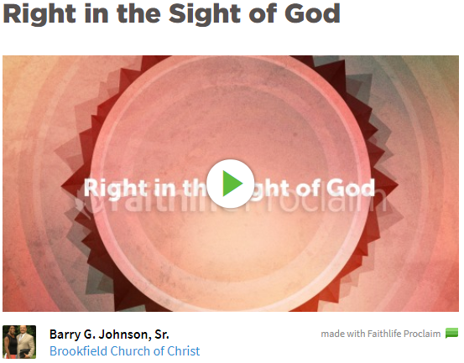
¹⁴ And most of the brothers, having become confident in the Lord by my imprisonment, are much more bold to speak the word without fear.
click graphic for presentation from February 5, 2017

C. Reproving Sin
Isaiah 58:1 ESV
¹ “Cry aloud; do not hold back;
lift up your voice like a trumpet;
declare to my people their transgression,
to the house of Jacob their sins.
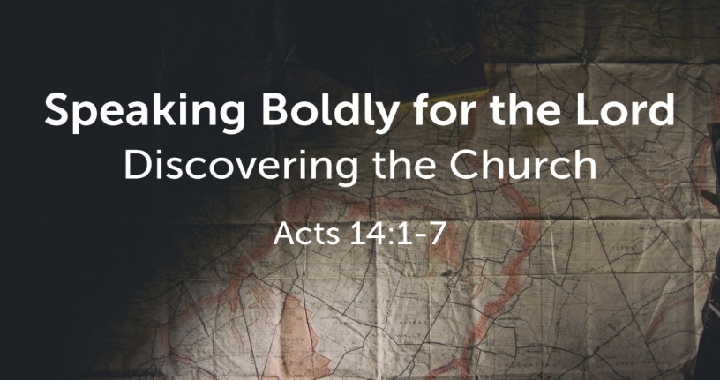
Micah 3:8 ESV
click graphic for presentation 1of sermon from June 7, 2017
⁸ But as for me, I am filled with power,
with the Spirit of the Lord,
and with justice and might,
to declare to Jacob his transgression
and to Israel his sin.

D. In the Face of Opposition
Acts 13:46 ESV
⁴⁶ And Paul and Barnabas spoke out boldly, saying, “It was necessary that the word of God be spoken first to you. Since you thrust it aside and judge yourselves unworthy of eternal life, behold, we are turning to the Gentiles.
1 Thessalonians 2:2 ESV
² But though we had already suffered and been shamefully treated at Philippi, as you know, we had boldness in our God to declare to you the gospel of God in the midst of much conflict.

God’s Plan of Redemption

Hear - Romans 10:17
Believe - John 1:7
Confess - Hebrews 4:14
Repent and Be Baptized - Acts 2:38

Remain Faithful - Matthew 25:21

New to the Faith?
• First Principles
Have you fallen away from Faith
• Need to be Restored
My Decision Today
• I would like to be baptized today
• I would like to renew my life to Christ
• I would like to learn more about Jesus and the Bible
Questions: What are my next steps?
• Come forward to be baptized
• Request a Bible Study to learn more
• Attend Bible Class to grow and mature
• Find a place to serve others
• Apply today’s lesson to my life

