Christian Character
Barry G. Johnson, Sr.
Church of Christ, Brookfield, IL
Christian Character
Life of Faith

Life of Faith
Barry G. Johnson, Sr. / www.barygjohnsonsr.com
Christian Character / Faith; Character; Evangelism; Walk; Life; The Way; Followers of the Way / John 14:12; 1 Corinthians 13:13
The way by which believers’ journey through this world and into the life to come. Jesus Christ himself is the way to life. The life of faith stirs evangelism.
1 Corinthians 13:13 ESV
¹³ So now faith, hope, and love abide, these three; but the greatest of these is love.
John 14:12 ESV
¹² “Truly, truly, I say to you, whoever believes in me will also do the works that I do; and greater works than these will he do, because I am going to the Father.

Life of Faith is travelling with God

Walking with God
Genesis 17:1 ESV
¹ When Abram was ninety-nine years old the Lord appeared to Abram and said to him, “I am God Almighty; walk before me, and be blameless,
1 John 2:4–6 ESV
⁴ Whoever says “I know him” but does not keep his commandments is a liar, and the truth is not in him, ⁵ but whoever keeps his word, in him truly the love of God is perfected. By this we may know that we are in him: ⁶ whoever says he abides in him ought to walk in the same way in which he walked.

God’s Word guides along the way
1 Thessalonians 4:1–12 ESV
¹ Finally, then, brothers, we ask and urge you in the Lord Jesus, that as you received from us how you ought to walk and to please God, just as you are doing, that you do so more and more. ² For you know what instructions we gave you through the Lord Jesus. ³ For this is the will of God, your sanctification: that you abstain from sexual immorality; ⁴ that each one of you know how to control his own body in holiness and honor, ⁵ not in the passion of lust like the Gentiles who do not know God; ⁶ that no one transgress and wrong his brother in this matter, because the Lord is an avenger in all these things, as we told you beforehand and solemnly warned you. ⁷ For God has not called us for impurity, but in holiness. ⁸ Therefore whoever disregards this, disregards not man but God, who gives his Holy Spirit to you.
⁹ Now concerning brotherly love you have no need for anyone to write to you, for you yourselves have been taught by God to love one another, ¹⁰ for that indeed is what you are doing to all the brothers throughout Macedonia. But we urge you, brothers, to do this more and more, ¹¹ and to aspire to live quietly, and to mind your own affairs, and to work with your hands, as we instructed you, ¹² so that you may walk properly before outsiders and be dependent on no one.

Sinners refuse to follow God’s way
Isaiah 53:6 ESV
⁶ All we like sheep have gone astray; we have turned—every one—to his own way; and the Lord has laid on him the iniquity of us all.
Acts 14:15–16 ESV
¹⁵ “Men, why are you doing these things? We also are men, of like nature with you, and we bring you good news, that you should turn from these vain things to a living God, who made the heaven and the earth and the sea and all that is in them. ¹⁶ In past generations he allowed all the nations to walk in their own ways.

All other routes end in death
Proverbs 14:12 ESV
¹² There is a way that seems right to a man, but its end is the way to death.

Those who travel God’s way are blessed
Proverbs 4:18 ESV
¹⁸ But the path of the righteous is like the light of dawn, which shines brighter and brighter until full day.

Jesus Christ is the way to life
John 14:6 ESV
⁶ Jesus said to him, “I am the way, and the truth, and the life. No one comes to the Father except through me.

Entrance of life by faith is narrow

Entrance to life is restricted
Matthew 7:13–14 ESV
¹³ “Enter by the narrow gate. For the gate is wide and the way is easy that leads to destruction, and those who enter by it are many. ¹⁴ For the gate is narrow and the way is hard that leads to life, and those who find it are few.

Entrance made possible by faith
Hebrews 11:8–10 ESV
⁸ By faith Abraham obeyed when he was called to go out to a place that he was to receive as an inheritance. And he went out, not knowing where he was going. ⁹ By faith he went to live in the land of promise, as in a foreign land, living in tents with Isaac and Jacob, heirs with him of the same promise. ¹⁰ For he was looking forward to the city that has foundations, whose designer and builder is God.
See also Jn 3:15–16; 2 Co 5:7; Heb 11:6; Heb 11:13–16

The Life of Faith stirs Evangelism

What is Evangelism?
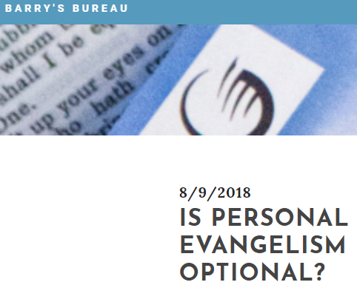
"The compassionate sharing of the Good News of Jesus Christ with lost people, in the power of the Holy Spirit, for the purpose of bringing them to Christ as Savior and Lord, that they in turn might share Him with others. "

1. Spirit of Evangelism - Compassion

2. Method of Evangelism - Sharing (verbal and non-verbal; act and a process).

3. Content of Evangelism - Good News of Jesus Christ

4. Recipients of Evangelism - Lost People

5. Power of Evangelism - Holy Spirit

6. Purpose of Evangelism - Bringing them to Christ as Savior and Lord

7. Perpetuation of Evangelism - They win others
Figure 1 - Click graphic to read Blog

God’s Invitation and Plan of Salvation

Hear
Romans 10:17 ESV
¹⁷ So faith comes from hearing, and hearing through the word of Christ.

Believe and Confess
Romans 10:9–10 ESV
⁹ because, if you confess with your mouth that Jesus is Lord and believe in your heart that God raised him from the dead, you will be saved. ¹⁰ For with the heart one believes and is justified, and with the mouth one confesses and is saved.

Repent
Luke 13:3 ESV
³ No, I tell you; but unless you repent, you will all likewise perish.

Be Baptized
Romans 6:3–4 ESV
³ Do you not know that all of us who have been baptized into Christ Jesus were baptized into his death? ⁴ We were buried therefore with him by baptism into death, in order that, just as Christ was raised from the dead by the glory of the Father, we too might walk in newness of life.

Remain Faithful
Revelation 2:10 ESV
¹⁰ Do not fear what you are about to suffer. Behold, the devil is about to throw some of you into prison, that you may be tested, and for ten days you will have tribulation. Be faithful unto death, and I will give you the crown of life.

New to the Faith
• First Principles

Have you fallen away from Faith
• Need to be Restored

My Decision Today
• I would like to be baptized today
• I would like to renew my life to Christ
• I would like to learn more about Jesus and the Bible

Questions: What are my next steps?
• Come forward to be baptized
• Request a Bible Study to learn more
• Attend Bible Class to grow and mature
• Find a place to serve others
• Apply today’s lesson to my life
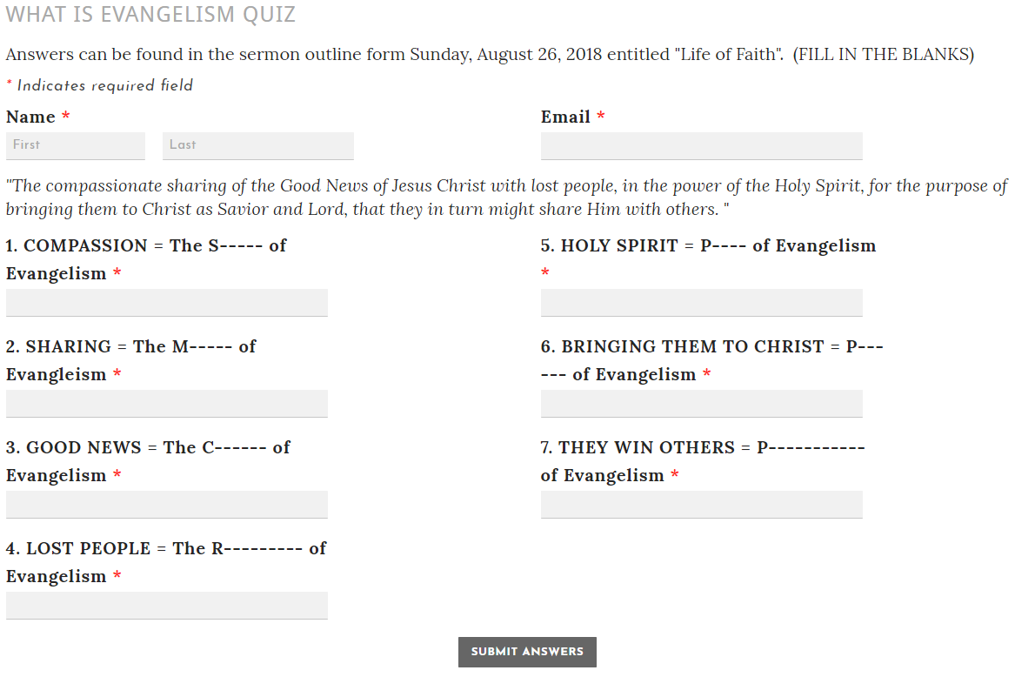
Figure 2 - Click Graphic to take Quiz on my website

