Book of Joshua
“Courage and Conquest”

Bible Study Resources
Sunday Mornings @9:30am
Brookfield Church of Christ
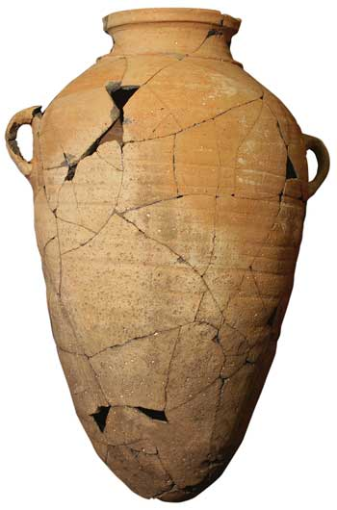

Presenter: Talmadge L. Gerald III
www.archwithtal.com
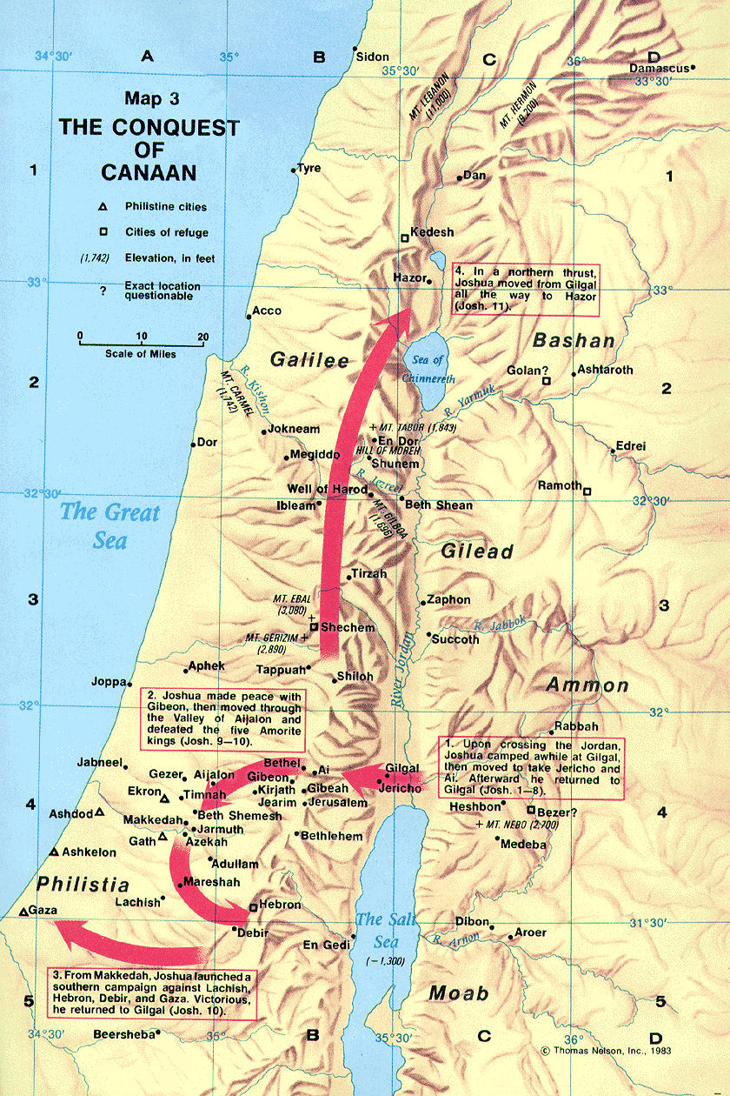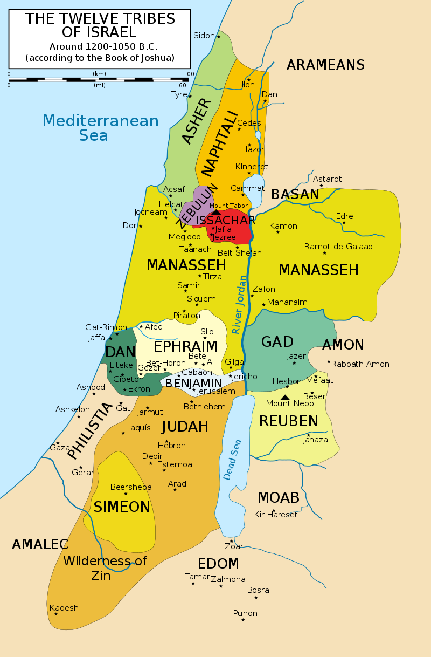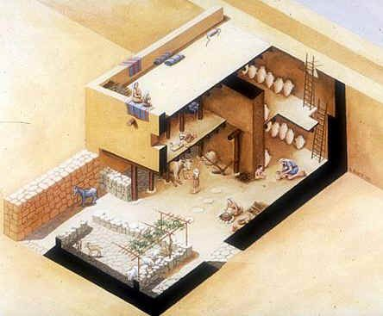
Israelite “Four-Room House”
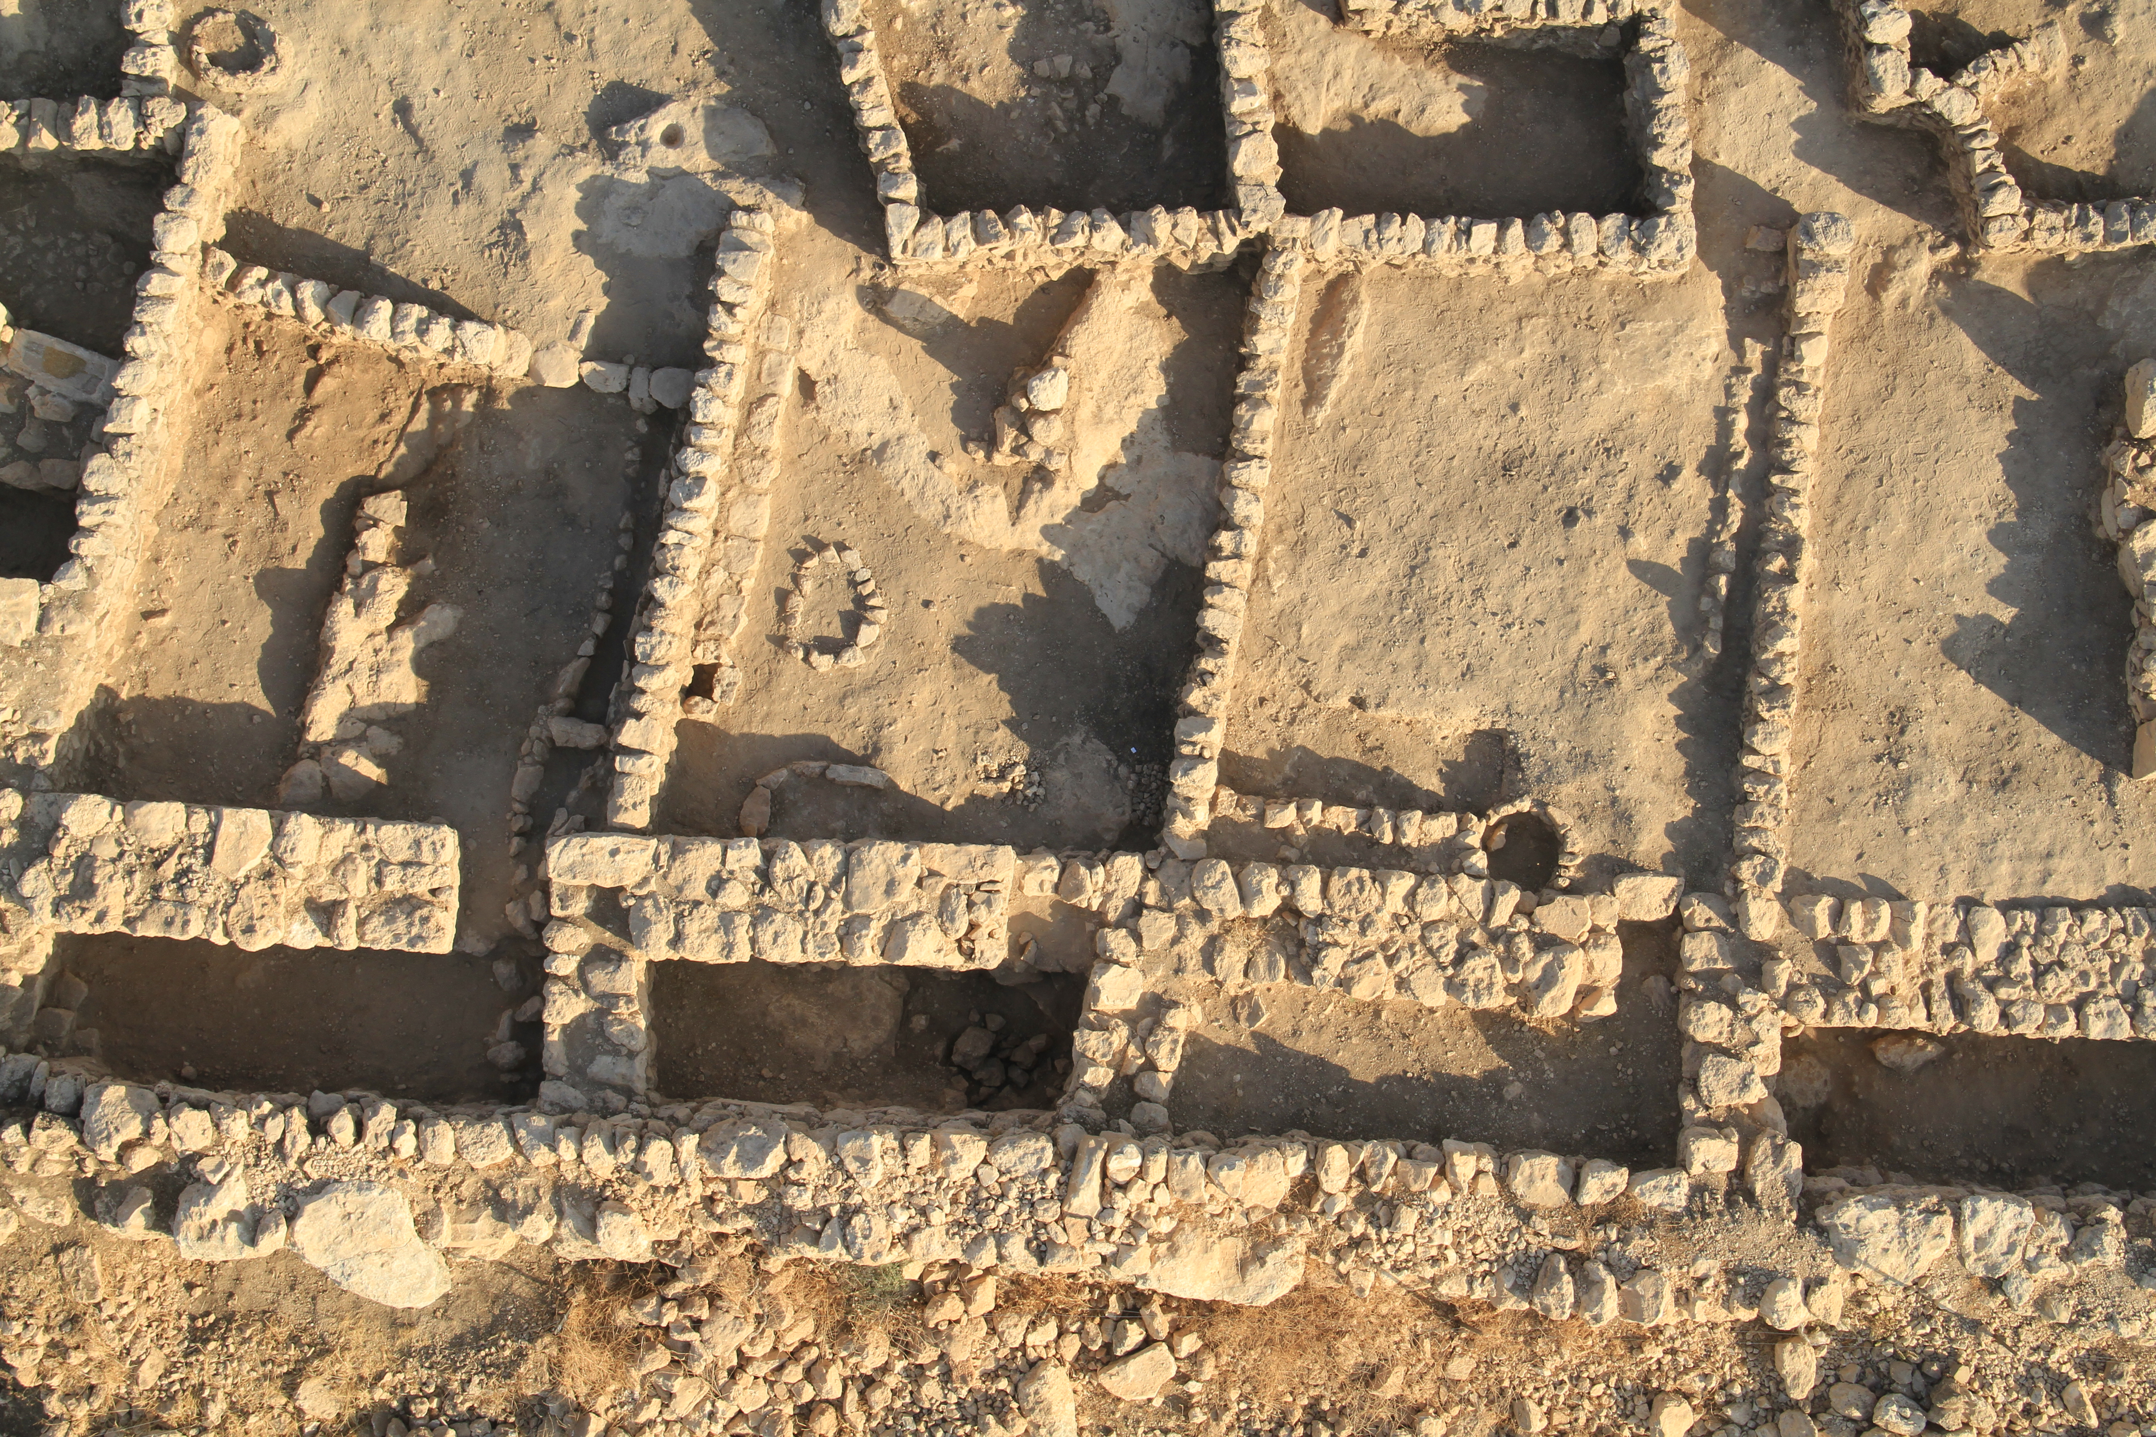
Casemate, double-wall structure. Rahab “lived in the walls”
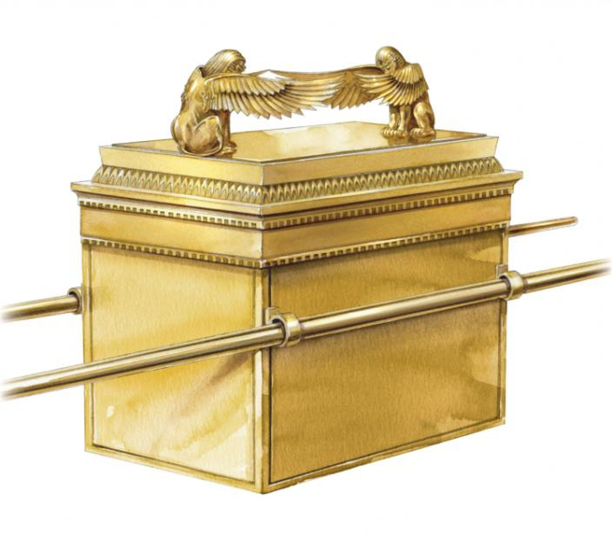
Ark of the Covenant (ESV Study Bible, Crossway)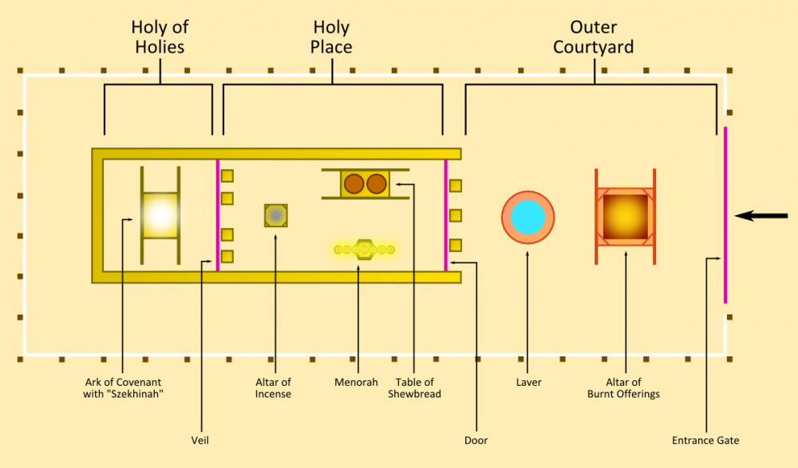
Layout of the Tabernacle

Notes:
________________________________________________________________________
________________________________________________________________________
________________________________________________________________________
________________________________________________________________________
________________________________________________________________________
________________________________________________________________________
________________________________________________________________________
________________________________________________________________________
________________________________________________________________________
________________________________________________________________________
________________________________________________________________________
________________________________________________________________________
________________________________________________________________________
________________________________________________________________________
________________________________________________________________________
________________________________________________________________________
________________________________________________________________________
________________________________________________________________________
________________________________________________________________________
________________________________________________________________________
________________________________________________________________________
________________________________________________________________________
________________________________________________________________________
________________________________________________________________________
________________________________________________________________________
________________________________________________________________________
________________________________________________________________________
________________________________________________________________________
________________________________________________________________________
________________________________________________________________________
________________________________________________________________________
________________________________________________________________________
________________________________________________________________________
________________________________________________________________________
________________________________________________________________________
________________________________________________________________________
________________________________________________________________________
________________________________________________________________________

And if it is evil in your eyes to serve the LORD, choose this day whom you will serve, whether the gods your fathers served in the region beyond the River, or the gods of the Amorites in whose land you dwell.

But as for me and my house, we will serve the LORD.”
Joshua 24:15 ESV

