Barry G. Johnson, Sr. / www.barrygjohnsonsr.com
Jesus the Way / God; Jesus / John 14:6
It is Jesus that shows us the Father that we might draw closer to Him in relationship as the family of God.
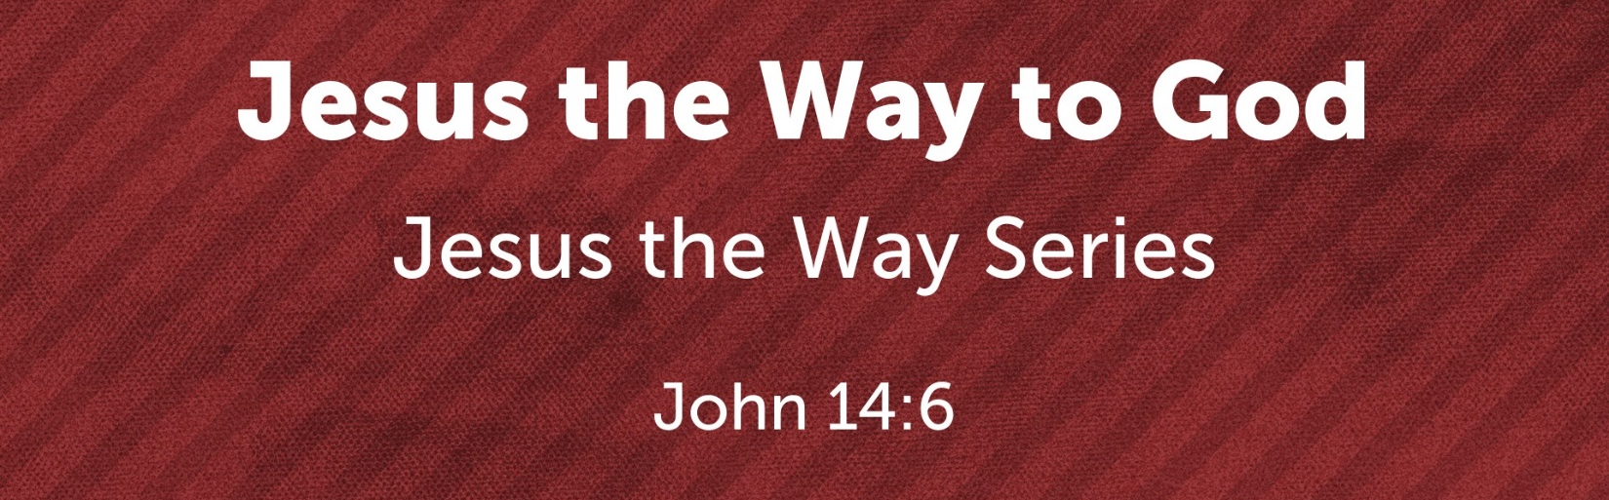
John 14:1–7 ESV
¹ “Let not your hearts be troubled. Believe in God; believe also in me. ² In my Father’s house are many rooms. If it were not so, would I have told you that I go to prepare a place for you? ³ And if I go and prepare a place for you, I will come again and will take you to myself, that where I am you may be also. ⁴ And you know the way to where I am going.” ⁵ Thomas said to him, “Lord, we do not know where you are going. How can we know the way?” ⁶ Jesus said to him, “I am the way, and the truth, and the life. No one comes to the Father except through me. ⁷ If you had known me, you would have known my Father also. From now on you do know him and have seen him.”

THE DIFFERENCE BETWEEN GOD AND MAN
Jeremiah 23:23–24 ESV
²³ “Am I a God at hand, declares the Lord, and not a God far away? ²⁴ Can a man hide himself in secret places so that I cannot see him? declares the Lord. Do I not fill heaven and earth? declares the Lord.
Acts 17:24–28 ESV
²⁴ The God who made the world and everything in it, being Lord of heaven and earth, does not live in temples made by man, ²⁵ nor is he served by human hands, as though he needed anything, since he himself gives to all mankind life and breath and everything. ²⁶ And he made from one man every nation of mankind to live on all the face of the earth, having determined allotted periods and the boundaries of their dwelling place, ²⁷ that they should seek God, and perhaps feel their way toward him and find him. Yet he is actually not far from each one of us, ²⁸ for
“ ‘In him we live and move and have our being’;
as even some of your own poets have said,
“ ‘For we are indeed his offspring.’
Exodus 3:6 ESV
⁶ And he said, “I am the God of your father, the God of Abraham, the God of Isaac, and the God of Jacob.” And Moses hid his face, for he was afraid to look at God.
Job 9:32–33 ESV
³² For he is not a man, as I am, that I might answer him,
that we should come to trial together.
³³ There is no arbiter between us,
who might lay his hand on us both.

HOW JESUS IS THE WAY TO GOD
John 1:18 ESV
¹⁸ No one has ever seen God; the only God, who is at the Father’s side, he has made him known.
John 6:46 ESV
⁴⁶ not that anyone has seen the Father except he who is from God; he has seen the Father.
John 1:1–2 ESV
¹ In the beginning was the Word, and the Word was with God, and the Word was God. ² He was in the beginning with God.
John 1:14 ESV
¹⁴ And the Word became flesh and dwelt among us, and we have seen his glory, glory as of the only Son from the Father, full of grace and truth.
John 14:7 ESV
⁷ If you had known me, you would have known my Father also. From now on you do know him and have seen him.”
Colossians 2:9 ESV
⁹ For in him the whole fullness of deity dwells bodily,
Hebrews 1:1–3 ESV
¹ Long ago, at many times and in many ways, God spoke to our fathers by the prophets, ² but in these last days he has spoken to us by his Son, whom he appointed the heir of all things, through whom also he created the world. ³ He is the radiance of the glory of God and the exact imprint of his nature, and he upholds the universe by the word of his power. After making purification for sins, he sat down at the right hand of the Majesty on high,
Hebrews 4:14 ESV
¹⁴ Since then we have a great high priest who has passed through the heavens, Jesus, the Son of God, let us hold fast our confession.
Hebrews 4:15 ESV
¹⁵ For we do not have a high priest who is unable to sympathize with our weaknesses, but one who in every respect has been tempted as we are, yet without sin.
Hebrews 4:16 ESV
¹⁶ Let us then with confidence draw near to the throne of grace, that we may receive mercy and find grace to help in time of need.

TERMS USED TO DESCRIBE THOSE WHO ARE IN JESUS
Galatians 3:26 ESV
²⁶ for in Christ Jesus you are all sons of God, through faith.
1 Timothy 3:15 ESV
¹⁵ if I delay, you may know how one ought to behave in the household of God, which is the church of the living God, a pillar and buttress of the truth.
2 Corinthians 6:16 ESV
¹⁶ What agreement has the temple of God with idols? For we are the temple of the living God; as God said,
“I will make my dwelling among them and walk among them,
and I will be their God,
and they shall be my people.
1 Peter 2:5 ESV
⁵ you yourselves like living stones are being built up as a spiritual house, to be a holy priesthood, to offer spiritual sacrifices acceptable to God through Jesus Christ.
1 Peter 2:9 ESV
⁹ But you are a chosen race, a royal priesthood, a holy nation, a people for his own possession, that you may proclaim the excellencies of him who called you out of darkness into his marvelous light.

God’s Salvation Invitation

Hear - Believe - Confess - Repent - Be Baptized - Be Faithful
Matthew 7:24 ESV
²⁴ “Everyone then who hears these words of mine and does them will be like a wise man who built his house on the rock.
John 1:12 ESV
¹² But to all who did receive him, who believed in his name, he gave the right to become children of God,
1 John 2:23 ESV
²³ No one who denies the Son has the Father. Whoever confesses the Son has the Father also.
Luke 13:3 ESV
³ No, I tell you; but unless you repent, you will all likewise perish.
Galatians 3:27 ESV
²⁷ For as many of you as were baptized into Christ have put on Christ.
James 1:3–4 ESV
³ for you know that the testing of your faith produces steadfastness. ⁴ And let steadfastness have its full effect, that you may be perfect and complete, lacking in nothing.

Questions to Stimulate Your Thinking...
1. What did Job wished he had between himself and God? (Job 9:33)
______________________________________________________________
2. How is Jesus described in John 1:18?
______________________________________________________________
3. How can Jesus be a sympathetic High Priest? (Hebrews 4:15)

4. If one does not have the Son, what else do they not have? (1 John 5:12)
______________________________________________________________
5. What is the only way to the Father? (John 14:6)
______________________________________________________________

6. What do we have through the blood of Jesus? (Ephesians 1:7)
______________________________________________________________
7. How can both Jew and Gentile have access to the Father? (Ephesians 2:18)
______________________________________________________________
8. What has God done through Jesus Christ? (2 Corinthians 5:18)
______________________________________________________________
9. What do we become through faith in Christ Jesus? (Galatians 3:26)
______________________________________________________________
10. Where is the eternal life that God gives? (1 John 5:11)
______________________________________________________________
11. What is Jesus called in these passages: 1 Timothy 2:5; Hebrews 4:14; John 14:6; Ephesians 2:14?
______________________________________________________________
______________________________________________________________
Answers can be found on my website www.barrygjohnsonsr.com sermons 2019 page

