How Do I know the Bible is Really True?
Barry G. Johnson, Sr. / www.barrygjohnsonsr.com
Top Objections to Christianity / Bible; Evidence; Archaeology; Science; Prophecy; Manuscript; Proof / John 17:14–19
There is overwhelming evidence for the accuracy and reliability of the Bible, no ancient document even compares.
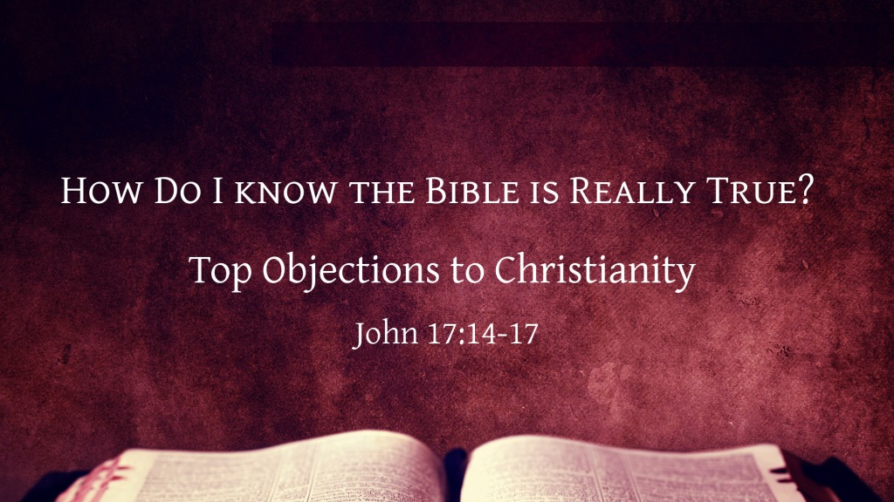
John 17:14–17 ESV
¹⁴ I have given them your word, and the world has hated them because they are not of the world, just as I am not of the world. ¹⁵ I do not ask that you take them out of the world, but that you keep them from the evil one. ¹⁶ They are not of the world, just as I am not of the world. ¹⁷ Sanctify them in the truth; your word is truth.

I. SCIENTIFIC FOREKNOWLEDGE
1. In the Bible there are statements related to astronomy, cosmology, medicine, meteorology, oceanography, etc.
2. Mentioned thousands of years prior to scientific discovery of these truths
3. Discovered in modern times with the aid of scientific instruments
4. The writers of the Bible could have known these facts only through divine inspiration
5. Such evidence of inspiration confirms the Bible’s claim to be from God the Creator

II. FULFILLED PROPHECIES
Isaiah 42:8–9 ESV
⁸ I am the Lord; that is my name;
my glory I give to no other,
nor my praise to carved idols.
⁹ Behold, the former things have come to pass,
and new things I now declare;
before they spring forth
I tell you of them.”
Luke 24:44–45 ESV
⁴⁴ Then he said to them, “These are my words that I spoke to you while I was still with you, that everything written about me in the Law of Moses and the Prophets and the Psalms must be fulfilled.” ⁴⁵ Then he opened their minds to understand the Scriptures,

III. ARCHAEOLOGICAL CONFIRMATION
Discoveries by archaeologists confirm the historical accuracy of the Bible
1. Cities in Abraham’s time (Ur, Haran)
2. Ancient empires once doubted (Hittites)
3. Cities in ancient Israel (Jericho, Shechem, Dan, etc.)
4. The house of David and Solomon’s temple
5. The census at the time of Jesus’ birth
6. Lysanias, tetrarch of Abilene
7. The Pavement (Gabbatha) in the court of the tower of Antonia
8. The politarchs in Thessalonica

IV. MANUSCRIPT CORROBORATION
How many copies of the NT manuscripts are available?
Over 4,000 Greek manuscripts; 13,000 copies of portions
Compare with other ancient writings: Caesar's Gallic Wars (10), Annals of Tacitus (2), Livy (20), Plato (7), Sophocles (100)
What time has passed between the original and earliest copies of the NT?
Several papyri fragments of the NT have been dated to within 30-100 years
Complete NT Greek manuscripts were copied within 300-400 years
Compare the time span with other classical histories:
1) Histories of Thucydides - 1300 years
2) Histories of Herodotus - 1350 years
3) Caesar’s Gallic War - 950 years
4) Roman History of Livy - 350 years (and it is a fragment)
5) Histories of Tacitus - 750 years
6) Annals of Tacitus - 950 years (and there are just two manuscripts)
What variances exist between the copies of the NT?
Only 1/2 of one percent is in question (compared to 5 percent for the Iliad)

V. PERSONAL EXPERIENCE
For one willing to obey the Bible from the heart, there is:
Peace to calm the troubled heart - Jn 14:27; 16:33; Php 4:7
Joy to lift our spirits - Jn 15:11; 1Pe 1:8
Love which casts out fear - 1Jn 4:18; Jn 15:9; Ep 3:19
Hope for facing the future - Jn 11:25; Re 14:13

God’s Plan of Salvation
Romans 10:17 ESV
¹⁷ So faith comes from hearing, and hearing through the word of Christ.
Hebrews 11:6 ESV
⁶ And without faith it is impossible to please him, for whoever would draw near to God must believe that he exists and that he rewards those who seek him.
Acts 17:30 ESV
³⁰ The times of ignorance God overlooked, but now he commands all people everywhere to repent,
1 Timothy 6:12 ESV
¹² Fight the good fight of the faith. Take hold of the eternal life to which you were called and about which you made the good confession in the presence of many witnesses.
1 Peter 3:21 ESV
²¹ Baptism, which corresponds to this, now saves you, not as a removal of dirt from the body but as an appeal to God for a good conscience, through the resurrection of Jesus Christ,
Revelation 2:10 ESV
¹⁰ Do not fear what you are about to suffer. Behold, the devil is about to throw some of you into prison, that you may be tested, and for ten days you will have tribulation. Be faithful unto death, and I will give you the crown of life.

