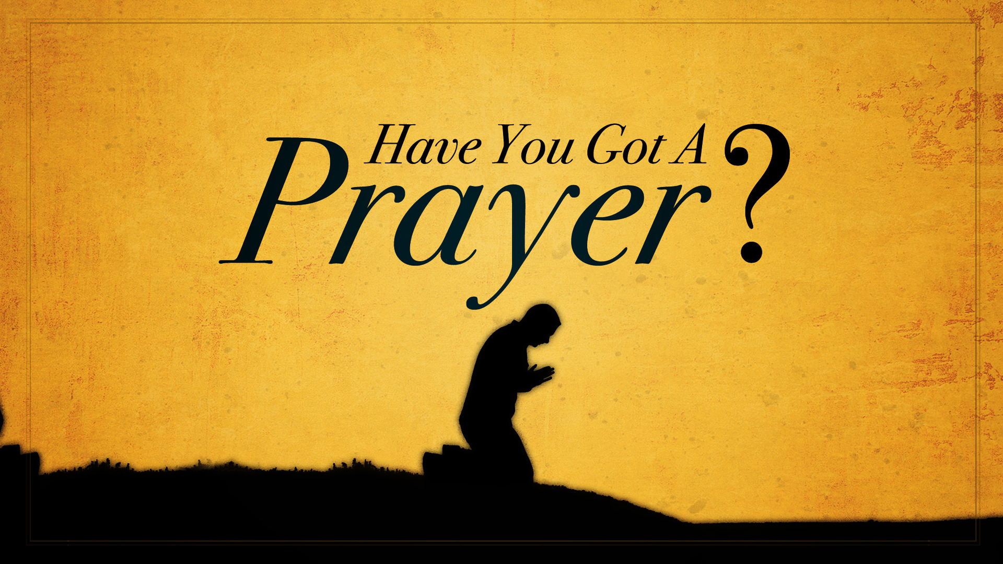
A Sermon about Prayerfulness, taken primarily from Acts 1:14
Central Idea / Synopsis
An attitude by which a constant relationship between God and believers is developed.

Prayerfulness is a way of life
Luke 2:37 ESV
and then as a widow until she was eighty-four. She did not depart from the temple, worshiping with fasting and prayer night and day.
See also Ps 5:3; Ps 55:17; Ps 109:4; Da 6:10–11; Da 6:13
What should prayer become to those who are trying to operate in a consistent relationship with God?
answer:_______________________________________________________________
Prayerfulness arises from a desire to be with God
Psalm 130:5–6 ESV
I wait for the LORD, my soul waits,
and in his word I hope;
my soul waits for the Lord
more than watchmen for the morning,
more than watchmen for the morning.
See also Ps 42:1–4; Ps 84:1–2
Prayerfulness arises from an awareness of need that can only be met by God
1 Timothy 5:5 ESV
She who is truly a widow, left all alone, has set her hope on God and continues in supplications and prayers night and day,
See also Ps 86:1; Ps 105:4
What does prayer acknowledge and make us aware of?
answer:_______________________________________________________________
Prayerfulness demonstrates a continuing trust in God
John 15:5–8 ESV
I am the vine; you are the branches. Whoever abides in me and I in him, he it is that bears much fruit, for apart from me you can do nothing. If anyone does not abide in me he is thrown away like a branch and withers; and the branches are gathered, thrown into the fire, and burned. If you abide in me, and my words abide in you, ask whatever you wish, and it will be done for you. By this my Father is glorified, that you bear much fruit and so prove to be my disciples.
See also Ps 63:1–8
Prayerfulness involves a heart that is right with God
Isaiah 1:15–17 ESV
When you spread out your hands,
I will hide my eyes from you;
even though you make many prayers,
I will not listen;
your hands are full of blood.
Wash yourselves; make yourselves clean;
remove the evil of your deeds from before my eyes;
cease to do evil,
learn to do good;
seek justice,
correct oppression;
bring justice to the fatherless,
plead the widow’s cause.
See also Mt 6:7; Mk 12:40
Prayerfulness involves the need to be alert
Matthew 26:41 ESV
Watch and pray that you may not enter into temptation. The spirit indeed is willing, but the flesh is weak.”
See also Mic 7:7; Lk 21:36; Col 4:2
What spiritual means is available to us, helping prevent falling into temptation?
answer:_______________________________________________________________
Prayerfulness needs to be maintained especially in difficult circumstances
Luke 18:1 ESV
And he told them a parable to the effect that they ought always to pray and not lose heart.
See also Hab 3:16–19; Ac 16:25; 1 Th 5:17; 1 Pe 4:7
When the christian loses heart, what should he do?
answer:_______________________________________________________________
Examples of people whose prayerfulness proved effective
Hannah, who prayed for a child
1 Samuel 1:20 ESV
And in due time Hannah conceived and bore a son, and she called his name Samuel, for she said, “I have asked for him from the LORD.”
See also Is 1:10–18
Elijah, an ordinary man who prayed
James 5:17–18 ESV
Elijah was a man with a nature like ours, and he prayed fervently that it might not rain, and for three years and six months it did not rain on the earth. Then he prayed again, and heaven gave rain, and the earth bore its fruit.
See also 1 Ki 17:1; 1 Ki 18:41–46
Nehemiah, a man who discovered God’s plan through prayer
Nehemiah 1:4 ESV
As soon as I heard these words I sat down and wept and mourned for days, and I continued fasting and praying before the God of heaven.
See also Ne 1:5–11; Ne 2:4–5
David, sustained through trials
1 Samuel 30:6 ESV
And David was greatly distressed, for the people spoke of stoning him, because all the people were bitter in soul, each for his sons and daughters. But David strengthened himself in the LORD his God.
See also 2 Sa 22:1–4; Ps 3:1–8
Daniel, whose patience in prayer was rewarded
Daniel 10:12 ESV
Then he said to me, “Fear not, Daniel, for from the first day that you set your heart to understand and humbled yourself before your God, your words have been heard, and I have come because of your words.
See also Da 9:1–19
Jesus Christ, who perfectly trusted his Father
Hebrews 5:7 ESV
In the days of his flesh, Jesus offered up prayers and supplications, with loud cries and tears, to him who was able to save him from death, and he was heard because of his reverence.
See also Lk 5:16; Jn 11:41–42
The early church, which was founded upon prayer
Acts 1:14 ESV
All these with one accord were devoting themselves to prayer, together with the women and Mary the mother of Jesus, and his brothers.
See also Ac 2:42; Ac 4:23–31; Ac 6:4; Ac 12:5
Paul, who prayed for all the churches which he founded or visited
Colossians 1:9 ESV
And so, from the day we heard, we have not ceased to pray for you, asking that you may be filled with the knowledge of his will in all spiritual wisdom and understanding,
See also Ro 1:9–10; Eph 1:16; Php 1:4; 1 Th 3:10; 2 Th 1:11; 2 Ti 1:3; Phm 4

Hear - Romans 10:17 (NIV)
¹⁷ Consequently, faith comes from hearing the message, and the message is heard through the word about Christ.
Believe - Hebrews 11:6 (NIV)
⁶ And without faith it is impossible to please God, because anyone who comes to him must believe that he exists and that he rewards those who earnestly seek him.
Repent - Acts 17:30 (NIV)
³⁰ In the past God overlooked such ignorance, but now he commands all people everywhere to repent.
Confess - 1 Timothy 6:12 (NIV)
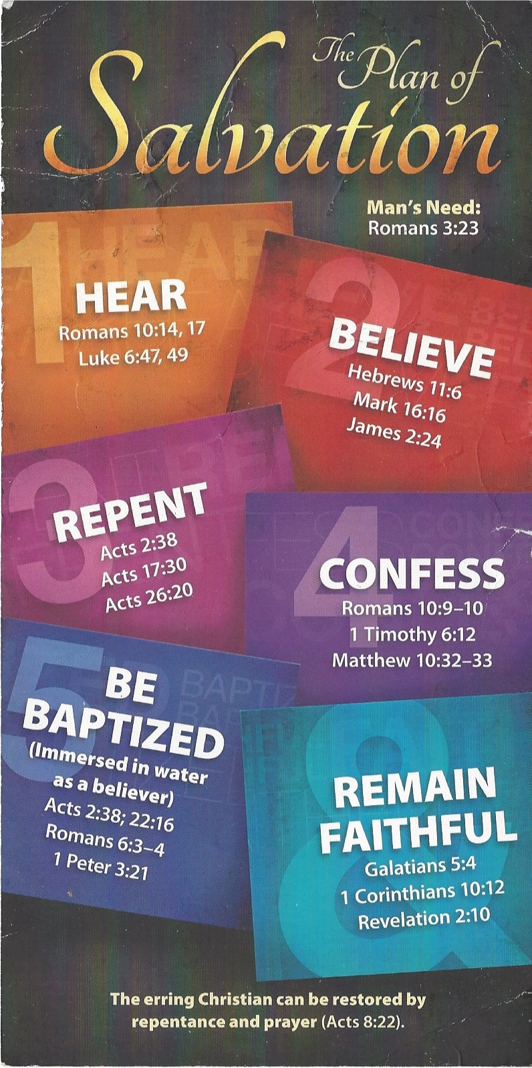
¹² Fight the good fight of the faith. Take hold of the eternal life to which you were called when you made your good confession in the presence of many witnesses.

Be Baptized - Acts 22:16 (NIV)
¹⁶ And now what are you waiting for? Get up, be baptized and wash your sins away, calling on his name.’
Remain Steadfast - Revelation 2:10 (NIV)
¹⁰ Do not be afraid of what you are about to suffer. I tell you, the devil will put some of you in prison to test you, and you will suffer persecution for ten days. Be faithful, even to the point of death, and I will give you life as your victor’s crown.

