Barry G. Johnson, Sr. / www.bgjsr22.com
Christianity is Reality - Reality is, There is a God / God; God (Deity); Providence; Sustain / Hebrews 1:1–4
The continuing and often unseen activity of God in sustaining his universe, providing for the needs of every creature, and preparing for the completion of his eternal purposes.
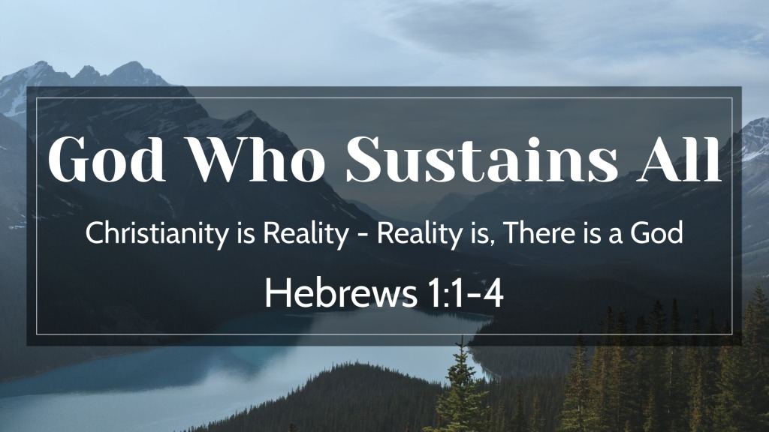
Hebrews 1:1–4 ESV
¹ Long ago, at many times and in many ways, God spoke to our fathers by the prophets, ² but in these last days he has spoken to us by his Son, whom he appointed the heir of all things, through whom also he created the world. ³ He is the radiance of the glory of God and the exact imprint of his nature, and he upholds the universe by the word of his power. After making purification for sins, he sat down at the right hand of the Majesty on high, ⁴ having become as much superior to angels as the name he has inherited is more excellent than theirs.

Jesus Christ, Sustains all Things
John 1:3 ESV
³ All things were made through him, and without him was not any thing made that was made.
Colossians 1:15–17 ESV
¹⁵ He is the image of the invisible God, the firstborn of all creation. ¹⁶ For by him all things were created, in heaven and on earth, visible and invisible, whether thrones or dominions or rulers or authorities—all things were created through him and for him. ¹⁷ And he is before all things, and in him all things hold together.

A Peek at God’s Sustaining

God sustains the created order
Genesis 8:22 ESV
²² While the earth remains, seedtime and harvest, cold and heat, summer and winter, day and night, shall not cease.”

All life is dependent on God
1 Timothy 6:13 ESV
¹³ I charge you in the presence of God, who gives life to all things, and of Christ Jesus, who in his testimony before Pontius Pilate made the good confession,

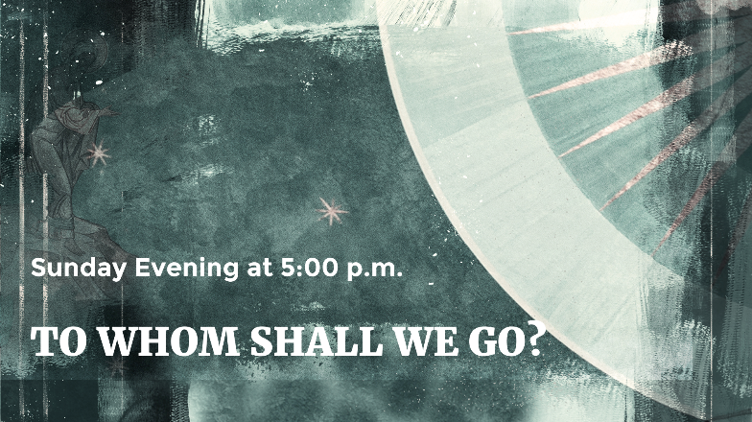
God controls the elements
Psalm 147:8 ESV
⁸ He covers the heavens with clouds;
he prepares rain for the earth;
he makes grass grow on the hills.

God provides for the created world
Psalm 145:15–16 ESV
¹⁵ The eyes of all look to you, and you give them their food in due season.
¹⁶ You open your hand; you satisfy the desire of every living thing.

God Sustains Miraculously
Job 5:9–10 ESV
⁹ who does great things and unsearchable,
marvelous things without number:
¹⁰ he gives rain on the earth
and sends waters on the fields;

God Establishes in Human History

God establishes human intentions
Habakkuk 1:12 ESV
¹² Are you not from everlasting, O Lord my God, my Holy One?
We shall not die. O Lord, you have ordained them as a judgment,
and you, O Rock, have established them for reproof.

God’s providential actions on behalf of individuals
Romans 8:28 ESV
²⁸ And we know that for those who love God all things work together for good, for those who are called according to his purpose.

God’s saving purposes fulfilled through providence
Genesis 50:20 ESV
²⁰ As for you, you meant evil against me, but God meant it for good, to bring it about that many people should be kept alive, as they are today.

God Sustains His Ultimate Purpose

God is forming a people for himself
Revelation 21:3 ESV
³ And I heard a loud voice from the throne saying, “Behold, the dwelling place of God is with man. He will dwell with them, and they will be his people, and God himself will be with them as their God.

God will bring all things under Jesus Christ’s authority
Ephesians 1:9–10 ESV
⁹ making known to us the mystery of his will, according to his purpose, which he set forth in Christ ¹⁰ as a plan for the fullness of time, to unite all things in him, things in heaven and things on earth.

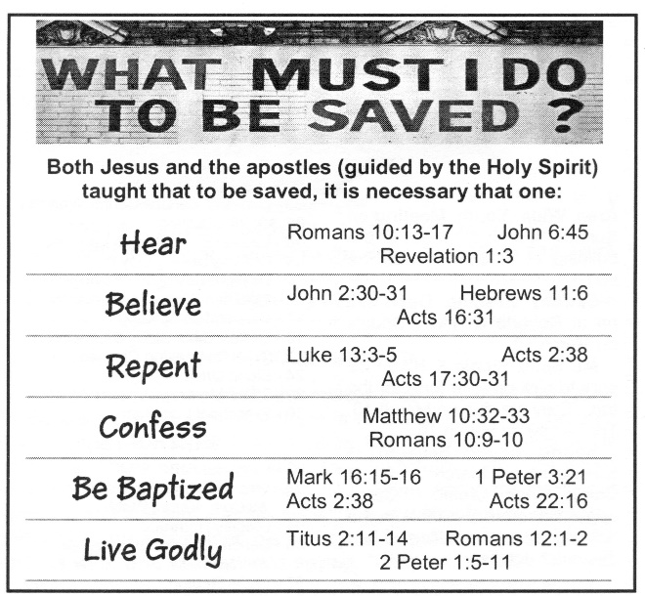
God will complete his purpose for creation
Romans 8:20–21 ESV
²⁰ For the creation was subjected to futility, not willingly, but because of him who subjected it, in hope ²¹ that the creation itself will be set free from its bondage to corruption and obtain the freedom of the glory of the children of God.

God directs all things for his glory
Romans 11:36 ESV
³⁶ For from him and through him and to him are all things. To him be glory forever. Amen.

God’s Ultimate Purpose - Salvation
Ro 10:17; Jn 8:24; Ac 17:30; Ro 10:10; Ga 3:27; Re 2:10

