Barry G. Johnson, Sr. / www.bgjsr22.com
Christianity is Reality – “Reality is, There is a God” / God; God (Deity); Beginning; Creation / Genesis 1:1–4
The heavens and the earth were created by God and ordered by him and for him.
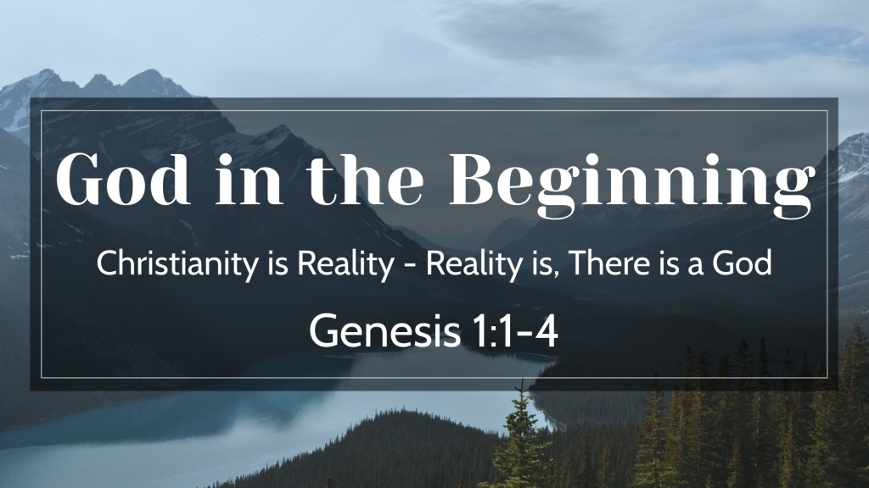
Genesis 1:1–4 ESV
¹ In the beginning, God created the heavens and the earth. ² The earth was without form and void, and darkness was over the face of the deep. And the Spirit of God was hovering over the face of the waters.
³ And God said, “Let there be light,” and there was light. ⁴ And God saw that the light was good. And God separated the light from the darkness.

The world was created out of nothing

By the will of God
Genesis 1:1 ESV
¹ In the beginning, God created the heavens and the earth.

By the word of God
John 1:1–3 ESV
¹ In the beginning was the Word, and the Word was with God, and the Word was God. ² He was in the beginning with God. ³ All things were made through him, and without him was not any thing made that was made.
Genesis 1:3 ESV
³ And God said, “Let there be light,” and there was light.

By the Spirit of God
Genesis 1:2 ESV
² The earth was without form and void, and darkness was over the face of the deep. And the Spirit of God was hovering over the face of the waters.

By the hand of God
Hebrews 1:10 ESV
¹⁰ And,
“You, Lord, laid the foundation of the earth in the beginning,
and the heavens are the work of your hands;

By the mind of God
Psalm 136:5 ESV
⁵ to him who by understanding made the heavens,
for his steadfast love endures forever;

The world God created was perfect
Genesis 1:31 ESV
³¹ And God saw everything that he had made, and behold, it was very good. And there was evening and there was morning, the sixth day.

God created the world for a purpose

For his glory
Psalm 19:1–2 ESV
¹ The heavens declare the glory of God,
and the sky above proclaims his handiwork.
² Day to day pours out speech,
and night to night reveals knowledge.

That people might worship and revere him
Psalm 147:4–5 ESV
⁴ He determines the number of the stars;
he gives to all of them their names.
⁵ Great is our Lord, and abundant in power;
his understanding is beyond measure.

For his possession and use
Deuteronomy 10:14 ESV
¹⁴ Behold, to the Lord your God belong heaven and the heaven of heavens, the earth with all that is in it.
Colossians 1:16–17 ESV
¹⁶ For by him all things were created, in heaven and on earth, visible and invisible, whether thrones or dominions or rulers or authorities—all things were created through him and for him. ¹⁷ And he is before all things, and in him all things hold together.
