Barry G. Johnson, Sr. / www.bgjsr22.com
Evangelism 2019 / Sin; Eternity; Eternal Life; Eternal State and Death / Romans 6:23
Sin brings death, whereas obedience to God brings eternal life.
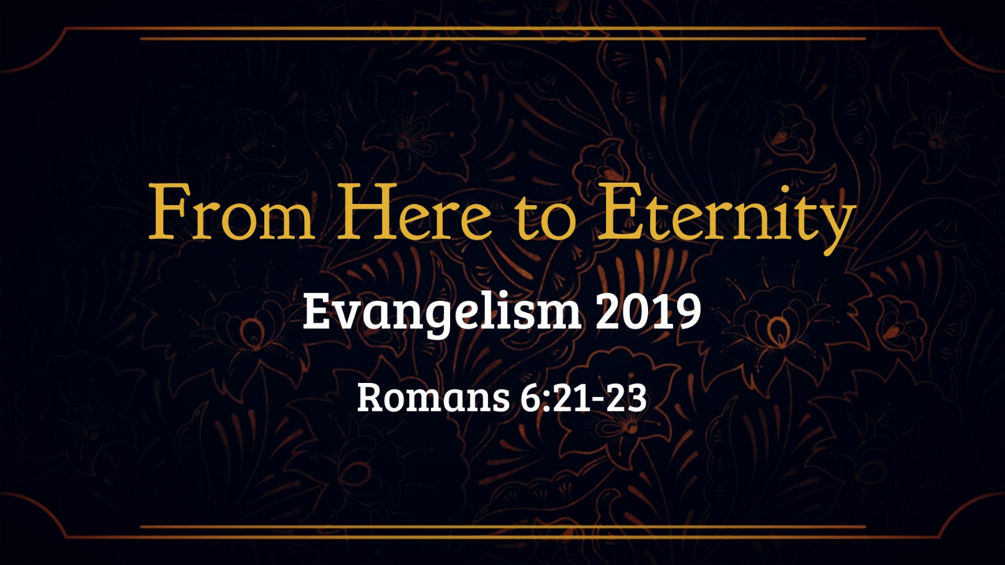
Romans 6:21–23 ESV
But what fruit were you getting at that time from the things of which you are now ashamed? For the end of those things is death. But now that you have been set free from sin and have become slaves of God, the fruit you get leads to sanctification and its end, eternal life. For the wages of sin is death, but the free gift of God is eternal life in Christ Jesus our Lord.

Once Upon a Time Slaves to Sin
1 Corinthians 6:9–11 (ESV)
⁹ Or do you not know that the unrighteous will not inherit the kingdom of God? Do not be deceived: neither the sexually immoral, nor idolaters, nor adulterers, nor men who practice homosexuality, ¹⁰ nor thieves, nor the greedy, nor drunkards, nor revilers, nor swindlers will inherit the kingdom of God. ¹¹ And such were some of you. But you were washed, you were sanctified, you were justified in the name of the Lord Jesus Christ and by the Spirit of our God.

Philippians 3:19 ESV
Their end is destruction, their god is their belly, and they glory in their shame, with minds set on earthly things.

James 1:15 ESV
Then desire when it has conceived gives birth to sin, and sin when it is fully grown brings forth death.

Now Slaves of God
John 8:32 ESV
and you will know the truth, and the truth will set you free.”

Romans 8:2 ESV
For the law of the Spirit of life has set you free in Christ Jesus from the law of sin and death.

1 Peter 2:16 ESV
Live as people who are free, not using your freedom as a cover-up for evil, but living as servants of God.

Wage Earned versus a Gift Received
Galatians 6:7–8 ESV
Do not be deceived: God is not mocked, for whatever one sows, that will he also reap. For the one who sows to his own flesh will from the flesh reap corruption, but the one who sows to the Spirit will from the Spirit reap eternal life.

1 John 5:11–12 ESV
And this is the testimony, that God gave us eternal life, and this life is in his Son. Whoever has the Son has life; whoever does not have the Son of God does not have life.
