Discovering the Antioch Church
Discovering the Antioch Church
Barry G. Johnson, Sr. / General
Discovering the Church / Preaching; Teaching; Barnabas; Encouragement; Church: Nature; Antioch; Christian / Acts 11:19–26
The Church is established by teaching about and from Christ, which is why members are called Christians.
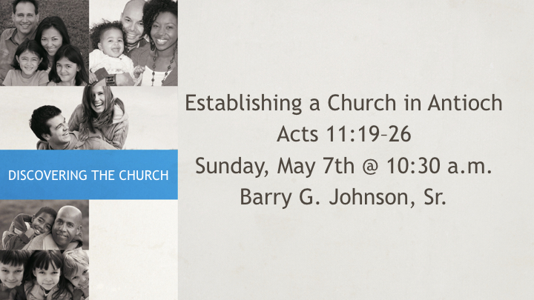

I. Scattered and Preaching

A. The Word moved with the People
Acts 8:4 ESV
⁴ Now those who were scattered went about preaching the word.

B. God works to bring all into the fold of safety
John 10:16 ESV
¹⁶ And I have other sheep that are not of this fold. I must bring them also, and they will listen to my voice. So there will be one flock, one shepherd.

C. Jesus speaks of persecution early on
Matthew 10:23 ESV
²³ When they persecute you in one town, flee to the next, for truly, I say to you, you will not have gone through all the towns of Israel before the Son of Man comes.

II. Son of Encouragement

A. The Apostles send encouragement
Acts 4:36 ESV
³⁶ Thus Joseph, who was also called by the apostles Barnabas (which means son of encouragement), a Levite, a native of Cyprus,

B. The scriptures give us encouragement
Romans 15:4–5 ESV
⁴ For whatever was written in former days was written for our instruction, that through endurance and through the encouragement of the Scriptures we might have hope.
⁵ May the God of endurance and encouragement grant you to live in such harmony with one another, in accord with Christ Jesus,

C. Encouragement needed because life will require it
Acts 14:22 ESV
²² strengthening the souls of the disciples, encouraging them to continue in the faith, and saying that through many tribulations we must enter the kingdom of God.

III. Christians are Made Through Teaching

A. God’s plan for His Church includes what is needed
1 Corinthians 12:28–29 ESV
²⁸ And God has appointed in the church first apostles, second prophets, third teachers, then miracles, then gifts of healing, helping, administrating, and various kinds of tongues.
²⁹ Are all apostles? Are all prophets? Are all teachers? Do all work miracles?

B. Preaching the Word for the making of Christians
Romans 10:14 ESV
¹⁴ How then will they call on him in whom they have not believed? And how are they to believe in him of whom they have never heard? And how are they to hear without someone preaching?

C. Christians also continue in their teaching
2 Timothy 3:17 ESV
¹⁷ that the man of God may be complete, equipped for every good work.

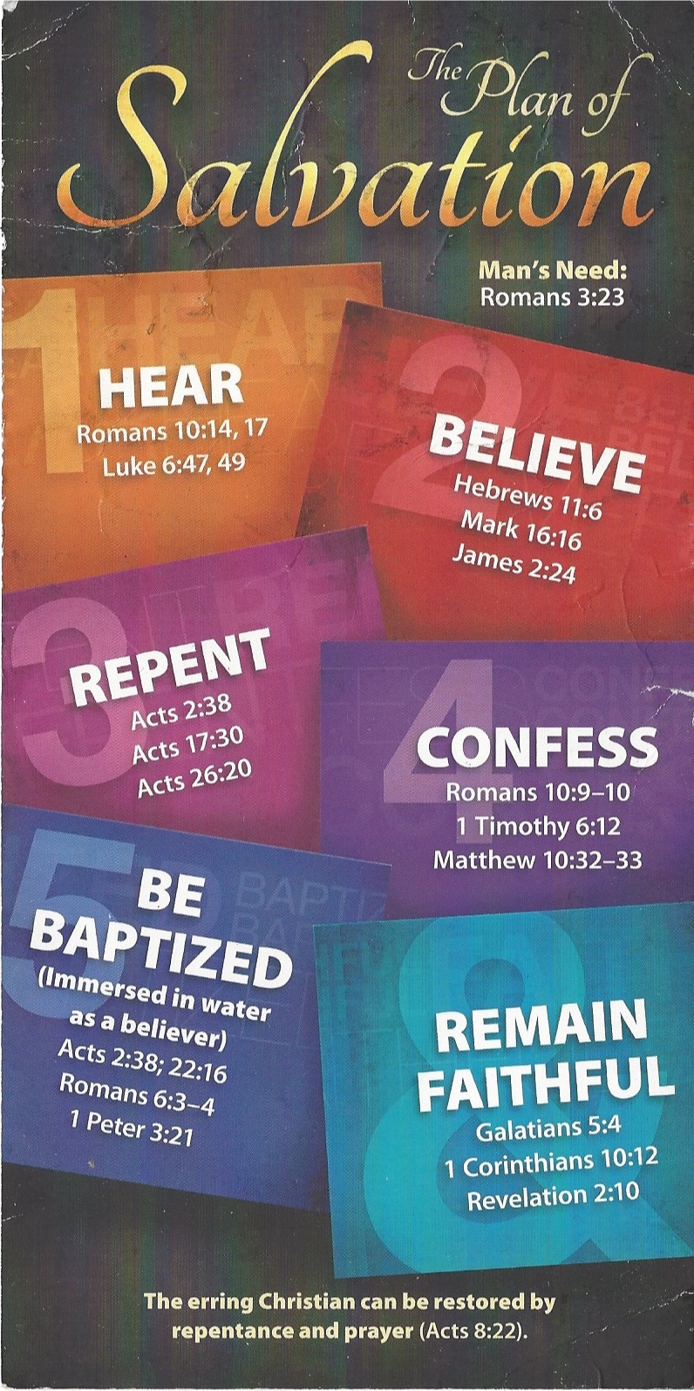
Hear - Romans 10:17 (NIV)
¹⁷ Consequently, faith comes from hearing the message, and the message is heard through the word about Christ.
Believe - Hebrews 11:6 (NIV)
⁶ And without faith it is impossible to please God, because anyone who comes to him must believe that he exists and that he rewards those who earnestly seek him.
Repent - Acts 17:30 (NIV)
³⁰ In the past God overlooked such ignorance, but now he commands all people everywhere to repent.
Confess - 1 Timothy 6:12 (NIV)
¹² Fight the good fight of the faith. Take hold of the eternal life to which you were called when you made your good confession in the presence of many witnesses.
Be Baptized - Acts 2:38 (ESV)
³⁸ And Peter said to them, “Repent and be baptized every one of you in the name of Jesus Christ for the forgiveness of your sins, and you will receive the gift of the Holy Spirit.
Remain Steadfast - Revelation 2:10 (NIV)
¹⁰ Do not be afraid of what you are about to suffer. I tell you, the devil will put some of you in prison to test you, and you will suffer persecution for ten days. Be faithful, even to the point of death, and I will give you life as your victor’s crown.

