Barry G. Johnson, Sr. / www.barrygjohnsonsr.com
Discovering the Church / Confidence; Assurance / Acts 27:13–38
God-given assurance produces spiritual maturity and stability, so that believers may withstand the adverse conditions of life.
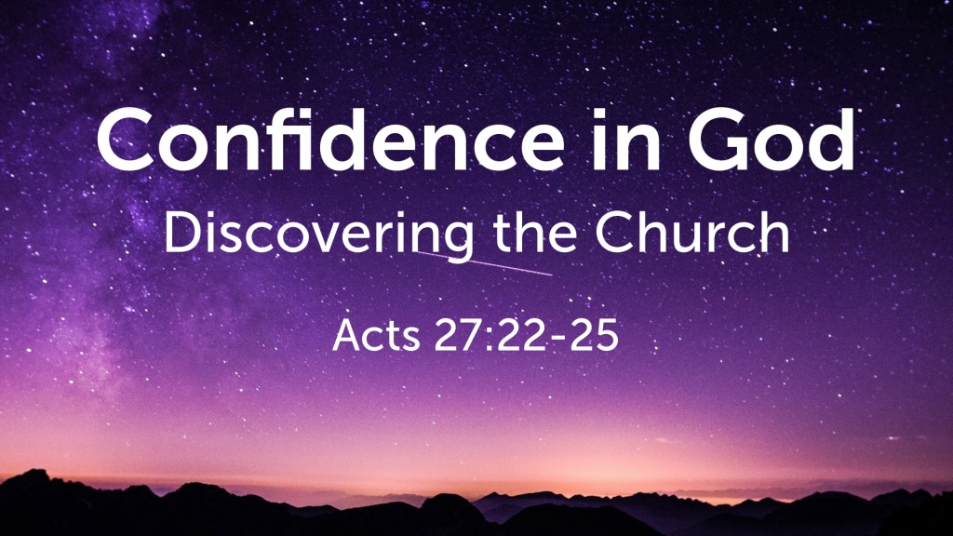
Acts 27:22–25 ESV
²² Yet now I urge you to take heart, for there will be no loss of life among you, but only of the ship. ²³ For this very night there stood before me an angel of the God to whom I belong and whom I worship, ²⁴ and he said, ‘Do not be afraid, Paul; you must stand before Caesar. And behold, God has granted you all those who sail with you.’ ²⁵ So take heart, men, for I have faith in God that it will be exactly as I have been told.

Confidence in God’s protection removes fear of disaster
Psalm 46:1–2 ESV
¹ God is our refuge and strength, a very present help in trouble. ² Therefore we will not fear though the earth gives way, though the mountains be moved into the heart of the sea,
Exodus 14:13–14 ESV
¹³ And Moses said to the people, “Fear not, stand firm, and see the salvation of the Lord, which he will work for you today. For the Egyptians whom you see today, you shall never see again. ¹⁴ The Lord will fight for you, and you have only to be silent.”

Confidence in God’s purposes produces hope
Psalm 130:7 ESV
⁷ O Israel, hope in the Lord! For with the Lord there is steadfast love, and with him is plentiful redemption.
Proverbs 23:17–18 ESV
¹⁷ Let not your heart envy sinners, but continue in the fear of the Lord all the day. ¹⁸ Surely there is a future, and your hope will not be cut off.
2 Corinthians 1:10 ESV
¹⁰ He delivered us from such a deadly peril, and he will deliver us. On him we have set our hope that he will deliver us again.
Hebrews 6:17–19 ESV
¹⁷ So when God desired to show more convincingly to the heirs of the promise the unchangeable character of his purpose, he guaranteed it with an oath, ¹⁸ so that by two unchangeable things, in which it is impossible for God to lie, we who have fled for refuge might have strong encouragement to hold fast to the hope set before us. ¹⁹ We have this as a sure and steadfast anchor of the soul, a hope that enters into the inner place behind the curtain,

Confidence in God’s presence makes his people bold
Isaiah 41:8–10 ESV
⁸ But you, Israel, my servant, Jacob, whom I have chosen, the offspring of Abraham, my friend; ⁹ you whom I took from the ends of the earth, and called from its farthest corners, saying to you, “You are my servant, I have chosen you and not cast you off”; ¹⁰ fear not, for I am with you; be not dismayed, for I am your God; I will strengthen you, I will help you, I will uphold you with my righteous right hand.
Acts 4:13 ESV
¹³ Now when they saw the boldness of Peter and John, and perceived that they were uneducated, common men, they were astonished. And they recognized that they had been with Jesus.
Acts 9:27 ESV
²⁷ But Barnabas took him and brought him to the apostles and declared to them how on the road he had seen the Lord, who spoke to him, and how at Damascus he had preached boldly in the name of Jesus.
Acts 18:9–11 ESV
⁹ And the Lord said to Paul one night in a vision, “Do not be afraid, but go on speaking and do not be silent, ¹⁰ for I am with you, and no one will attack you to harm you, for I have many in this city who are my people.” ¹¹ And he stayed a year and six months, teaching the word of God among them.
Ephesians 6:10–11 ESV
¹⁰ Finally, be strong in the Lord and in the strength of his might. ¹¹ Put on the whole armor of God, that you may be able to stand against the schemes of the devil.

Confidence in God enables believers to endure difficulties
Habakkuk 3:17–19 ESV
¹⁷ Though the fig tree should not blossom, nor fruit be on the vines, the produce of the olive fail and the fields yield no food, the flock be cut off from the fold and there be no herd in the stalls, ¹⁸ yet I will rejoice in the Lord; I will take joy in the God of my salvation. ¹⁹ God, the Lord, is my strength; he makes my feet like the deer’s; he makes me tread on my high places. To the choirmaster: with stringed instruments.
Romans 5:3–5 ESV
³ Not only that, but we rejoice in our sufferings, knowing that suffering produces endurance, ⁴ and endurance produces character, and character produces hope, ⁵ and hope does not put us to shame, because God’s love has been poured into our hearts through the Holy Spirit who has been given to us.
2 Timothy 3:10–11 ESV
¹⁰ You, however, have followed my teaching, my conduct, my aim in life, my faith, my patience, my love, my steadfastness, ¹¹ my persecutions and sufferings that happened to me at Antioch, at Iconium, and at Lystra—which persecutions I endured; yet from them all the Lord rescued me.

Confidence in God leads to awareness of security
Psalm 28:7 ESV
⁷ The Lord is my strength and my shield; in him my heart trusts, and I am helped; my heart exults, and with my song I give thanks to him.
Psalm 46:1–3 ESV
¹ God is our refuge and strength, a very present help in trouble. ² Therefore we will not fear though the earth gives way, though the mountains be moved into the heart of the sea, ³ though its waters roar and foam, though the mountains tremble at its swelling. Selah
Psalm 112:6–8 ESV
⁶ For the righteous will never be moved; he will be remembered forever. ⁷ He is not afraid of bad news; his heart is firm, trusting in the Lord. ⁸ His heart is steady; he will not be afraid, until he looks in triumph on his adversaries.
Proverbs 14:26 ESV
²⁶ In the fear of the Lord one has strong confidence, and his children will have a refuge.
Ephesians 6:13 ESV
¹³ Therefore take up the whole armor of God, that you may be able to withstand in the evil day, and having done all, to stand firm.
2 Timothy 1:12 ESV
¹² which is why I suffer as I do. But I am not ashamed, for I know whom I have believed, and I am convinced that he is able to guard until that day what has been entrusted to me.
God’s Plan of Salvation, confidently revealed to us through scripture
HEAR - Romans 10:17 (ESV)
¹⁷ So faith comes from hearing, and hearing through the word of Christ.
BELIEVE - Hebrews 11:6 (ESV)
⁶ And without faith it is impossible to please him, for whoever would draw near to God must believe that he exists and that he rewards those who seek him.
REPENT - Acts 17:30 (ESV)
³⁰ The times of ignorance God overlooked, but now he commands all people everywhere to repent,
CONFESS - 1 Timothy 6:12 (ESV)
¹² Fight the good fight of the faith. Take hold of the eternal life to which you were called and about which you made the good confession in the presence of many witnesses.
BE BAPTIZED - Acts 22:16 (ESV)
¹⁶ And now why do you wait? Rise and be baptized and wash away your sins, calling on his name.’
REMAIN FAITHFUL - Revelation 2:10 (ESV)
¹⁰ Do not fear what you are about to suffer. Behold, the devil is about to throw some of you into prison, that you may be tested, and for ten days you will have tribulation. Be faithful unto death, and I will give you the crown of life.

