Barry G. Johnson, Sr. / www.bgjsr22.com
House to House series / Confession; Confess / Psalm 32:1–11
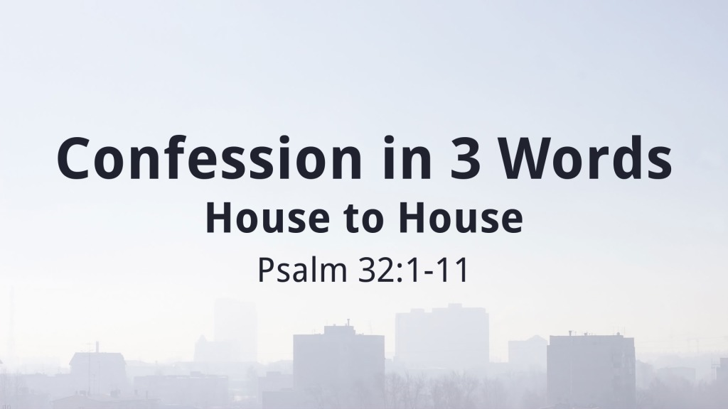
Psalm 32:1–11 ESV
Blessed is the one whose transgression is forgiven,
whose sin is covered.
Blessed is the man against whom the Lord counts no iniquity,
and in whose spirit there is no deceit.
For when I kept silent, my bones wasted away
through my groaning all day long.
For day and night your hand was heavy upon me;
my strength was dried up as by the heat of summer. Selah
I acknowledged my sin to you,
and I did not cover my iniquity;
I said, “I will confess my transgressions to the Lord,”
and you forgave the iniquity of my sin. Selah
Therefore let everyone who is godly
offer prayer to you at a time when you may be found;
surely in the rush of great waters,
they shall not reach him.
You are a hiding place for me;
you preserve me from trouble;
you surround me with shouts of deliverance. Selah
I will instruct you and teach you in the way you should go;
I will counsel you with my eye upon you.
Be not like a horse or a mule, without understanding,
which must be curbed with bit and bridle,
or it will not stay near you.
Many are the sorrows of the wicked,
but steadfast love surrounds the one who trusts in the Lord.
Be glad in the Lord, and rejoice, O righteous,
and shout for joy, all you upright in heart!
Introduction:
Hosea 4:16 ESV
Like a stubborn heifer,
Israel is stubborn;
can the Lord now feed them
like a lamb in a broad pasture?

Jeremiah 14:7 ESV
“Though our iniquities testify against us,
act, O Lord, for your name’s sake;
for our backslidings are many;
we have sinned against you.

Hosea 4:16 KJV 1900
For Israel slideth back as a backsliding heifer:
Now the Lord will feed them as a lamb in a large place.

2 Timothy 4:9–10 ESV
Do your best to come to me soon. For Demas, in love with this present world, has deserted me and gone to Thessalonica. Crescens has gone to Galatia, Titus to Dalmatia.

Revelation 2:4–5 ESV
But I have this against you, that you have abandoned the love you had at first. Remember therefore from where you have fallen; repent, and do the works you did at first. If not, I will come to you and remove your lampstand from its place, unless you repent.

Acknowledging Sin to God

Proverbs 28:13 ESV
Whoever conceals his transgressions will not prosper,
but he who confesses and forsakes them will obtain mercy.

1 John 1:9 ESV
If we confess our sins, he is faithful and just to forgive us our sins and to cleanse us from all unrighteousness.

Agreeing with God about Sin

Psalm 32:5 ESV
I acknowledged my sin to you,
and I did not cover my iniquity;
I said, “I will confess my transgressions to the Lord,”
and you forgave the iniquity of my sin. Selah

Romans 3:4 ESV
By no means! Let God be true though every one were a liar, as it is written,
“That you may be justified in your words,
and prevail when you are judged.”

Accepting Responsibility for Sin

Matthew 3:8 ESV
Bear fruit in keeping with repentance.

James 5:16 ESV
Therefore, confess your sins to one another and pray for one another, that you may be healed. The prayer of a righteous person has great power as it is working.

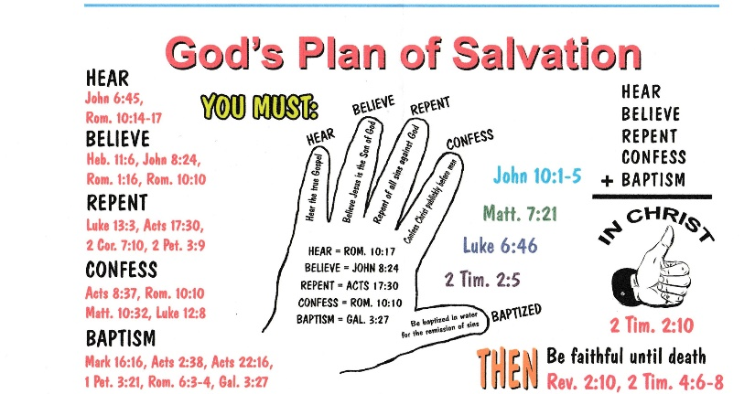
God’s Plan for Saving Man

