Romans: The Righteous Live by Faith / Call; Calling; Service / Romans 1:1–7
Central Idea: God’s summoning of individuals and people to himself, so that they will belong to him and serve him in his world. The calling of a believer may involve a specific place, task, or vocation in life.
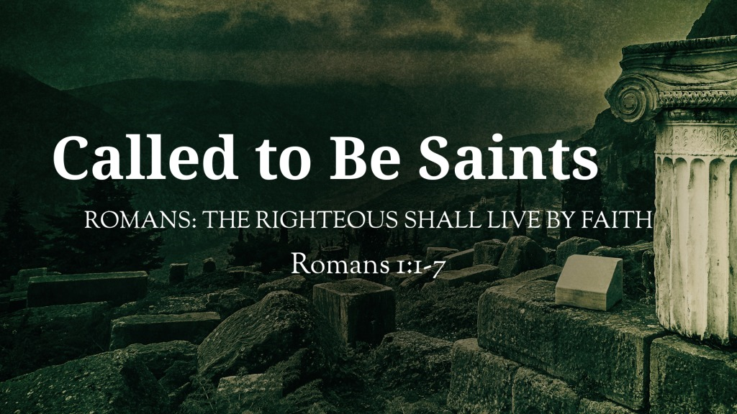
Romans 1:1–7 ESV
¹ Paul, a servant of Christ Jesus, called to be an apostle, set apart for the gospel of God, ² which he promised beforehand through his prophets in the holy Scriptures, ³ concerning his Son, who was descended from David according to the flesh ⁴ and was declared to be the Son of God in power according to the Spirit of holiness by his resurrection from the dead, Jesus Christ our Lord, ⁵ through whom we have received grace and apostleship to bring about the obedience of faith for the sake of his name among all the nations, ⁶ including you who are called to belong to Jesus Christ,
⁷ To all those in Rome who are loved by God and called to be saints:
Grace to you and peace from God our Father and the Lord Jesus Christ.

I. God calls to belong to him and serve him

A. God calls all people everywhere
Acts 17:30 ESV
³⁰ The times of ignorance God overlooked, but now he commands all people everywhere to repent,

B. Few respond positively to God’s call
Matthew 22:14 ESV
¹⁴ For many are called, but few are chosen.”

C. Responding to God’s call results in salvation
Hebrews 9:15 ESV
¹⁵ Therefore he is the mediator of a new covenant, so that those who are called may receive the promised eternal inheritance, since a death has occurred that redeems them from the transgressions committed under the first covenant.
- Have you heard God’s call to you?
- What has been the result of His call?

II. God calls Christians to live differently

A. Living in peace:
Colossians 3:15 ESV
¹⁵ And let the peace of Christ rule in your hearts, to which indeed you were called in one body. And be thankful.

B. Living in service
Galatians 5:13 ESV
¹³ For you were called to freedom, brothers. Only do not use your freedom as an opportunity for the flesh, but through love serve one another.

C. Living in hope:
1 Thessalonians 4:7 ESV
⁷ For God has not called us for impurity, but in holiness.
- What difference should God make in your life?

III. God calls to do specific tasks at specific times

A. Abraham:
Ge 12:1–3; Is 51:2; Heb 11:8
Ex 3:4 Moses; 1 Sa 3:4–10 Samuel; Is 6:8 Isaiah

B. Cyrus:
Is 41:2; Is 45:4

C. The servant of the Lord:
Is 42:6; Is 49:1
Je 1:4–5 Jeremiah; Ho 1:2 Hosea; Am 7:15 Amos

D. Jonah:
Jon 1:1–2; Jon 3:1–2

E. The disciples:
Mt 4:18–22; Lk 5:2–11; Jn 1:35–42
Ac 13:2 Barnabas and Paul

F. Paul:
Ro 1:1; 1 Co 1:1; Ga 1:15
- What task has God called you to?

IV. The believer’s place in life is our starting point
1 Corinthians 7:24 ESV
²⁴ So, brothers, in whatever condition each was called, there let him remain with God.

God’s Call Heard in His Plan of Salvation

Hear
Romans 10:17 ESV
¹⁷ So faith comes from hearing, and hearing through the word of Christ.

Believe
Hebrews 11:6 ESV
⁶ And without faith it is impossible to please him, for whoever would draw near to God must believe that he exists and that he rewards those who seek him.

Repent
Luke 13:3 ESV
³ No, I tell you; but unless you repent, you will all likewise perish.

Confess
Romans 10:9 ESV
⁹ because, if you confess with your mouth that Jesus is Lord and believe in your heart that God raised him from the dead, you will be saved.

Be Baptized
Acts 2:38 ESV
³⁸ And Peter said to them, “Repent and be baptized every one of you in the name of Jesus Christ for the forgiveness of your sins, and you will receive the gift of the Holy Spirit.

Remain Faithful
Revelation 2:10 ESV
¹⁰ Do not fear what you are about to suffer. Behold, the devil is about to throw some of you into prison, that you may be tested, and for ten days you will have tribulation. Be faithful unto death, and I will give you the crown of life.

