Acts 13:38–41 (ESV)
³⁸ Let it be known to you therefore, brothers, that through this man forgiveness of sins is proclaimed to you, ³⁹ and by him everyone who believes is freed from everything from which you could not be freed by the law of Moses. ⁴⁰ Beware, therefore, lest what is said in the Prophets should come about:
⁴¹ “ ‘Look, you scoffers,
be astounded and perish;
for I am doing a work in your days,
a work that you will not believe, even if one tells it to you.’ ”
Barry G. Johnson, Sr. / General
Discovering the Church / Topics: Calling; Invite; Salvation; Gospel; Appeal

God’s summoning of individuals and people to himself, so that they will belong to him and serve him in his world.
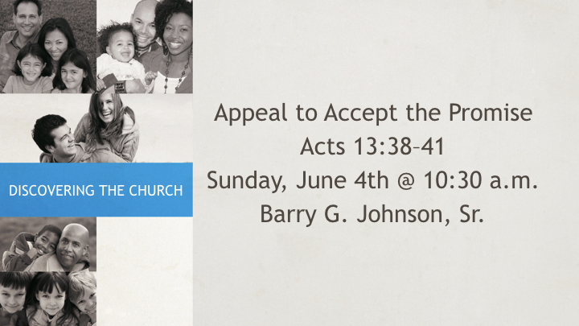

I. God calls individuals to belong to Him and serve Him

A. God calls all people everywhere
Acts 17:30 ESV
³⁰ The times of ignorance God overlooked, but now he commands all people everywhere to repent,
Check out these scripture references: Pr 8:4; Is 45:22; Is 55:1; Mt 9:13; Mt 11:28–30; Mt 22:9; Jn 7:37; Ac 2:39; Ro 10:18; Ps 19:4

B. Few respond positively to God’s call
Matthew 22:14 ESV
¹⁴ For many are called, but few are chosen.”
Check out these scripture references: Is 65:12; Is 66:4; Je 7:13; Je 35:17; Mt 22:2–10

C. Responding to God’s call results in salvation
Hebrews 9:15 ESV
¹⁵ Therefore he is the mediator of a new covenant, so that those who are called may receive the promised eternal inheritance, since a death has occurred that redeems them from the transgressions committed under the first covenant.
Jude 1 ESV
¹ Jude, a servant of Jesus Christ and brother of James, To those who are called, beloved in God the Father and kept for Jesus Christ:
Check out these scripture references: Jn 5:25; Jn 10:3; Ro 1:6; Ro 8:28–30; Ro 11:29; 1 Co 1:9; 1 Co 1:24–29; 1 Co 7:18–22; Ga 1:6; Eph 4:1; Php 3:14; 2 Th 1:11; 2 Th 2:14; 1 Ti 6:12; Heb 3:1; 1 Pe 5:10; 2 Pe 1:3; 2 Pe 1:10; Re 17:14

II. God calls Christians to live differently
2 Timothy 1:9 ESV
⁹ who saved us and called us to a holy calling, not because of our works but because of his own purpose and grace, which he gave us in Christ Jesus before the ages began,
1 Peter 2:9 ESV
⁹ But you are a chosen race, a royal priesthood, a holy nation, a people for his own possession, that you may proclaim the excellencies of him who called you out of darkness into his marvelous light.

A. Living in peace:
Colossians 3:15 ESV
¹⁵ And let the peace of Christ rule in your hearts, to which indeed you were called in one body. And be thankful.
Check out these scripture references: 1 Co 7:15; Ga 5:13 serving one another

B. Living in hope:
Ephesians 1:18 ESV
¹⁸ having the eyes of your hearts enlightened, that you may know what is the hope to which he has called you, what are the riches of his glorious inheritance in the saints,
Ephesians 4:4 ESV
⁴ There is one body and one Spirit—just as you were called to the one hope that belongs to your call—
1 Thessalonians 4:7 ESV
⁷ For God has not called us for impurity, but in holiness.
Check out these scripture references: 1 Pe 2:20–21; 1 Pe 3:9

III. God called particular individuals to do specific tasks at specific times

A. Abraham:
Ge 12:1–3; Is 51:2; Heb 11:8
Ex 3:4 Moses; 1 Sa 3:4–10 Samuel; Is 6:8 Isaiah

B. Cyrus:
Is 41:2; Is 45:4

C. The servant of the Lord:
Is 42:6; Is 49:1
Je 1:4–5 Jeremiah; Ho 1:2 Hosea; Am 7:15 Amos

D. Jonah:
Jon 1:1–2; Jon 3:1–2

E. The disciples:
Mt 4:18–22; Lk 5:2–11; Jn 1:35–42
Ac 13:2 Barnabas and Paul

F. Paul:
Ro 1:1; 1 Co 1:1; Ga 1:15

IV. God called a people, Israel, to serve him in a special way
Isaiah 43:1 ESV
¹ But now thus says the Lord, he who created you, O Jacob, he who formed you, O Israel: “Fear not, for I have redeemed you; I have called you by name, you are mine.
Check out these scripture references: Ho 11:1–2
Hosea 11:1–2 ESV
¹ When Israel was a child, I loved him, and out of Egypt I called my son.
² The more they were called, the more they went away; they kept sacrificing to the Baals and burning offerings to idols.

V. The believer’s place in life is understood to be a calling
1 Corinthians 7:17 ESV
¹⁷ Only let each person lead the life that the Lord has assigned to him, and to which God has called him. This is my rule in all the churches.
Check out these scripture references: 1 Co 7:20; 1 Co 7:240
INVITATION
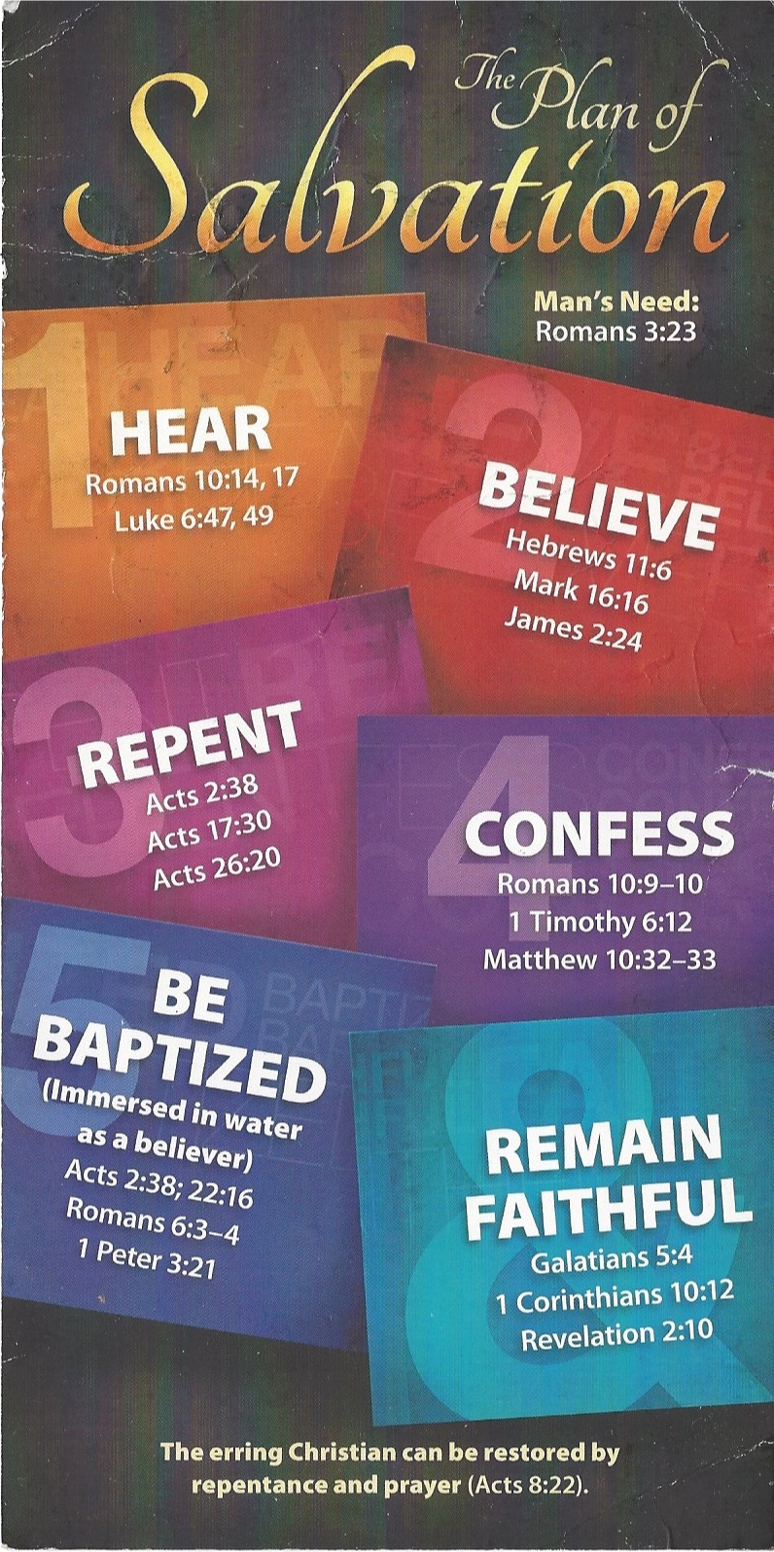
Hear - Romans 10:17 (NIV)
¹⁷ Consequently, faith comes from hearing the message, and the message is heard through the word about Christ.
Believe - Hebrews 11:6 (NIV)
⁶ And without faith it is impossible to please God, because anyone who comes to him must believe that he exists and that he rewards those who earnestly seek him.
Repent - Acts 17:30 (NIV)
³⁰ In the past God overlooked such ignorance, but now he commands all people everywhere to repent.
Confess - 1 Timothy 6:12 (NIV)
¹² Fight the good fight of the faith. Take hold of the eternal life to which you were called when you made your good confession in the presence of many witnesses.
Be Baptized - Acts 2:38 (ESV)
³⁸ And Peter said to them, “Repent and be baptized every one of you in the name of Jesus Christ for the forgiveness of your sins, and you will receive the gift of the Holy Spirit.
Remain Steadfast - Revelation 2:10 (NIV)
¹⁰ Do not be afraid of what you are about to suffer. I tell you, the devil will put some of you in prison to test you, and you will suffer persecution for ten days. Be faithful, even to the point of death, and I will give you life as your victor’s crown.

