Synopsis
Deceit is condemned by God as an attempt to deny his sovereignty and his revelation of himself.

Question
- What did it mean for the Church to have all things in common?
Acts 4:32 (ESV)
³² Now the full number of those who believed were of one heart and soul, and no one said that any of the things that belonged to him was his own, but they had everything in common.

Question
- What commitment have you made to the Church? Have you held back on that commitment?
Reread Acts 5:1-2…

Question
- Why was it wrong for Ananias and Sapphira to keep back some of the proceeds from the sell of their property?
Reread Acts 5:3-4…

- Deceit is forbidden by God
  - Condemnation of deception in general
Leviticus 19:11 (ESV) — 11 “You shall not steal; you shall not deal falsely; you shall not lie to one another.
Proverbs 12:22 (ESV) — 22 Lying lips are an abomination to the Lord, but those who act faithfully are his delight.
Proverbs 24:28 (ESV) — 28 Be not a witness against your neighbor without cause, and do not deceive with your lips.
  - False witnesses condemned
Exodus 20:16 (ESV) — 16 “You shall not bear false witness against your neighbor.
Proverbs 19:9 (ESV) — 9 A false witness will not go unpunished, and he who breathes out lies will perish.
  - False measures prohibited
Leviticus 19:35 (ESV) — 35 “You shall do no wrong in judgment, in measures of length or weight or quantity.
Deuteronomy 25:13 (ESV) — 13 “You shall not have in your bag two kinds of weights, a large and a small.
Proverbs 11:1 (ESV) — 1 A false balance is an abomination to the Lord, but a just weight is his delight.
Proverbs 20:10 (ESV) — 10 Unequal weights and unequal measures are both alike an abomination to the Lord.
Micah 6:11 (ESV) — 11 Shall I acquit the man with wicked scales and with a bag of deceitful weights?
  - Spiritual deception condemned
Titus 1:16 (ESV) — 16 They profess to know God, but they deny him by their works. They are detestable, disobedient, unfit for any good work.
Malachi 1:14 (ESV) — 14 Cursed be the cheat who has a male in his flock, and vows it, and yet sacrifices to the Lord what is blemished. For I am a great King, says the Lord of hosts, and my name will be feared among the nations.
Matthew 23:27–28 (ESV) — 27 “Woe to you, scribes and Pharisees, hypocrites! For you are like whitewashed tombs, which outwardly appear beautiful, but within are full of dead people’s bones and all uncleanness. 28 So you also outwardly appear righteous to others, but within you are full of hypocrisy and lawlessness.
Luke 6:46 (ESV) — 46 “Why do you call me ‘Lord, Lord,’ and not do what I tell you?
Romans 2:21 (ESV) — 21 you then who teach others, do you not teach yourself? While you preach against stealing, do you steal?
- Deception must not be found in the people of God
  - God’s people must not practice deceit
1 Peter 2:1 (ESV) — 1 So put away all malice and all deceit and hypocrisy and envy and all slander.
Job 27:4 (ESV) — 4 my lips will not speak falsehood, and my tongue will not utter deceit.
Psalm 24:3–4 (ESV) — 3 Who shall ascend the hill of the Lord? And who shall stand in his holy place? 4 He who has clean hands and a pure heart, who does not lift up his soul to what is false and does not swear deceitfully.
Psalm 32:2 (ESV) — 2 Blessed is the man against whom the Lord counts no iniquity, and in whose spirit there is no deceit.
John 4:24 (ESV) — 24 God is spirit, and those who worship him must worship in spirit and truth.”
Ephesians 4:25 (ESV) — 25 Therefore, having put away falsehood, let each one of you speak the truth with his neighbor, for we are members one of another.
Colossians 3:9 (ESV) — 9 Do not lie to one another, seeing that you have put off the old self with its practices
1 Peter 3:10 (ESV) — 10 For “Whoever desires to love life and see good days, let him keep his tongue from evil and his lips from speaking deceit;
  - Christian leaders in particular must not deceive
2 Corinthians 4:2 (ESV) — 2 But we have renounced disgraceful, underhanded ways. We refuse to practice cunning or to tamper with God’s word, but by the open statement of the truth we would commend ourselves to everyone’s conscience in the sight of God.
2 Corinthians 2:17 (ESV) — 17 For we are not, like so many, peddlers of God’s word, but as men of sincerity, as commissioned by God, in the sight of God we speak in Christ.
1 Thessalonians 2:3–5 (ESV) — 3 For our appeal does not spring from error or impurity or any attempt to deceive, 4 but just as we have been approved by God to be entrusted with the gospel, so we speak, not to please man, but to please God who tests our hearts. 5 For we never came with words of flattery, as you know, nor with a pretext for greed—God is witness.
1 Timothy 3:8 (ESV) — 8 Deacons likewise must be dignified, not double-tongued, not addicted to much wine, not greedy for dishonest gain.
Titus 1:7 (ESV) — 7 For an overseer, as God’s steward, must be above reproach. He must not be arrogant or quick-tempered or a drunkard or violent or greedy for gain,
  - God’s people warned against being deceived
Ephesians 5:6 (ESV) — 6 Let no one deceive you with empty words, for because of these things the wrath of God comes upon the sons of disobedience.
Jeremiah 29:8 (ESV) — 8 For thus says the Lord of hosts, the God of Israel: Do not let your prophets and your diviners who are among you deceive you, and do not listen to the dreams that they dream,
1 Corinthians 15:33 (ESV) — 33 Do not be deceived: “Bad company ruins good morals.”
Galatians 6:7 (ESV) — 7 Do not be deceived: God is not mocked, for whatever one sows, that will he also reap.
Colossians 2:8 (ESV) — 8 See to it that no one takes you captive by philosophy and empty deceit, according to human tradition, according to the elemental spirits of the world, and not according to Christ.
- Deceit results in God’s judgment
Psalm 5:6 (ESV) — 6 You destroy those who speak lies; the Lord abhors the bloodthirsty and deceitful man.
Deuteronomy 25:16 (ESV) — 16 For all who do such things, all who act dishonestly, are an abomination to the Lord your God.
Psalm 119:118 (ESV) — 118 You spurn all who go astray from your statutes, for their cunning is in vain.
Proverbs 20:17 (ESV) — 17 Bread gained by deceit is sweet to a man, but afterward his mouth will be full of gravel.
Ezekiel 13:9 (ESV) — 9 My hand will be against the prophets who see false visions and who give lying divinations. They shall not be in the council of my people, nor be enrolled in the register of the house of Israel, nor shall they enter the land of Israel. And you shall know that I am the Lord God.
Acts 5:9–10 (ESV) — 9 But Peter said to her, “How is it that you have agreed together to test the Spirit of the Lord? Behold, the feet of those who have buried your husband are at the door, and they will carry you out.” 10 Immediately she fell down at his feet and breathed her last. When the young men came in they found her dead, and they carried her out and buried her beside her husband.
Revelation 21:8 (ESV) — 8 But as for the cowardly, the faithless, the detestable, as for murderers, the sexually immoral, sorcerers, idolaters, and all liars, their portion will be in the lake that burns with fire and sulfur, which is the second death.”
Revelation 21:27 (ESV) — 27 But nothing unclean will ever enter it, nor anyone who does what is detestable or false, but only those who are written in the Lamb’s book of life.
Revelation 22:15 (ESV) — 15 Outside are the dogs and sorcerers and the sexually immoral and murderers and idolaters, and everyone who loves and practices falsehood.

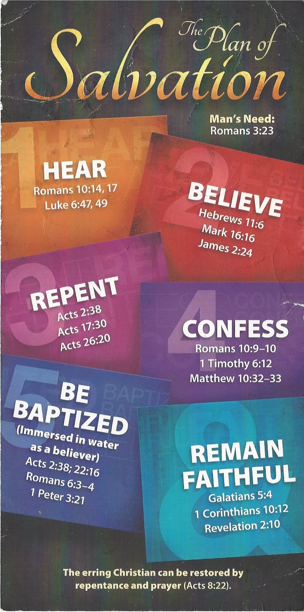
Hear - Romans 10:17 (NIV)
¹⁷ Consequently, faith comes from hearing the message, and the message is heard through the word about Christ.
Believe - Hebrews 11:6 (NIV)
⁶ And without faith it is impossible to please God, because anyone who comes to him must believe that he exists and that he rewards those who earnestly seek him.
Repent - Acts 17:30 (NIV)
³⁰ In the past God overlooked such ignorance, but now he commands all people everywhere to repent.
Confess - 1 Timothy 6:12 (NIV)
¹² Fight the good fight of the faith. Take hold of the eternal life to which you were called when you made your good confession in the presence of many witnesses.
Be Baptized - Acts 2:38 (ESV)
³⁸ And Peter said to them, “Repent and be baptized every one of you in the name of Jesus Christ for the forgiveness of your sins, and you will receive the gift of the Holy Spirit.
Remain Steadfast - Revelation 2:10 (NIV)
¹⁰ Do not be afraid of what you are about to suffer. I tell you, the devil will put some of you in prison to test you, and you will suffer persecution for ten days. Be faithful, even to the point of death, and I will give you life as your victor’s crown.

