Barry G. Johnson, Sr. / General
Romans: The Righteous Shall Live by Faith / Wrath of God; God: Wrath; Wicked; Unrighteous People; An Unrighteous Person; Lust; Truth; Ungodliness / Romans 1:18–25
God's wrath is revealed due to mankind’s exchanging of truth for lies, the result is sin and destruction.
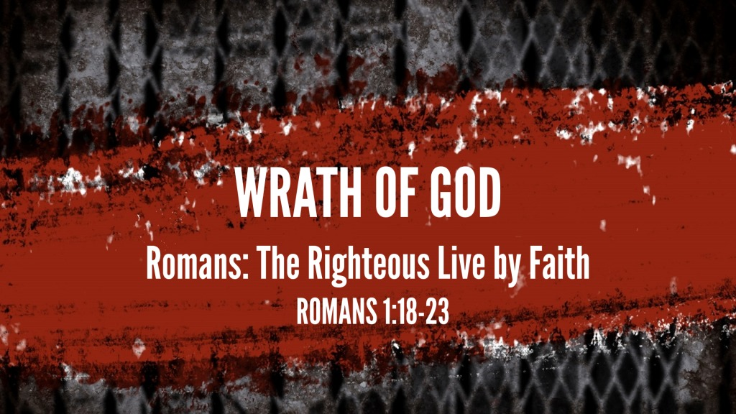

I. The revelation of God’s wrath

A. Because people commit ungodly acts suppressing the truth
Romans 1:18 ESV
¹⁸ For the wrath of God is revealed from heaven against all ungodliness and unrighteousness of men, who by their unrighteousness suppress the truth.
Romans 1:32 ESV
³² Though they know God’s righteous decree that those who practice such things deserve to die, they not only do them but give approval to those who practice them.
1 Timothy 4:1–2 ESV
¹ Now the Spirit expressly says that in later times some will depart from the faith by devoting themselves to deceitful spirits and teachings of demons, ² through the insincerity of liars whose consciences are seared,

B. Because people have no excuse
Romans 1:19–20 ESV
¹⁹ For what can be known about God is plain to them, because God has shown it to them. ²⁰ For his invisible attributes, namely, his eternal power and divine nature, have been clearly perceived, ever since the creation of the world, in the things that have been made. So they are without excuse.
Psalm 19:1–6 ESV
¹ The heavens declare the glory of God, and the sky above proclaims his handiwork. ² Day to day pours out speech, and night to night reveals knowledge. ³ There is no speech, nor are there words, whose voice is not heard. ⁴ Their voice goes out through all the earth, and their words to the end of the world. In them he has set a tent for the sun, ⁵ which comes out like a bridegroom leaving his chamber, and, like a strong man, runs its course with joy. ⁶ Its rising is from the end of the heavens, and its circuit to the end of them, and there is nothing hidden from its heat.
Acts 17:29 ESV
²⁹ Being then God’s offspring, we ought not to think that the divine being is like gold or silver or stone, an image formed by the art and imagination of man.

II. The expression of mankind's unrighteousness and suppression of the truth

A. Exchanging the truth for a lie
Romans 1:21–24 ESV
²¹ For although they knew God, they did not honor him as God or give thanks to him, but they became futile in their thinking, and their foolish hearts were darkened. ²² Claiming to be wise, they became fools, ²³ and exchanged the glory of the immortal God for images resembling mortal man and birds and animals and creeping things. ²⁴ Therefore God gave them up in the lusts of their hearts to impurity, to the dishonoring of their bodies among themselves,
2 Timothy 3:1–5 ESV
¹ But understand this, that in the last days there will come times of difficulty. ² For people will be lovers of self, lovers of money, proud, arrogant, abusive, disobedient to their parents, ungrateful, unholy, ³ heartless, unappeasable, slanderous, without self-control, brutal, not loving good, ⁴ treacherous, reckless, swollen with conceit, lovers of pleasure rather than lovers of God, ⁵ having the appearance of godliness, but denying its power. Avoid such people.

B. Exchanging the glory of God for images
Romans 1:25–26 ESV
²⁵ because they exchanged the truth about God for a lie and worshiped and served the creature rather than the Creator, who is blessed forever! Amen. ²⁶ For this reason God gave them up to dishonorable passions. For their women exchanged natural relations for those that are contrary to nature;
Psalm 115:5–8 ESV
⁵ They have mouths, but do not speak; eyes, but do not see. ⁶ They have ears, but do not hear; noses, but do not smell. ⁷ They have hands, but do not feel; feet, but do not walk; and they do not make a sound in their throat. ⁸ Those who make them become like them; so do all who trust in them.

C. Exchanging the natural order for the unnatural
Romans 1:26–31 ESV
²⁶ For this reason God gave them up to dishonorable passions. For their women exchanged natural relations for those that are contrary to nature; ²⁷ and the men likewise gave up natural relations with women and were consumed with passion for one another, men committing shameless acts with men and receiving in themselves the due penalty for their error. ²⁸ And since they did not see fit to acknowledge God, God gave them up to a debased mind to do what ought not to be done. ²⁹ They were filled with all manner of unrighteousness, evil, covetousness, malice. They are full of envy, murder, strife, deceit, maliciousness. They are gossips, ³⁰ slanderers, haters of God, insolent, haughty, boastful, inventors of evil, disobedient to parents, ³¹ foolish, faithless, heartless, ruthless.
Leviticus 18:22 ESV
²² You shall not lie with a male as with a woman; it is an abomination

God has also revealed His Plan of Salvation
To be saved God revealed than mankind must:
Hear; Believe; Repent; Confess; Be Baptized; and Remain Faithful
Romans 10:17 ESV
¹⁷ So faith comes from hearing, and hearing through the word of Christ.
John 8:24 ESV
²⁴ I told you that you would die in your sins, for unless you believe that I am he you will die in your sins.”
Acts 17:30 ESV
³⁰ The times of ignorance God overlooked, but now he commands all people everywhere to repent,
Philippians 2:9–11 ESV
⁹ Therefore God has highly exalted him and bestowed on him the name that is above every name, ¹⁰ so that at the name of Jesus every knee should bow, in heaven and on earth and under the earth, ¹¹ and every tongue confess that Jesus Christ is Lord, to the glory of God the Father.
Acts 2:41 ESV
⁴¹ So those who received his word were baptized, and there were added that day about three thousand souls.
1 Corinthians 15:58 ESV
⁵⁸ Therefore, my beloved brothers, be steadfast, immovable, always abounding in the work of the Lord, knowing that in the Lord your labor is not in vain.

