Synopsis
Jesus Christ is described as Son of David, Son of Man and Son of God. His sonship speaks of his divinity and humanity and is closely associated with his role as promised Messiah, suffering Saviour, risen Lord and coming judge and king. It also speaks of his intimate, obedient and unique relationship with his Father and of his mission to enable people to become children of God through faith in him.
- Jesus Christ as the Son of David
- He is physically descended from David
Matthew 1:1 (ESV) — 1 The book of the genealogy of Jesus Christ, the son of David, the son of Abraham.
See also Mt 1:2–20; Lk 1:27; Lk 1:32; Lk 2:4; Lk 2:11; Lk 3:23–38; Ro 1:3; 2 Ti 2:8; Re 22:16
- He is the promised royal Messiah of David’s line
Isaiah 16:5 (ESV) — 5 then a throne will be established in steadfast love, and on it will sit in faithfulness in the tent of David one who judges and seeks justice and is swift to do righteousness.”
See also 2 Sa 7:12–16; Ps 89:1–4; Ps 132:11; Ps 132:17; Is 9:7; Is 11:1; Je 23:5–6; Je 33:15–16; Eze 34:23–24; Eze 37:24–25
- He is both the Son and Lord of David
Psalm 110:1 (ESV) — 1 The Lord says to my Lord: “Sit at my right hand, until I make your enemies your footstool.”
- Jesus Christ as the Son of Man
Mark 2:10 (ESV) — 10 But that you may know that the Son of Man has authority on earth to forgive sins”—he said to the paralytic—
John 3:13 (ESV) — 13 No one has ascended into heaven except he who descended from heaven, the Son of Man.
See also Da 7:13–14; Mk 2:28; Jn 1:51; Jn 6:27; Jn 8:28
- Jesus Christ as the Son of God
- His divine origin and divinity
Luke 1:32–35 (ESV) — 32 He will be great and will be called the Son of the Most High. And the Lord God will give to him the throne of his father David, 33 and he will reign over the house of Jacob forever, and of his kingdom there will be no end.” 34 And Mary said to the angel, “How will this be, since I am a virgin?” 35 And the angel answered her, “The Holy Spirit will come upon you, and the power of the Most High will overshadow you; therefore the child to be born will be called holy—the Son of God.
See also Jn 1:13; Jn 1:18; Jn 5:18; Jn 17:5; Jn 17:24
- His intimate relationship with the Father
Mk 14:36 “Abba” was a term of intimacy and familiarity that children used with their own fathers.
Mark 14:36 (ESV) — 36 And he said, “Abba, Father, all things are possible for you. Remove this cup from me. Yet not what I will, but what you will.”
See also Mt 3:17; Lk 2:49; Jn 1:18; Jn 1:32–34; Jn 3:35; Jn 5:20; Jn 8:38; Jn 14:31; Jn 17:23
- His knowledge of the Father’s will
Matthew 11:25–27 (ESV) — 25 At that time Jesus declared, “I thank you, Father, Lord of heaven and earth, that you have hidden these things from the wise and understanding and revealed them to little children; 26 yes, Father, for such was your gracious will. 27 All things have been handed over to me by my Father, and no one knows the Son except the Father, and no one knows the Father except the Son and anyone to whom the Son chooses to reveal him.
See also Jn 6:45–46; Jn 8:55; Jn 14:13–16; Jn 15:15
- His obedience to the Father’s mission
Matthew 26:42 (ESV) — 42 Again, for the second time, he went away and prayed, “My Father, if this cannot pass unless I drink it, your will be done.”
See also Mt 3:13–17 His baptism; Mt 4:1–11 His temptation; Mt 12:50; Jn 3:17; Jn 8:55; Jn 10:17; Jn 10:36; Jn 14:31; Jn 17:8
- His sharing in the Father’s work
Jn 3:34; Jn 4:34; Jn 5:17; Jn 5:21–26; Jn 6:40; Jn 8:16; Jn 9:4; Jn 12:49–50; Jn 14:11
John 4:34 (ESV) — 34 Jesus said to them, “My food is to do the will of him who sent me and to accomplish his work.
John 5:17 (ESV) — 17 But Jesus answered them, “My Father is working until now, and I am working.”
John 5:21–26 (ESV) — 21 For as the Father raises the dead and gives them life, so also the Son gives life to whom he will. 22 The Father judges no one, but has given all judgment to the Son, 23 that all may honor the Son, just as they honor the Father. Whoever does not honor the Son does not honor the Father who sent him. 24 Truly, truly, I say to you, whoever hears my word and believes him who sent me has eternal life. He does not come into judgment, but has passed from death to life. 25 “Truly, truly, I say to you, an hour is coming, and is now here, when the dead will hear the voice of the Son of God, and those who hear will live. 26 For as the Father has life in himself, so he has granted the Son also to have life in himself.
John 12:49–50 (ESV) — 49 For I have not spoken on my own authority, but the Father who sent me has himself given me a commandment—what to say and what to speak. 50 And I know that his commandment is eternal life. What I say, therefore, I say as the Father has told me.”
John 14:11 (ESV) — 11 Believe me that I am in the Father and the Father is in me, or else believe on account of the works themselves.
- His role as promised Messiah
Matthew 16:16 (ESV) — 16 Simon Peter replied, “You are the Christ, the Son of the living God.”
See also 2 Sa 7:12–14; Ps 89:26–27; Is 9:6–7; Mt 1:23; Is 7:14; Mt 2:15; Ho 11:1; Mt 26:63–64; Lk 4:41; Lk 22:29–30; Jn 1:49; Jn 11:27; Jn 20:31; Ac 13:33; Heb 1:5; Heb 5:5; Ps 2:7
- His sharing the Father’s character and being
Hebrews 1:3 (ESV) — 3 He is the radiance of the glory of God and the exact imprint of his nature, and he upholds the universe by the word of his power. After making purification for sins, he sat down at the right hand of the Majesty on high,
See also Jn 1:14; Jn 5:26; Jn 6:57; Jn 10:30; Jn 17:5
John 1:14 (ESV) — 14 And the Word became flesh and dwelt among us, and we have seen his glory, glory as of the only Son from the Father, full of grace and truth.
John 5:26 (ESV) — 26 For as the Father has life in himself, so he has granted the Son also to have life in himself.
John 6:57 (ESV) — 57 As the living Father sent me, and I live because of the Father, so whoever feeds on me, he also will live because of me.
John 10:30 (ESV) — 30 I and the Father are one.”
John 17:5 (ESV) — 5 And now, Father, glorify me in your own presence with the glory that I had with you before the world existed.
- The uniqueness of his sonship
John 1:18 (ESV) — 18 No one has ever seen God; the only God, who is at the Father’s side, he has made him known.
Hebrews 1:3 (ESV) — 3 He is the radiance of the glory of God and the exact imprint of his nature, and he upholds the universe by the word of his power. After making purification for sins, he sat down at the right hand of the Majesty on high,
- Jesus Christ’s disciples become children of God through him
Galatians 4:4–7 (ESV) — 4 But when the fullness of time had come, God sent forth his Son, born of woman, born under the law, 5 to redeem those who were under the law, so that we might receive adoption as sons. 6 And because you are sons, God has sent the Spirit of his Son into our hearts, crying, “Abba! Father!” 7 So you are no longer a slave, but a son, and if a son, then an heir through God.
See also Mt 12:50; Jn 3:16–18; Jn 5:23–24; Jn 6:40; Jn 11:26–27; Jn 14:1–2; Jn 20:31; Ro 8:13–17; Eph 1:5–6

Hear - Romans 10:17 (NIV)
¹⁷ Consequently, faith comes from hearing the message, and the message is heard through the word about Christ.
Believe - Hebrews 11:6 (NIV)
⁶ And without faith it is impossible to please God, because anyone who comes to him must believe that he exists and that he rewards those who earnestly seek him.
Repent - Acts 17:30 (NIV)
³⁰ In the past God overlooked such ignorance, but now he commands all people everywhere to repent.
Confess - Matthew 10:32–33 (NIV)
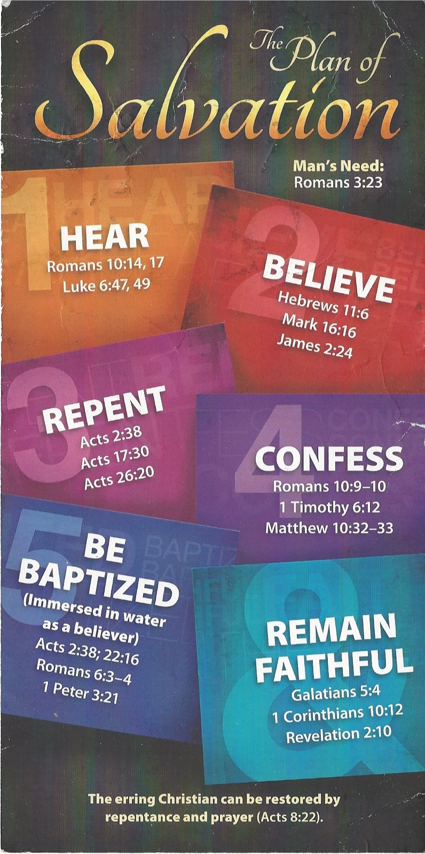
³² “Whoever acknowledges me before others, I will also acknowledge before my Father in heaven. ³³ But whoever disowns me before others, I will disown before my Father in heaven.
Be Baptized - Acts 22:16 (NIV)
¹⁶ And now what are you waiting for? Get up, be baptized and wash your sins away, calling on his name.’
Remain Steadfast - Revelation 2:10 (NIV)
¹⁰ Do not be afraid of what you are about to suffer. I tell you, the devil will put some of you in prison to test you, and you will suffer persecution for ten days. Be faithful, even to the point of death, and I will give you life as your victor’s crown.

