Barry G. Johnson, Sr. / www.bgjsr22.com
Questions Asked of Jesus / Question; Demon; Submission; Authority; Judgment; Time / Matthew 8:29
Men must submit as Demons who know Jesus and His authority.
Matthew 8:28–29 ESV
And when he came to the other side, to the country of the Gadarenes, two demon-possessed men met him, coming out of the tombs, so fierce that no one could pass that way. And behold, they cried out, “What have you to do with us, O Son of God? Have you come here to torment us before the time?”

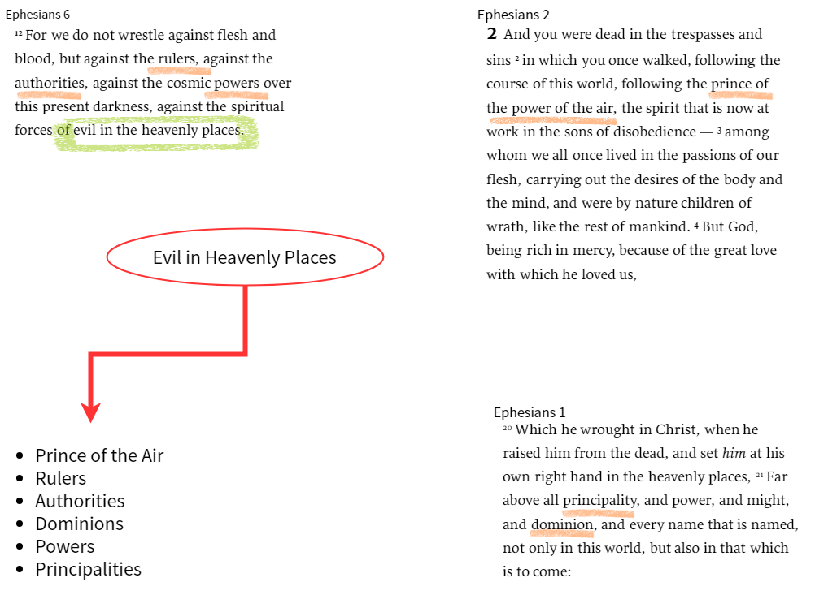Demons Know who Jesus is
Mark 3:10–11 ESV
for he had healed many, so that all who had diseases pressed around him to touch him. And whenever the unclean spirits saw him, they fell down before him and cried out, “You are the Son of God.”
Acts 19:15 ESV
But the evil spirit answered them, “Jesus I know, and Paul I recognize, but who are you?”
James 2:19 ESV
You believe that God is one; you do well. Even the demons believe—and shudder!

Demons Know the Authority of Jesus
Ephesians 1:19–22 ESV
and what is the immeasurable greatness of his power toward us who believe, according to the working of his great might that he worked in Christ when he raised him from the dead and seated him at his right hand in the heavenly places, far above all rule and authority and power and dominion, and above every name that is named, not only in this age but also in the one to come. And he put all things under his feet and gave him as head over all things to the church,
Philippians 2:9–10 ESV
Therefore God has highly exalted him and bestowed on him the name that is above every name, so that at the name of Jesus every knee should bow, in heaven and on earth and under the earth,

Demons Know their time is short
Hebrews 9:27 ESV
And just as it is appointed for man to die once, and after that comes judgment,
2 Peter 2:4 ESV
For if God did not spare angels when they sinned, but cast them into hell and committed them to chains of gloomy darkness to be kept until the judgment;
Jude 6 ESV
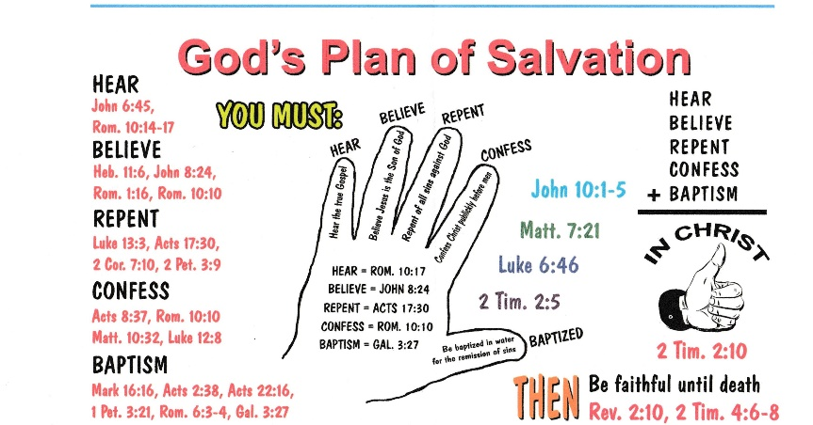
And the angels who did not stay within their own position of authority, but left their proper dwelling, he has kept in eternal chains under gloomy darkness until the judgment of the great day—

Biblical Plan of Salvation

