Barry G. Johnson, Sr. / www.barrygjohnsonsr.com
Top Objections to Christianity / Seek; Seekers; A Seeker of the Lord / Matthew 7:7–11
God is not far from any who seek Him.
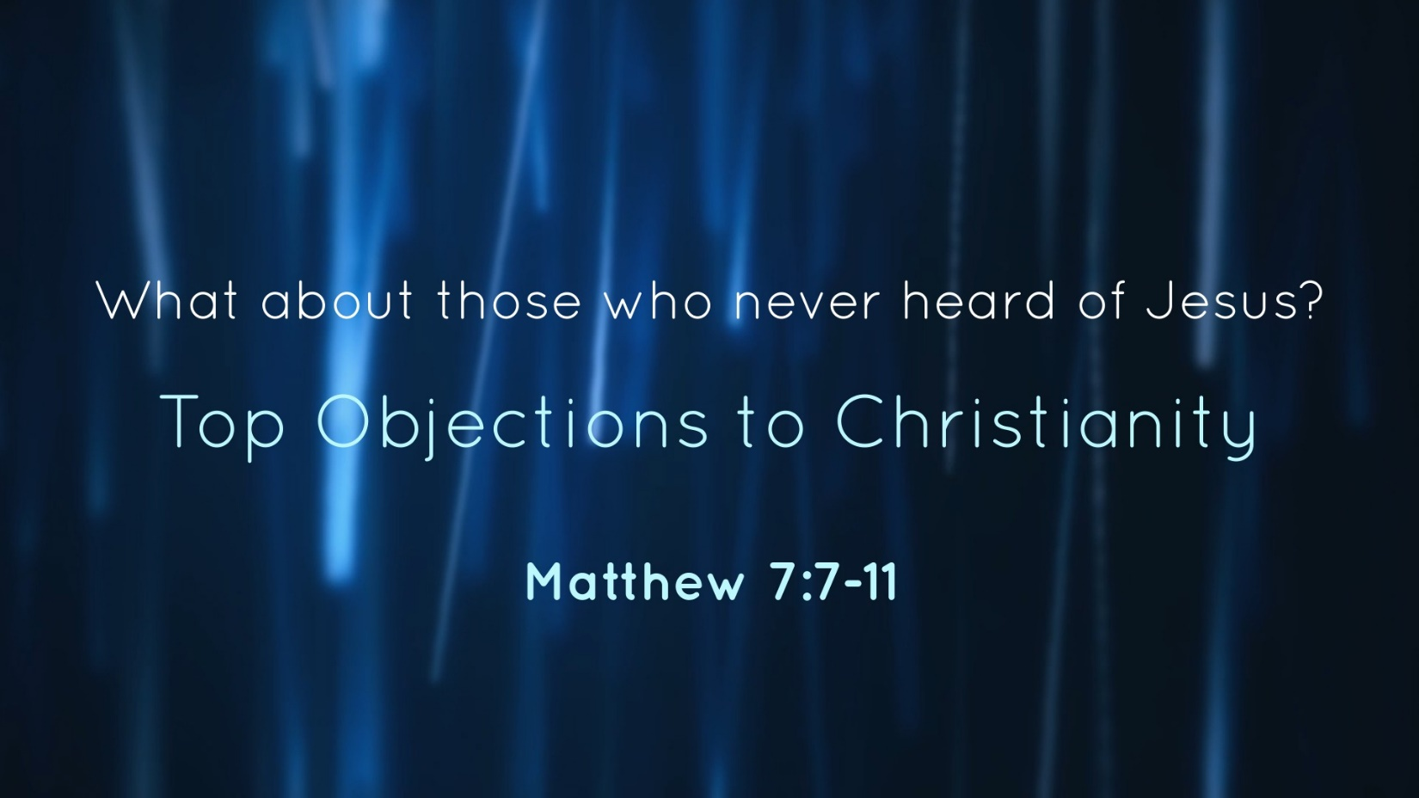

I. Those who have not heard are not excused

A. God is made known through creation
Romans 1:18–20 ESV
¹⁸ For the wrath of God is revealed from heaven against all ungodliness and unrighteousness of men, who by their unrighteousness suppress the truth. ¹⁹ For what can be known about God is plain to them, because God has shown it to them. ²⁰ For his invisible attributes, namely, his eternal power and divine nature, have been clearly perceived, ever since the creation of the world, in the things that have been made. So they are without excuse.

B. God revealed himself to Israel
Nehemiah 9:13–14 ESV
¹³ You came down on Mount Sinai and spoke with them from heaven and gave them right rules and true laws, good statutes and commandments, ¹⁴ and you made known to them your holy Sabbath and commanded them commandments and statutes and a law by Moses your servant.

II. Ignorance of God the Result of Sin and Rebellion

A. Among the Gentiles
Ephesians 4:18–19 ESV
¹⁸ They are darkened in their understanding, alienated from the life of God because of the ignorance that is in them, due to their hardness of heart. ¹⁹ They have become callous and have given themselves up to sensuality, greedy to practice every kind of impurity.

B. In Israel
Isaiah 1:2–3 ESV
² Hear, O heavens, and give ear, O earth;
for the Lord has spoken:
“Children have I reared and brought up,
but they have rebelled against me.
³ The ox knows its owner,
and the donkey its master’s crib,
but Israel does not know,
my people do not understand.”

III. You may claim to not have heard of God but God has heard about you
Genesis 6:5 ESV
⁵ The Lord saw that the wickedness of man was great in the earth, and that every intention of the thoughts of his heart was only evil continually.
Hebrews 4:13 ESV
¹³ And no creature is hidden from his sight, but all are naked and exposed to the eyes of him to whom we must give account.

IV. Ignorance does not excuse sin
Acts 3:17–20 ESV
¹⁷ “And now, brothers, I know that you acted in ignorance, as did also your rulers. ¹⁸ But what God foretold by the mouth of all the prophets, that his Christ would suffer, he thus fulfilled. ¹⁹ Repent therefore, and turn back, that your sins may be blotted out, ²⁰ that times of refreshing may come from the presence of the Lord, and that he may send the Christ appointed for you, Jesus,
Acts 26:9–11 ESV
⁹ “I myself was convinced that I ought to do many things in opposing the name of Jesus of Nazareth. ¹⁰ And I did so in Jerusalem. I not only locked up many of the saints in prison after receiving authority from the chief priests, but when they were put to death I cast my vote against them. ¹¹ And I punished them often in all the synagogues and tried to make them blaspheme, and in raging fury against them I persecuted them even to foreign cities.

V. Ignorance of God and salvation
Acts 17:24–28 ESV
²⁴ The God who made the world and everything in it, being Lord of heaven and earth, does not live in temples made by man, ²⁵ nor is he served by human hands, as though he needed anything, since he himself gives to all mankind life and breath and everything. ²⁶ And he made from one man every nation of mankind to live on all the face of the earth, having determined allotted periods and the boundaries of their dwelling place, ²⁷ that they should seek God, and perhaps feel their way toward him and find him. Yet he is actually not far from each one of us, ²⁸ for
“ ‘In him we live and move and have our being’;
as even some of your own poets have said,
“ ‘For we are indeed his offspring.’

VI. Ignorance and God’s judgment

A. God’s justice
Luke 12:47–48 ESV
⁴⁷ And that servant who knew his master’s will but did not get ready or act according to his will, will receive a severe beating. ⁴⁸ But the one who did not know, and did what deserved a beating, will receive a light beating. Everyone to whom much was given, of him much will be required, and from him to whom they entrusted much, they will demand the more.
2 Thessalonians 1:8–10 ESV
⁸ in flaming fire, inflicting vengeance on those who do not know God and on those who do not obey the gospel of our Lord Jesus. ⁹ They will suffer the punishment of eternal destruction, away from the presence of the Lord and from the glory of his might, ¹⁰ when he comes on that day to be glorified in his saints, and to be marveled at among all who have believed, because our testimony to you was believed.

C. God’s judgment falls severely on those who choose to disobey him
Acts 17:29–31 ESV
²⁹ Being then God’s offspring, we ought not to think that the divine being is like gold or silver or stone, an image formed by the art and imagination of man. ³⁰ The times of ignorance God overlooked, but now he commands all people everywhere to repent, ³¹ because he has fixed a day on which he will judge the world in righteousness by a man whom he has appointed; and of this he has given assurance to all by raising him from the dead.”
Hebrews 2:2–3 ESV
² For since the message declared by angels proved to be reliable, and every transgression or disobedience received a just retribution, ³ how shall we escape if we neglect such a great salvation? It was declared at first by the Lord, and it was attested to us by those who heard,

God’s Plan of Salvation

Romans 10:17 ESV
¹⁷ So faith comes from hearing, and hearing through the word of Christ.
Hebrews 11:6 ESV
⁶ And without faith it is impossible to please him, for whoever would draw near to God must believe that he exists and that he rewards those who seek him.
Luke 13:3 ESV
³ No, I tell you; but unless you repent, you will all likewise perish.
1 Timothy 6:12–13 ESV
¹² Fight the good fight of the faith. Take hold of the eternal life to which you were called and about which you made the good confession in the presence of many witnesses. ¹³ I charge you in the presence of God, who gives life to all things, and of Christ Jesus, who in his testimony before Pontius Pilate made the good confession,
Acts 2:37–38 ESV
³⁷ Now when they heard this they were cut to the heart, and said to Peter and the rest of the apostles, “Brothers, what shall we do?” ³⁸ And Peter said to them, “Repent and be baptized every one of you in the name of Jesus Christ for the forgiveness of your sins, and you will receive the gift of the Holy Spirit.
Revelation 2:10 ESV
¹⁰ Do not fear what you are about to suffer. Behold, the devil is about to throw some of you into prison, that you may be tested, and for ten days you will have tribulation. Be faithful unto death, and I will give you the crown of life.

