Barry Johnson
www.barrygjohnsonsr.com
Walking Christian on the Holy Spirit
Definitions - Characteristics - Causes - Solutions
Romans 8:1-11
Living Free in the Power and Peace of the Spirit
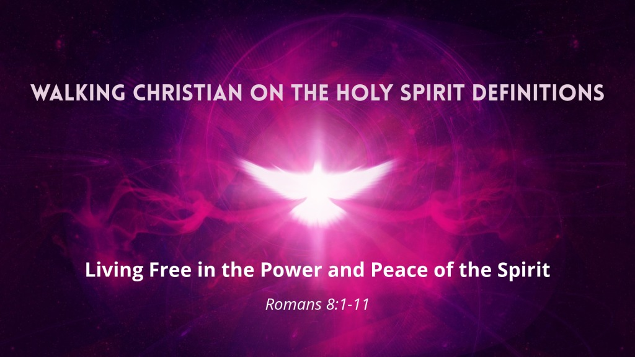

Walking Christian on the Holy Spirit DEFINITIONS
Barry G. Johnson, Sr. / www.barrygjohnsonsr.com
Walking Christian on the Holy Spirit / Holy Spirit / Romans 8:1-11

I. DEFINITIONS
1 Corinthians 6:19
Holy Ghost—the third Person of the Trinity.
His personality is proved
(1) from the fact that the attributes of personality, as i___________ and v________, are ascribed to him (John 14:17, 26; 15:26; 1 Cor. 2:10, 11; 12:11).
He r________, helps, g_________, intercedes (John 16:7–13; Rom. 8:26).
(2) He executes the offices peculiar only to a p______.
The very nature of these offices involves p________ distinction (Luke 12:12; Acts 5:32; 15:28; 16:6; 28:25; 1 Cor. 2:13; Heb. 2:4; 3:7; 2 Pet. 1:21).
His divinity is established
(1) from the fact that the n_____ of God are ascribed to him
(Ex. 17:7; Ps. 95:7; comp. Heb. 3:7–11); and
(2) that d______ attributes are also ascribed to him,
omni_________ (Ps. 139:7; Eph. 2:17, 18; 1 Cor. 12:13);
omni________ (1 Cor. 2:10, 11);
omni________ (Luke 1:35; Rom. 8:11);
e________ (Heb. 9:4).
(3) C________ is ascribed to him
(Gen. 1:2; Job 26:13; Ps. 104:30), and
the working of miracles (Matt. 12:28; 1 Cor. 12:9–11).
(4) W_______ is required and ascribed to him
(Isa. 6:3; Acts 28:25; Rom. 9:1; Rev. 1:4; Matt. 28:19).

A. Who Is the Holy Spirit?
• The Holy Spirit is the Person of the —the God.
2 Corinthians 13:14
• The Holy Spirit is the active and of God in the life of an individual.
Ephesians 3:16
• The word translated as “holy” comes from the Greek word hagios, which means “ .”

1 Corinthians 2:12
Matthew 6:9
Romans 8:26–27
2 Thessalonians 2:13

• The English word translated as “ ” comes from the Greek word , which means “wind or breath.”
John 3:8

QUESTION: “What is the difference between the Holy Spirit and the Holy Ghost?”
ANSWER: .
Luke 23:46 KJV

B. How Does the Bible Describe the Holy Spirit?

• His Position
— He is the of God the Father.
Matthew 10:20

• His Position
— He is the Spirit of the Son.
Romans 8:9

• His Position
— He is the Person of the .
Acts 2:32–33

• His Character
— He is the Spirit of .
Romans 1:3–4

• His Character
— He is the Spirit of .
Hebrews 10:29

• His Character
— He is the Spirit of .
John 14:17

• His Work
— He you into God’s family.
Romans 8:15

• His Work
— He you all things.
John 14:26

• His Work
— He you into all truth.
John 16:13

QUESTION: “Does the Holy Spirit have the same authority as Jesus?”
ANSWER: .
The Holy Spirit is a member of the Trinity, composed of Father, Son, and Holy Spirit.
However, all three have different roles.

Luke 22:42
John 16:14

C. What Was the Holy Spirit’s Role before Pentecost?

Leviticus 23:16
Acts 2:1–4
Genesis 1:1–2

• Old Testament Activity
— He imparted to Joseph to interpret Pharaoh’s dream and to present a plan for the coming famine.
Genesis 41:38–39
— He Joshua with the needed strength to be the successor to Moses.
Numbers 27:18
— He King Saul because of his deliberate disobedience.
1 Samuel 16:14
— He of future events through the prophets.
2 Samuel 23:2
— He was the behind the writers of Scripture.
2 Peter 1:21

• New Testament Activity before Pentecost

— He brought about the conception of Jesus in the virgin Mary’s womb.
Luke 1:35
— He indwelt and John the Baptist.
Luke 1:15
— He gave Simeon of a future encounter with Jesus.
Luke 2:26
— He Jesus with supernatural power for public ministry.

Isaiah 61:1
Luke 4:18–19

— He was promised by Jesus to the disciples as the coming who would be with them forever.
John 14:16

D. What Is the Holy Spirit’s Role in the Believer’s Life Today?

• He us that we are sinners.
the act of
John 16:8
• He us from sinners to saints.
the act of
Titus 3:5
• He cleanses us and places ( ) us into the body of Christ.
the act of
1 Corinthians 12:13
• He comes to live us.
the act of
1 Corinthians 6:19
• He us in the way we should go.
the act of
John 14:26
• He us to obey God’s will.
the act of
Ezekiel 36:27
• He our behavior.
the act of
Acts 13:52
• He our unspoken prayers.
the act of
Romans 8:26
• He our destiny in heaven.
the act of
2 Corinthians 1:22

QUESTION: “Are the spirit and the soul of a person the same thing?”
ANSWER:
In certain passages,

, while in other places the words body and spirit are used.
1 Thessalonians 5:23
Hebrews 4:12

THE MAKEUP OF A PERSON
• The __________
( in Greek) is the material part of a person that constitutes the physical anatomy (flesh, bones, and blood).
• The __________
( in Greek) is the immaterial, rational part of a person that produces behavior through the mind, will, and emotions.
— mind ( ) Acts 15:24
— will ( ) Ephesians 6:6
— emotions ( ) 1 Peter 1:22
• The __________
( in Greek) refers to the immaterial, innermost part of a person. The human spirit …
— needs to be made to God Ephesians 2:4–5
— with God John 4:23–24
— can live together with forever 1 Thessalonians 5:10

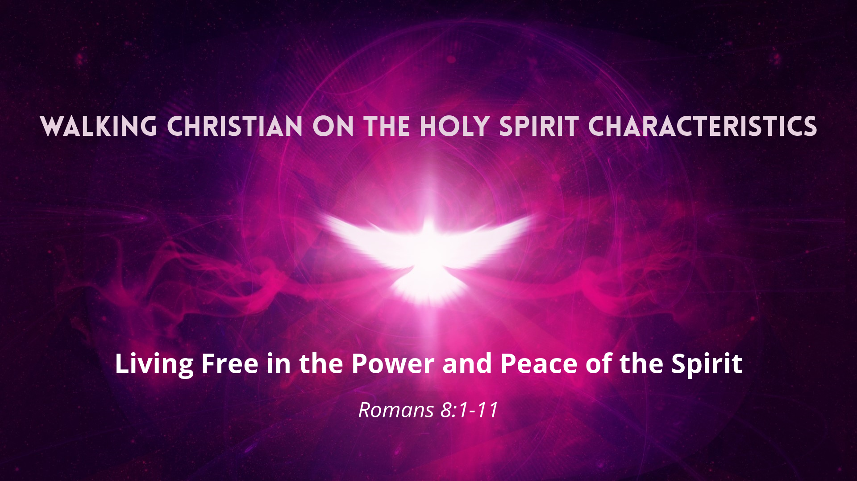

Walking Christian on the Holy Spirit CHARACTERISTICS
Barry G. Johnson, Sr. / www.barrygjohnsonsr.com
Walking Christian on the Holy Spirit / Holy Spirit; Holy Spirit: Fruit; Holy Spirit: Gifts / Galatians 5:22–26
If a man were in Christ Jesus, he will bear much fruit in the Spirit.

II. CHARACTERISTICS HOLY SPIRIT
A. What Is the Fruit of the Spirit?

John 15:5
Galatians 5:22–23

EVIDENCE OF BEING FILLED WITH THE SPIRIT?

_________Am I seeking the highest and best for others or seeking to serve my own needs?
_________Am I living with gladness over what I have or fretting over what I don’t have?
_________Am I resting in the strength and security of God or worrying about my circumstances?
_________Am I enduring difficult trials calmly or complaining and becoming bitter?
_________Am I exhibiting a benevolent heart by helping others or resenting having to meet the needs of others?
_________Am I displaying godly character with purity of heart or adopting the world’s standards of morality?
_________Am I trusting God during suffering and sorrow or doubting His perfect and persistent love?
_________Am I treating others with tenderness and respect or being harsh and short-tempered?
_________Am I rising to God’s call to do what is right in His sight or giving in to my feelings and selfish desires?
James 3:17

B. What are the Gifts of the Spirit?
QUESTION: “What are spiritual gifts?”
ANSWER: Spiritual gifts are …
— At one time it was abilities that the Holy Spirit bestowed upon a believer for the purpose of the church (the “body of Christ”)
— An opportunity for the Lord to accomplish His personalized for your life
— A means through which you express God’s to others
1 Corinthians 12:4–6
QUESTION: “What if I don’t have a spiritual gift?”
ANSWER:
A spiritual gift is given to believer.
If you are an authentic Christian, you have been given a spiritual gift, what that gift is.
1 Corinthians 12:7
QUESTION: “Does everyone have the same gift?”
ANSWER:
God doesn’t give everyone the gift. Even though some my have a similar gift. Always remember the gift is for .
1 Corinthians 12:8–10
QUESTION: “What are the different spiritual gifts?”
ANSWER:
There are different ways to of the Spirit.

Romans 12:6–8
—
an ability to proclaim or reveal God’s truth
—
an ability to recognize and meet the needs of others
—
an ability to communicate and clarify truth
—
an ability to inspire and stimulate the faith of others
—
an ability to entrust assets where they are most needed
—
an ability to administrate, organize, and coordinate efforts

—
an ability to reach out with active compassion to comfort others
Romans 12:6–8

1 Corinthians 12:7–11
—
an application of knowledge
—
an revelation
—
an ability to believe that God will provide
—
an ability to believe that God will cure human illness
—
an ability to perform feats outside the laws of nature
—
an ability to proclaim or reveal what is hidden
—
an ability to distinguish between truth and error, as well as good and evil spirits
—
an ability to speak in a language that the speaker has never learned
—
a supernatural ability to understand and interpret messages in tongues
1 Corinthians 12:7–11

QUESTION: “Can I choose a spiritual gift?”
ANSWER:
. Each person’s gift is chosen by .
1 Corinthians 12:11
QUESTION: “Can my spiritual gift change?”
ANSWER:
.
God is the One who put you in a specific place of in the body of Christ.
God uses the analogy of the physical body to explain how spiritual gifts function, and He makes it clear that if He made you a “hand” in the body of Christ, you should not try to be a “foot.”
In the same way that a hand remains a hand in the physical body, so spiritual gifts do not change.
1 Corinthians 12:18
QUESTION: “Can I become ineffective in the exercise of my spiritual gifts?”
ANSWER:
. Gifts mean nothing if they are not administered with a heart of .
1 Corinthians 13:1–3
QUESTION: “Is one gift more important than another?”
ANSWER:
. Each plays a vital role in the body of Christ. Gifts that may seem less honorable are .
1 Corinthians 12:21–23

QUESTION: “Why should I try to know my spiritual gifts?”
— To establish God-given in your life. The place where you serve must be in line with your .
1 Peter 4:10
— To experience the of being used by God.
Acts 13:52
— To up the church.
Ephesians 4:12
HOW DO YOU DISCERN YOUR SPIRITUAL GIFTS?
Proverbs 18:15
• Make sure you have come into a with Jesus Christ.
• Pray for the Holy Spirit to you to the truth about your personal spiritual gift(s).
• With a , desire only the gift(s) that the Spirit has given you to serve others. Don’t the gift of another.
• Make a of all the gifts and mark off those that you do not enjoy.
• when you as a Christian knew that God successfully used you to help others. those successes in light of spiritual gifts.
• Be aware of God’s through your own joy and fulfillment when helping others.
• Ask one or more mature Christians who know you well for their observations .
Proverbs 19:20
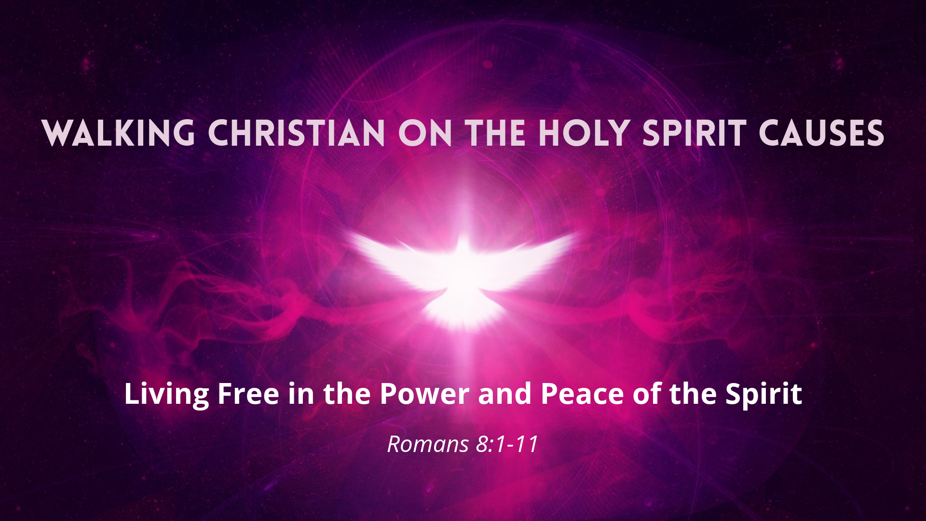
Walking Christian on the Holy Spirit CAUSES
Barry G. Johnson, Sr. / www.barrygjohnsonsr.com
Walking Christian on the Holy Spirit / Romans 8:1–11
To resist the Holy Spirit is to destine yourself to crash where life is concerned.

III. CAUSES FOR HINDERING THE WORK OF THE HOLY SPIRIT
John 3:8
A. Are You Rejecting God’s Flight Reports?
ARE YOU … RESISTING THE HOLY SPIRIT?
— by their God-given conscience
Romans 1:20
— by the claims of the Lord Jesus Christ
John 14:6
— by holding to a of religion without having a relationship with Christ
2 Timothy 3:5
Acts 7:51
ARE YOU … QUENCHING THE HOLY SPIRIT?
— by to act or speak as the Holy Spirit leads
— by circumstances that God allows to come into their lives
1 Thessalonians 5:19

ARE YOU … GRIEVING THE HOLY SPIRIT?
— by and distrusting God’s love and promises
— by to submit completely to God
— by personal time with God through His Word
Ephesians 4:30
B. Are You Refusing God’s Provision?
Romans 5:5
Romans 8:16
2 Corinthians 1:21–22
C. Are You Remaining in Control?—The Root Cause of Not Being Spirit-filled
WRONG BELIEF:
“It is only natural for me to be in control of my life and depend on my own efforts to achieve all that I can.”
• The Unbeliever:
1 Corinthians 2:14
• The Believer:
Galatians 3:3
RIGHT BELIEF:
“Life is not to be lived in my own but in to the Holy Spirit, giving Him complete .”
Zechariah 4:6

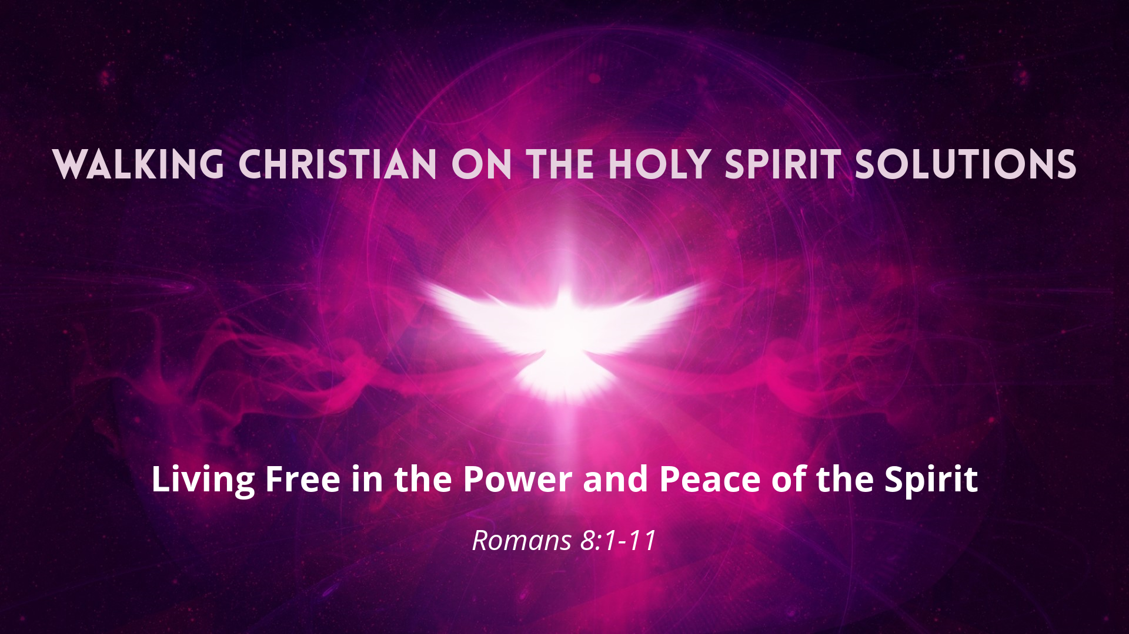

Walking Christian on the Holy Spirit SOLUTIONS
Barry G. Johnson, Sr. / www.barrygjohnsonsr.com
Walking Christian on the Holy Spirit / Holy Spirit; Spirit; Spirit of God; Spirit of Jesus Christ; Holy Spirit: Fruit; Holy Spirit: Gifts / Romans 8:1–11
We think that freedom to indulge our natural desires will bring ultimate fulfillment.

IV. STEPS TO SOLUTION
Galatians 5:16
A. Key Verse to Memorize
Romans 8:6
B. Key Passage to Read and Reread
Galatians 5:13–25
Galatians 5:24–25
C. Common Questions Regarding the Holy Spirit
QUESTION: “When does a person receive the Holy Spirit?”
ANSWER: At the moment of salvation, every true believer receives the .
Ephesians 1:13

QUESTION: “If I sin after receiving the Holy Spirit, will I lose my salvation?”
ANSWER:
, the Bible says that at the time of salvation every authentic Christian is sealed with the promised Holy Spirit, who is a guarantee, a promise from God that we will be physically redeemed in heaven.
2 Corinthians 1:21–22
QUESTION: “Can I be an authentic Christian and not have the Holy Spirit?”
ANSWER:
. You cannot have Christ without having the Spirit of Christ.
Romans 8:9
QUESTION: “When I placed my faith in the Lord Jesus Christ alone, did I receive Christ or the Holy Spirit to live in me?”
ANSWER:
The Scripture explains that those who are Christians have living within them.
Romans 8:9–11
QUESTION: “Does the phrase ‘baptism of the Holy Spirit’ apply only to those who speak in tongues?”
ANSWER:
. At the , you receive the the Holy Spirit.

1 Corinthians 12:8–11
1 Corinthians 12:13

QUESTION: “What does the filling of the Holy Spirit mean?”
ANSWER:
The apostle Paul uses the word filling to mean “ ”.
Ephesians 5:18
QUESTION: “Can I have the Holy Spirit living in me without being ‘filled’ with the Holy Spirit?”
ANSWER:
. Upon salvation you are sealed with the Holy Spirit as seen in
Ephesians 1:13 John 14:16
QUESTION: “What is blaspheming the Holy Spirit?”
ANSWER:
Blasphemy against the Holy Spirit— — , resulting in an unwillingness to yield to the convicting work of the Holy Spirit.
Mark 3:29
D. How to Be Filled with the Spirit
Ephesians 5:8, 10, 17–18
S— to the authority of Jesus Christ.
• R God’s claim on your life.
• R that God’s plan is to conform you to the image of Christ.
• R your right to be in control of your life.
Matthew 16:24
P— for conviction of sin.
• A your natural inclination to sin.
• A the Holy Spirit to make you aware of your specific sins.
• A with God about your need to change.

Psalm 139:23–24
I— with Christ’s death on the cross.
• See yourself as d to the ruling power of sin.
• See yourself as a to God because of the resurrection life of Christ within you.
• See the Holy Spirit as your power to o sin.
Romans 6:11
R— the indwelling presence of the Holy Spirit to teach you and to guide you.
• Listen with your h to the One sent by the Father.
• Listen to the gentle p of the Holy Spirit.
• Listen to His r of the truth as spoken by Jesus.
John 14:26
I— immediate obedience to the prompting of the Holy Spirit.
• Choose to acknowledge the p of the Holy Spirit.
• Choose to s your will to His will. (Don’t mentally argue.)
• Choose to act on His p tings.
Galatians 5:16
T— in the Holy Spirit to be your supernatural power for living a holy life.
• You have been called to be h .
• You cannot be holy by your own e .
• You must rely on the Holy Spirit, who e us to live a holy life.
2 Peter 1:3
F— on a regular basis with other believers.
• B to a Bible-based church.
• B involved in your church.
• Be s tive of others.

Hebrews 10:25
I— God’s Word in your heart.
• L up your thinking with God’s thinking.
• L one verse a day from the Book of Proverbs.
• L to teaching tapes on God’s Word.
Psalm 119:11
L— to have a thankful heart.
• Thank God for His un love.
• Thank God for His f ness to orchestrate events in your life.
• Thank God in all c ces, both good and bad.
1 Thessalonians 5:18
L— with an attitude of prayer.
• Keep your mind f ed on Christ.
• Keep your heart a t to the Holy Spirit.
• Keep p g through all circumstances.
Ephesians 6:18
E— victory!
• Know that your s gth is in Christ.
• Know that your own e s will fail.
• Know that v y is the Lord’s.
Zechariah 4:6
D— on the Holy Spirit to develop the character of Christ in your life.
• To r t the character of Christ is the Christian’s highest purpose.
• To the extent that you s t to the Holy Spirit, you will grow in Christ.
• To reflect Christ a ly will draw others to Him.
2 Corinthians 3:18

E. Are You Self-Centered or Spirit-Controlled?
Romans 6:11
THE THREE PARTS OF A PERSON
1 Thessalonians 5:23

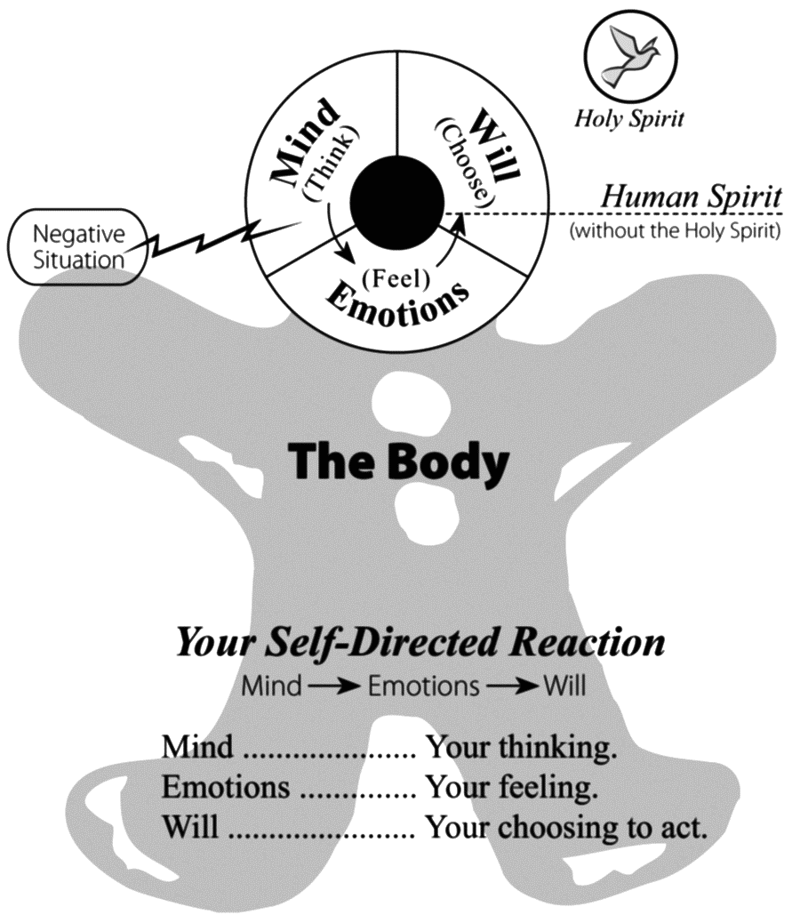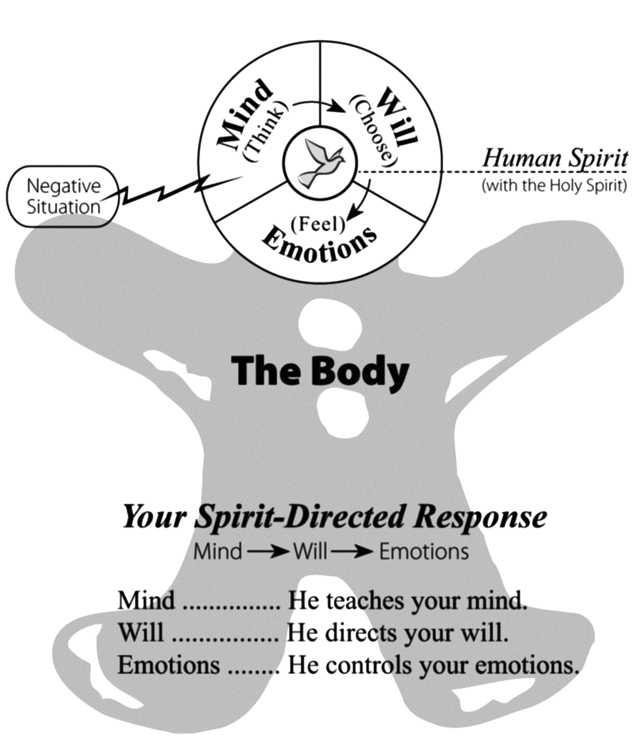

SELF IN CONTROL OF YOUR SOUL
Romans 12:2
Unjust Circumstance: Someone mistreats you.
• Human Response of the Soul:
— Your records the injustice and thinks angry thoughts.
— Your respond with angry feelings.
— Your reacts with angry behavior.
THE HOLY SPIRIT IN CONTROL OF YOUR SOUL
Romans 12:2
• Spiritual Response of the Soul:
— The Spirit teaches your how to think about the offense (John 14:26).
As your Counselor, He reminds you to “pray for those who persecute you” (Matthew 5:44).
— The Spirit directs your toward the right choice (John 16:13).
As your Conscience, He convicts you to pray, whether you feel like it or not.
— The Spirit controls your (Romans 5:5).
As you pray, the Comforter evokes loving compassion toward the unjust person who is spiritually needy.
Romans 8:5–6

F. Know the Truth about the Third Person of the Trinity
1 Peter 3:15
• Argument:
“The word Trinity does not appear in the Bible. And the Holy Spirit is not a person.… In the Bible no personal name is ascribed to the Spirit.”
Answer:
Although the word Trinity is not used in the Bible, the three persons of the Trinity, each with equal authority, are clearly identified in the .
Matthew 28:19
• Argument:
“The teaching of the Trinity promotes the worship of three gods—it is really polytheism.”
Answer:
No, the Bible clearly teaches there is only .
Deuteronomy 6:4
Therefore, the God of the Bible is one God consisting of a complex unity seen in …
— Genesis 1:26: “Then God said, ‘Let make man in image, in likeness.’ ”
— Genesis 3:22: “The LORD God said, ‘The man has now become like one of , knowing good and evil.’ ”
— Genesis 11:6–7: “The LORD said.… ‘Come, let go down and confuse their language so they will not understand each other.’ ”
Genesis 2:24
Numbers 13:23

• Argument:
“The Holy Spirit is not a person, but a powerful force that is only figuratively called ‘he.’ ”
Answer:
The Holy Spirit is positively a person. Every person has a or soul with a mind, will, and emotions. A force, such as g y or e city does not possess these attributes. However, the Bible presents many proofs of the personhood of the Holy Spirit.
— The Holy Spirit has a mind. First Corinthians 2:11
a. He knows the thoughts of God. Romans 8:27
b. He has a mind. (Electricity cannot think. People think.)
— The Holy Spirit has a will. First Corinthians 12:11
a. He gives spiritual gifts. First Corinthians 2:13
b. He teaches spiritual truth. (Gravity cannot give gifts or teach truth.)
— The Holy Spirit has emotions. Romans 15:30
a. He loves. Ephesians 4:30
b. He grieves. (Electricity cannot love. Gravity cannot grieve. People love and grieve.)
• Argument:
“The Holy Spirit is an ‘it,’ not a person. In the Greek Bible, neuter pronouns (like it) are used in reference to the word spirit, clearly implying that the Holy Spirit is not a person.”
Answer:
Neuter pronouns are appropriate because the Greek word pneuma ( ) is neuter in gender. However, instead of being a negative, this rule of grammar further supports the personhood of the Holy Spirit because …

Romans 8:26
Acts 13:2
Ephesians 1:13–14

• Argument:
“ ‘The Holy Spirit’ is just another name for God the Father. For example, a man may be a father, a husband, and a friend, but he is still the same person.”
Answer:
This type of reasoning is called m m and is heretical teaching because it implies that only one person of the Trinity exists in three roles or modes. Three distinct persons are seen in the baptism of Jesus. Each member of the Trinity is seen as distinctly different.
— Jesus was by John the Baptist.
— The Holy Spirit descended like a .
— The heavenly Father from above the clouds.
Matthew 3:16–17
• Argument:
“The Holy Spirit is an instrument of God, but not literally God.”
Answer:
The Holy Spirit is definitely d as demonstrated in both Testaments of the Bible.
— The Old Testament presents the Holy Spirit as God. In the Psalms, David ascribes to the Holy Spirit divine attributes, such as all-knowing, all-powerful, and all-present, totally unique to God.
Psalm 139:7–10
Acts 5:3–4
2 Corinthians 13:14

