The Mixed Response
Barry G. Johnson, Sr. / General
Discovering the Church / Responses to Jesus; Judaizers; Joy; Paul’s first missionary journey; Gentiles / Acts 13:44–52
Paul and Barnabas move unto the Gentiles after Jews consider themselves unworthy of an inheritance to eternal life.
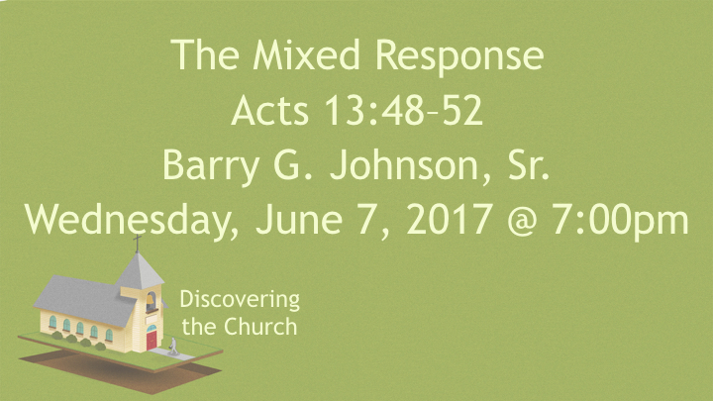

The Whole city
Acts 13:44 ESV
⁴⁴ The next Sabbath almost the whole city gathered to hear the word of the Lord.
Who gathered to hear the Word of the Lord?

Filled with Jealousy
Acts 13:45 ESV
⁴⁵ But when the Jews saw the crowds, they were filled with jealousy and began to contradict what was spoken by Paul, reviling him.
Who was filled with jealousy and contradicted what Paul had spoken?

Ref. Acts 21:21

To the Jew first
Acts 13:46 ESV
⁴⁶ And Paul and Barnabas spoke out boldly, saying, “It was necessary that the word of God be spoken first to you. Since you thrust it aside and judge yourselves unworthy of eternal life, behold, we are turning to the Gentiles.
Who was it necessary to preach the Word of the Lord to first?

Ref. 1 Cor. 1:23

This Little Light of Mine
Acts 13:47 ESV
⁴⁷ For so the Lord has commanded us, saying, “ ‘I have made you a light for the Gentiles, that you may bring salvation to the ends of the earth.’ ”
Who was Paul made a light unto?

Ref. Rom. 3:29; 9:24

Appointed to Eternal Life
Acts 13:48 ESV
⁴⁸ And when the Gentiles heard this, they began rejoicing and glorifying the word of the Lord, and as many as were appointed to eternal life believed.
What did the Gentiles do when they heard the news about Paul being a light unto them?

Ref. Rom. 15:9-12

Evangelism
Acts 13:49 ESV
⁴⁹ And the word of the Lord was spreading throughout the whole region.
What did the word of the Lord do after Paul and Barnabas turned unto the Gentiles?

A Zeal for God
Acts 13:50 ESV
⁵⁰ But the Jews incited the devout women of high standing and the leading men of the city, stirred up persecution against Paul and Barnabas, and drove them out of their district.
Who did the Jews stir up against Paul and Barnabas?

Ref. Rom. 10:2; 1 Cor. 1:26-29

Shaking the Dust
Acts 13:51 ESV
⁵¹ But they shook off the dust from their feet against them and went to Iconium.
What was Paul and Barnabas response to the persecution?

Ref. Mt. 10:14

Joy in the Spirit
Acts 13:52 ESV
⁵² And the disciples were filled with joy and with the Holy Spirit.
What were the Disciples filled with?

Ref. Lk. 6:22-23; 1 TH. 1:6

Address to the Gentiles (Acts 13:44–52)

