Barry G. Johnson, Sr. / www.bgjsr22.com
Christianity is Reality "All Have Sinned" / Sin; Truth; Realism; Delusion; Wicked; Evil / 1 John 1:8–10
Men have deluded themselves into believing they have no sin, by following another Gospel, whose word cannot save.
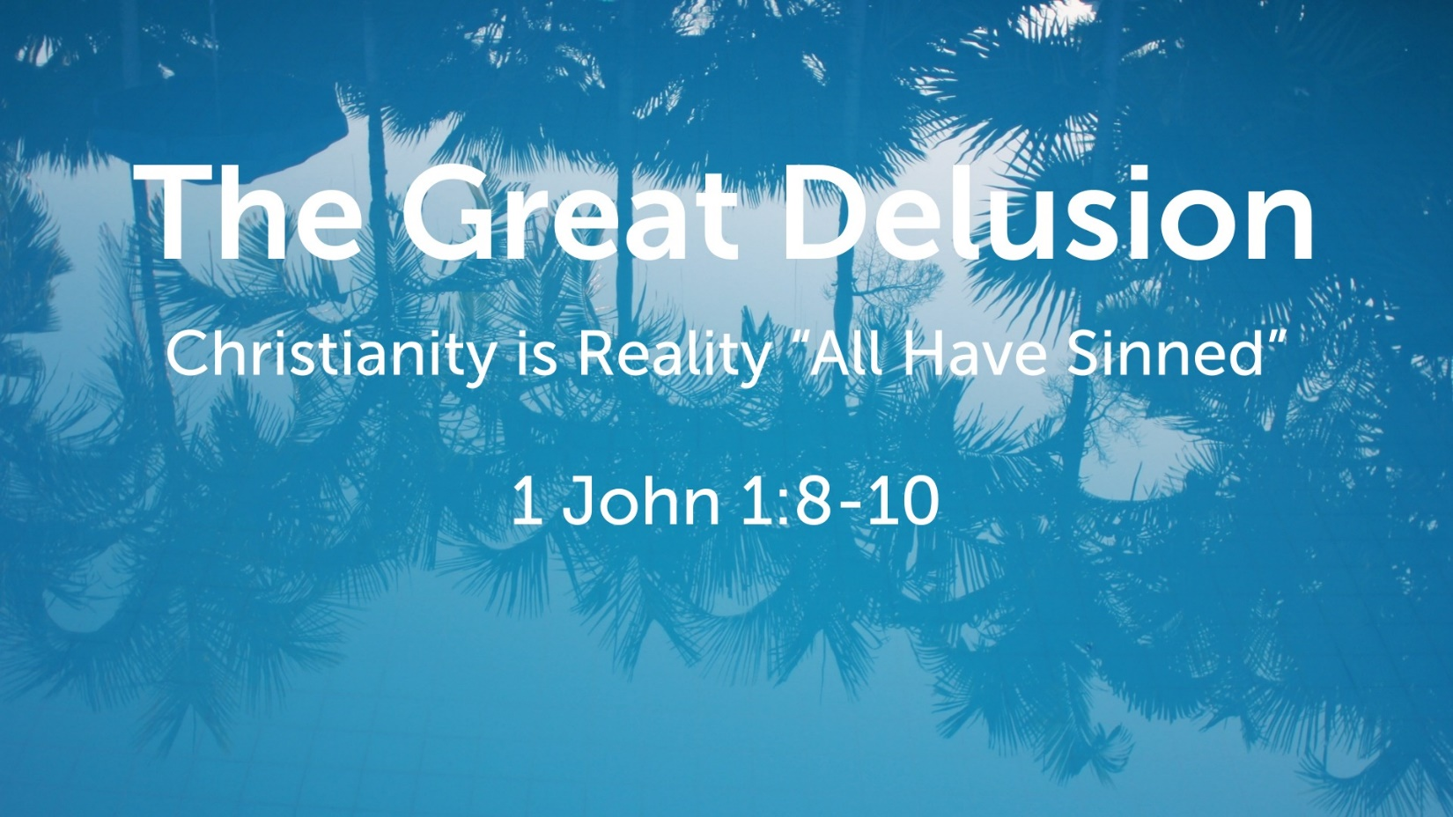

We walk in darkness
2 Corinthians 6:14–16 ESV
¹⁴ Do not be unequally yoked with unbelievers. For what partnership has righteousness with lawlessness? Or what fellowship has light with darkness? ¹⁵ What accord has Christ with Belial? Or what portion does a believer share with an unbeliever? ¹⁶ What agreement has the temple of God with idols? For we are the temple of the living God; as God said,
“I will make my dwelling among them and walk among them,
and I will be their God,
and they shall be my people.
Revelation 3:17–18 ESV
¹⁷ For you say, I am rich, I have prospered, and I need nothing, not realizing that you are wretched, pitiable, poor, blind, and naked. ¹⁸ I counsel you to buy from me gold refined by fire, so that you may be rich, and white garments so that you may clothe yourself and the shame of your nakedness may not be seen, and salve to anoint your eyes, so that you may see.

We say we have no sin
Proverbs 20:9 ESV
⁹ Who can say, “I have made my heart pure;
I am clean from my sin”?
Ecclesiastes 7:20 ESV
²⁰ Surely there is not a righteous man on earth who does good and never sins.
1 Timothy 6:5 ESV
⁵ and constant friction among people who are depraved in mind and deprived of the truth, imagining that godliness is a means of gain.

His Word is not in us
Ephesians 2:3 ESV
³ among whom we all once lived in the passions of our flesh, carrying out the desires of the body and the mind, and were by nature children of wrath, like the rest of mankind.
2 Thessalonians 2:10–12 ESV
¹⁰ and with all wicked deception for those who are perishing, because they refused to love the truth and so be saved. ¹¹ Therefore God sends them a strong delusion, so that they may believe what is false, ¹² in order that all may be condemned who did not believe the truth but had pleasure in unrighteousness.
1 John 2:4 ESV
⁴ Whoever says “I know him” but does not keep his commandments is a liar, and the truth is not in him,
Romans 8:6–8 ESV
⁶ For to set the mind on the flesh is death, but to set the mind on the Spirit is life and peace. ⁷ For the mind that is set on the flesh is hostile to God, for it does not submit to God’s law; indeed, it cannot. ⁸ Those who are in the flesh cannot please God.

Jesus Christ alone is sinless
Hebrews 4:15 ESV
¹⁵ For we do not have a high priest who is unable to sympathize with our weaknesses, but one who in every respect has been tempted as we are, yet without sin.
1 Peter 2:22 ESV
²² He committed no sin, neither was deceit found in his mouth.

How to Overcome the Delusion

Hear God’s Word - Romans 10:17

Believe God’s Word - Hebrews 11:6

Repent of your Sins - Luke 13:3

Confess Jesus as the Son of God - 1 John 4:3

Be Baptized for the Remission of Sin - Acts 22:16

Remain Steadfast for Life - 1 Corinthians 15:58

