Barry G. Johnson, Sr. / www.barrygjohnsonsr.com
Proverbs: The Way of Wisdom / Fool; Foolishness; A Foolish Man / Proverbs 9:13–18
The attitude that leads to a closing of the mind towards God and his truth, and a false self-confidence, which results in being easily led astray, failure to see danger, unpreparedness and ultimate ruin.
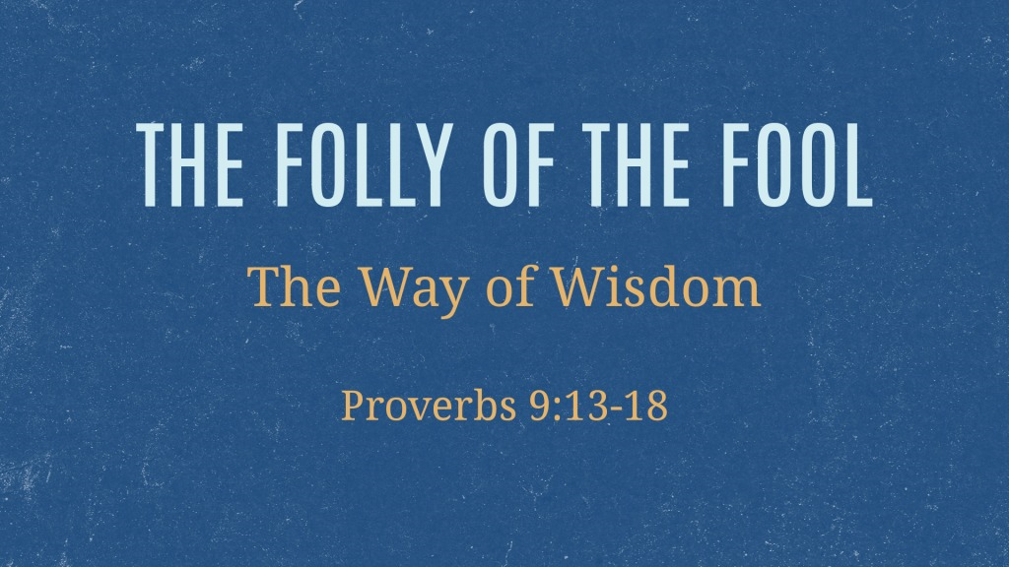

Folly gives a false basis for confidence

Contempt for God’s wisdom
Proverbs 1:7 ESV
The fear of the Lord is the beginning of knowledge;
fools despise wisdom and instruction.
See also Job 28:28; Ps 14:1; Ps 85:8; Ps 111:10; Pr 1:20–27; Pr 12:1; Pr 18:2
Job 28:28 ESV
And he said to man,
‘Behold, the fear of the Lord, that is wisdom,
and to turn away from evil is understanding.’ ”

Blindness to God’s truth
Ephesians 5:17 ESV
Therefore do not be foolish, but understand what the will of the Lord is.
See also Ps 92:6; Ec 5:1–4; Je 5:4; Lk 11:39–40 hypocrisy in worship; Ro 1:21; 1 Co 15:36 failure to understand the nature of death and resurrection; 2 Ti 2:23; Tt 3:9 futile controversies

Rebellion against God’s authority
Jeremiah 5:21–25 ESV
“Hear this, O foolish and senseless people,
who have eyes, but see not,
who have ears, but hear not.
Do you not fear me? declares the Lord.
Do you not tremble before me?
I placed the sand as the boundary for the sea,
a perpetual barrier that it cannot pass;
though the waves toss, they cannot prevail;
though they roar, they cannot pass over it.
But this people has a stubborn and rebellious heart;
they have turned aside and gone away.
They do not say in their hearts,
‘Let us fear the Lord our God,
who gives the rain in its season,
the autumn rain and the spring rain,
and keeps for us
the weeks appointed for the harvest.’
Your iniquities have turned these away,
and your sins have kept good from you.
Ps 107:17

Self-reliance
Proverbs 28:26 ESV
Whoever trusts in his own mind is a fool,
but he who walks in wisdom will be delivered.
See also Pr 11:28; Pr 12:15; Pr 14:12; Lk 12:20

Folly cannot be hidden
Ecclesiastes 10:3 ESV
Even when the fool walks on the road, he lacks sense,
and he says to everyone that he is a fool.
See also Ps 69:5; Pr 12:23; Pr 13:16; Pr 15:2; 2 Ti 3:9

Folly opens the way to deception
Proverbs 14:8 ESV
The wisdom of the prudent is to discern his way,
but the folly of fools is deceiving.

Being led astray
Proverbs 14:15 ESV
The simple believes everything,
but the prudent gives thought to his steps.
See also Pr 7:7–23; Pr 9:13–18; Ec 7:26; Ho 7:11; Ga 3:1

Failing to see danger
Proverbs 22:3 ESV
The prudent sees danger and hides himself,
but the simple go on and suffer for it.
See also Ec 4:13

Being unprepared
Matthew 25:10 ESV
And while they were going to buy, the bridegroom came, and those who were ready went in with him to the marriage feast, and the door was shut.

The consequences of folly

Destruction and ruin
Proverbs 1:32 ESV
For the simple are killed by their turning away,
and the complacency of fools destroys them;
See also Pr 5:23; Pr 10:8; Ec 7:17; 1 Ti 6:9

Shame
Proverbs 3:35 ESV
The wise will inherit honor,
but fools get disgrace.
See also Pr 18:13; Is 44:9; Je 8:9

Grief to parents
Proverbs 17:25 ESV
A foolish son is a grief to his father
and bitterness to her who bore him.
See also Pr 10:1; Pr 15:20; Pr 17:21

Punishment
Proverbs 16:22 ESV
Good sense is a fountain of life to him who has it,
but the instruction of fools is folly.
See also Ps 38:5; Pr 18:6
Proverbs 26:3 ESV
A whip for the horse, a bridle for the donkey,
and a rod for the back of fools.

Exclusion from God’s way of salvation
Isaiah 35:8 ESV
And a highway shall be there,
and it shall be called the Way of Holiness;
the unclean shall not pass over it.
It shall belong to those who walk on the way;
even if they are fools, they shall not go astray.
See also Mt 25:10–12
Matthew 25:10–12 ESV
And while they were going to buy, the bridegroom came, and those who were ready went in with him to the marriage feast, and the door was shut. Afterward the other virgins came also, saying, ‘Lord, lord, open to us.’ But he answered, ‘Truly, I say to you, I do not know you.’

Folly is persistent
Proverbs 27:22 ESV
Crush a fool in a mortar with a pestle
along with crushed grain,
yet his folly will not depart from him.
See also Pr 15:14; Pr 26:11

Remedies for folly

The forgiveness of foolish actions
Titus 3:3–5 ESV
For we ourselves were once foolish, disobedient, led astray, slaves to various passions and pleasures, passing our days in malice and envy, hated by others and hating one another. But when the goodness and loving kindness of God our Savior appeared, he saved us, not because of works done by us in righteousness, but according to his own mercy, by the washing of regeneration and renewal of the Holy Spirit,
Nu 12:11; Job 42:8; Ps 85:8; Tt 3:3–5

Discipline
Pr 19:25; Pr 21:11; Pr 22:15; Pr 29:15

Wisdom and instruction
Pr 8:5; Pr 14:33; Is 29:24
Romans 2:20 ESV
an instructor of the foolish, a teacher of children, having in the law the embodiment of knowledge and truth—

