Barry G. Johnson, Sr. www.barrygjohnsonsr.com
Discovering the Church / Lord’s Day; Worship; Lord’s Supper; Industrial Christian Fellowship; Sabbath and Rest

The first Christians assembled together on the first day of the week to commemorate Jesus Christ’s resurrection through the Lord’s Supper. The Lord’s Day quickly became the focal point of the Christian week, assuming the characteristics of the Jewish Sabbath, namely worship and rest.
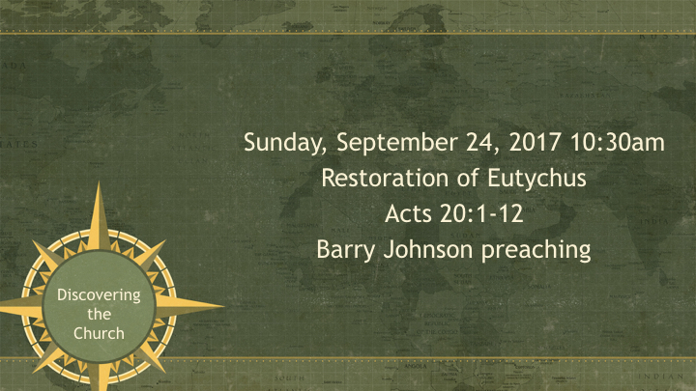

I. THE OBSERVANCE OF THE SUPPER

A. THE BIBLICAL EVIDENCE...
1 Corinthians 10:16–17 ESV
¹⁶ The cup of blessing that we bless, is it not a participation in the blood of Christ? The bread that we break, is it not a participation in the body of Christ?
¹⁷ Because there is one bread, we who are many are one body, for we all partake of the one bread.

B. THE HISTORICAL EVIDENCE...

II. THE DAY OF THE OBSERVANCE

A. WHY THE FIRST DAY OF THE WEEK...?

1. Jesus rose from the dead on Sunday - Mt 28:1; Mk 16:2,9; Lk 24:1; Jn 20:1

2. Jesus appeared to His disciples on Sunday - Jn 20:19

3. The church began on Pentecost, which was on a Sunday - Ac 2:1-42

4. The command to lay by in store was to be carried out on a Sunday - 1Co 16:1-2

5. Jesus appeared to John on "the Lord's Day", understood to be Sunday - Re 1:10

B. WHY NOT THE SABBATH...?
Nehemiah 9:14 ESV
¹⁴ and you made known to them your holy Sabbath and commanded them commandments and statutes and a law by Moses your servant.
Ezekiel 20:12 ESV
¹² Moreover, I gave them my Sabbaths, as a sign between me and them, that they might know that I am the Lord who sanctifies them.
2 Corinthians 3:4–6 ESV
⁴ Such is the confidence that we have through Christ toward God. ⁵ Not that we are sufficient in ourselves to claim anything as coming from us, but our sufficiency is from God, ⁶ who has made us sufficient to be ministers of a new covenant, not of the letter but of the Spirit. For the letter kills, but the Spirit gives life.
Hebrews 8:6–10 ESV
⁶ But as it is, Christ has obtained a ministry that is as much more excellent than the old as the covenant he mediates is better, since it is enacted on better promises. ⁷ For if that first covenant had been faultless, there would have been no occasion to look for a second. ⁸ For he finds fault with them when he says: “Behold, the days are coming, declares the Lord, when I will establish a new covenant with the house of Israel and with the house of Judah, ⁹ not like the covenant that I made with their fathers on the day when I took them by the hand to bring them out of the land of Egypt. For they did not continue in my covenant, and so I showed no concern for them, declares the Lord. ¹⁰ For this is the covenant that I will make with the house of Israel after those days, declares the Lord: I will put my laws into their minds, and write them on their hearts, and I will be their God, and they shall be my people.
Colossians 2:16–17 ESV
¹⁶ Therefore let no one pass judgment on you in questions of food and drink, or with regard to a festival or a new moon or a Sabbath.
¹⁷ These are a shadow of the things to come, but the substance belongs to Christ.

III. What we do on the First Day of the Week

We Pray
1 Timothy 2:1–2 ESV
¹ First of all, then, I urge that supplications, prayers, intercessions, and thanksgivings be made for all people, ² for kings and all who are in high positions, that we may lead a peaceful and quiet life, godly and dignified in every way.

We Sing
Colossians 3:16 ESV
¹⁶ Let the word of Christ dwell in you richly, teaching and admonishing one another in all wisdom, singing psalms and hymns and spiritual songs, with thankfulness in your hearts to God.

We Preach
Acts 2:42 ESV
⁴² And they devoted themselves to the apostles’ teaching and the fellowship, to the breaking of bread and the prayers.

We Give
1 Corinthians 16:1–2 ESV
¹ Now concerning the collection for the saints: as I directed the churches of Galatia, so you also are to do. ² On the first day of every week, each of you is to put something aside and store it up, as he may prosper, so that there will be no collecting when I come.
2 Corinthians 9:7 ESV
⁷ Each one must give as he has decided in his heart, not reluctantly or under compulsion, for God loves a cheerful giver.

We Communion
1 Corinthians 11:24–26 ESV
²⁴ and when he had given thanks, he broke it, and said, “This is my body, which is for you. Do this in remembrance of me.” ²⁵ In the same way also he took the cup, after supper, saying, “This cup is the new covenant in my blood. Do this, as often as you drink it, in remembrance of me.” ²⁶ For as often as you eat this bread and drink the cup, you proclaim the Lord’s death until he comes.

When we meet Two Governing Principles
1 Corinthians 14:25 ESV
²⁵ the secrets of his heart are disclosed, and so, falling on his face, he will worship God and declare that God is really among you.
1 Corinthians 14:40 ESV
⁴⁰ But all things should be done decently and in order.

God’s Plan of Salvation

Hear
Romans 10:17 ESV
¹⁷ So faith comes from hearing, and hearing through the word of Christ.

Believe
Hebrews 11:6 ESV
⁶ And without faith it is impossible to please him, for whoever would draw near to God must believe that he exists and that he rewards those who seek him.

Repent
Acts 17:30 ESV
³⁰ The times of ignorance God overlooked, but now he commands all people everywhere to repent,

Confess
1 Timothy 6:12 ESV
¹² Fight the good fight of the faith. Take hold of the eternal life to which you were called and about which you made the good confession in the presence of many witnesses.

Be Baptized
Acts 2:38 ESV
³⁸ And Peter said to them, “Repent and be baptized every one of you in the name of Jesus Christ for the forgiveness of your sins, and you will receive the gift of the Holy Spirit.

Remain Faithful
Galatians 5:4 ESV
⁴ You are severed from Christ, you who would be justified by the law; you have fallen away from grace.

