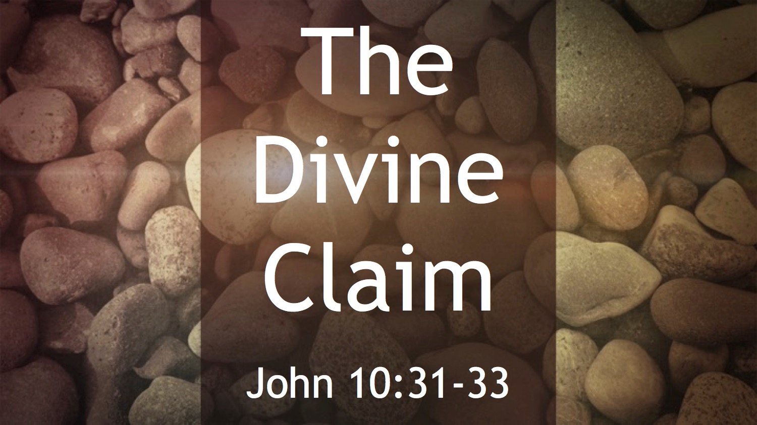
Synopsis
The equality and identity of Jesus Christ as God is clearly stated in the NT, and is also implied by the words and deeds of Jesus Christ. The OT prophecies also point to the divinity of the coming Messiah.
- NT affirms Jesus Christ’s Divinity
Hebrews 1:8 (NIV) — 8 But about the Son he says, “Your throne, O God, will last for ever and ever; a scepter of justice will be the scepter of your kingdom.
- Statements which imply Jesus Divinity
Isaiah 7:14 (NIV) — 14 Therefore the Lord himself will give you a sign: The virgin will conceive and give birth to a son, and will call him Immanuel.
Luke 1:35 (NIV) — 35 The angel answered, “The Holy Spirit will come on you, and the power of the Most High will overshadow you. So the holy one to be born will be called the Son of God.
Colossians 1:15 (NIV) — 15 The Son is the image of the invisible God, the firstborn over all creation.
Colossians 2:9 (NIV) — 9 For in Christ all the fullness of the Deity lives in bodily form,
1 Timothy 1:17 (NIV) — 17 Now to the King eternal, immortal, invisible, the only God, be honor and glory for ever and ever. Amen.
1 John 5:20 (NIV) — 20 We know also that the Son of God has come and has given us understanding, so that we may know him who is true. And we are in him who is true by being in his Son Jesus Christ. He is the true God and eternal life.
- Jesus names and titles point to his Divinity
- Jesus Christ as judge
Jn 5:27 In the OT, final responsibility for judgment is assigned to God.
John 5:27 (NIV) — 27 And he has given him authority to judge because he is the Son of Man.
- Jesus Christ as “I am”
Jn 11:25 “I am” is the meaning of God’s name in the OT (see Ex 3:14).
John 11:25 (NIV) — 25 Jesus said to her, “I am the resurrection and the life. The one who believes in me will live, even though they die;
See also Jn 6:35 ; Jn 8:12 ; Jn 10:7 ; Jn 10:11 ; Jn 14:6 ; Jn 15:1 ; Jn 18:5–6
- Jesus Christ as Saviour
Ac 5:31 According to the OT, God alone can save.
Acts 5:31 (NIV) — 31 God exalted him to his own right hand as Prince and Savior that he might bring Israel to repentance and forgive their sins.
- Jesus Christ as Lord
Ro 10:9 “Lord” was equivalent to God’s name in the OT.
Romans 10:9 (NIV) — 9 If you declare with your mouth, “Jesus is Lord,” and believe in your heart that God raised him from the dead, you will be saved.
- Jesus Christ as creator
Colossians 1:16 (NIV) — 16 For in him all things were created: things in heaven and on earth, visible and invisible, whether thrones or powers or rulers or authorities; all things have been created through him and for him.
- Jesus Christ as shepherd
Heb 13:20 “Shepherd” was a well-known OT name for God.
Hebrews 13:20 (NIV) — 20 Now may the God of peace, who through the blood of the eternal covenant brought back from the dead our Lord Jesus, that great Shepherd of the sheep,
- Recognizing Jesus Christ’s Divinity
- The disciples
John 20:28 (NIV) — 28 Thomas said to him, “My Lord and my God!”
- The demons
Luke 4:41 (NIV) — 41 Moreover, demons came out of many people, shouting, “You are the Son of God!” But he rebuked them and would not allow them to speak, because they knew he was the Messiah.
- Jesus Christ’s Eternal Nature Indicates His Divinity
- Jesus Christ Precedes Creation
Colossians 1:17 (NIV) — 17 He is before all things, and in him all things hold together.
1 John 1:1 (NIV) — 1 That which was from the beginning, which we have heard, which we have seen with our eyes, which we have looked at and our hands have touched—this we proclaim concerning the Word of life.
- Jesus Christ is Everlasting
Hebrews 1:12 (NIV) — 12 You will roll them up like a robe; like a garment they will be changed. But you remain the same, and your years will never end.”

- Jesus Christ’s Manifestation of God’s Glory Indicates His Divinity
Hebrews 1:3 (NIV) — 3 The Son is the radiance of God’s glory and the exact representation of his being, sustaining all things by his powerful word. After he had provided purification for sins, he sat down at the right hand of the Majesty in heaven.
- Jesus Christ’s Claims to Divinity
- He claimed to be one with the Father
John 5:17–18 (NIV) — 17 In his defense Jesus said to them, “My Father is always at his work to this very day, and I too am working.” 18 For this reason they tried all the more to kill him; not only was he breaking the Sabbath, but he was even calling God his own Father, making himself equal with God.
- He demonstrated his authority to forgive sin
Luke 7:47–48 (NIV) — 47 Therefore, I tell you, her many sins have been forgiven—as her great love has shown. But whoever has been forgiven little loves little.” 48 Then Jesus said to her, “Your sins are forgiven.”
- Jesus Christ’s Actions imply His Divinity
Matthew 8:26–27 (NIV) — 26 He replied, “You of little faith, why are you so afraid?” Then he got up and rebuked the winds and the waves, and it was completely calm. 27 The men were amazed and asked, “What kind of man is this? Even the winds and the waves obey him!”
- Jesus Christ’s Resurrection Confirms His Divinity
Romans 1:4 (NIV) — 4 and who through the Spirit of holiness was appointed the Son of God in power by his resurrection from the dead: Jesus Christ our Lord.
Invitation:
Hear
Romans 10:14 (NIV)
¹⁴ How, then, can they call on the one they have not believed in? And how can they believe in the one of whom they have not heard? And how can they hear without someone preaching to them?
Romans 10:17 (NIV)
¹⁷ Consequently, faith comes from hearing the message, and the message is heard through the word about Christ.
Believe
Hebrews 11:6 (NIV)
⁶ And without faith it is impossible to please God, because anyone who comes to him must believe that he exists and that he rewards those who earnestly seek him.
Repent
Acts 17:30 (NIV)
³⁰ In the past God overlooked such ignorance, but now he commands all people everywhere to repent.
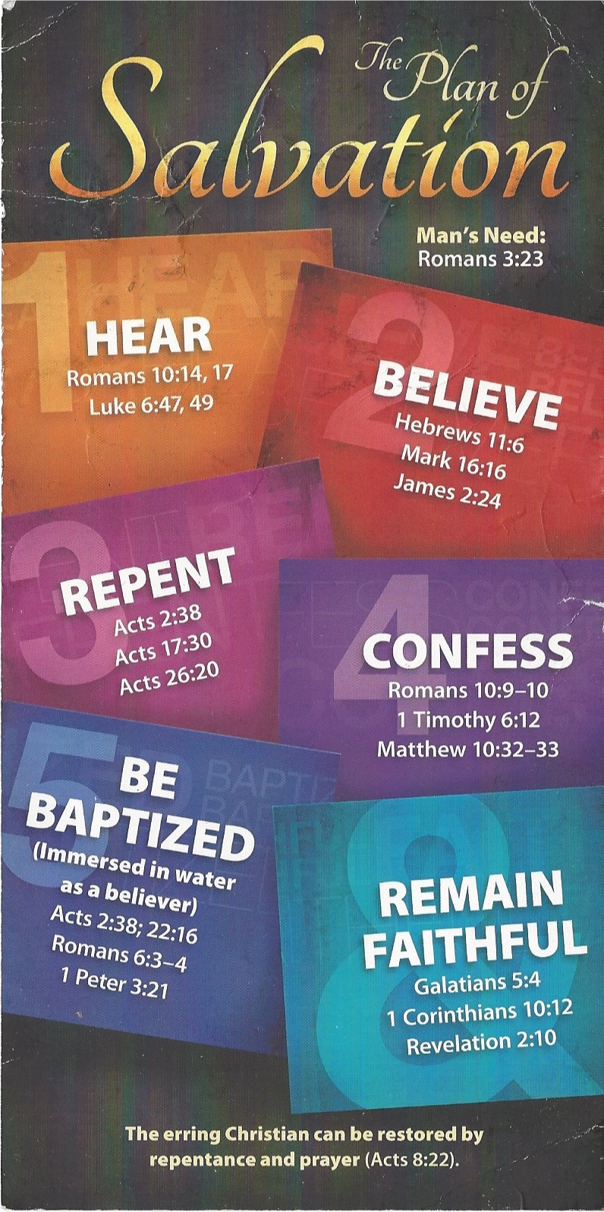
Confess
Romans 10:9–10 (NIV)
⁹ If you declare with your mouth, “Jesus is Lord,” and believe in your heart that God raised him from the dead, you will be saved. ¹⁰ For it is with your heart that you believe and are justified, and it is with your mouth that you profess your faith and are saved.
Be Baptized
1 Peter 3:21 (NIV)
²¹ and this water symbolizes baptism that now saves you also—not the removal of dirt from the body but the pledge of a clear conscience toward God. It saves you by the resurrection of Jesus Christ,
Remain Faithful
Galatians 5:4 (NIV)
⁴ You who are trying to be justified by the law have been alienated from Christ; you have fallen away from grace.

