Barry G. Johnson, Sr. / www.barrygjohnsonsr.com / General
Discovering the Church / Edification; Edify; Strength / Acts 18:18–23
The church is edified through God’s word, through the Holy Spirit and spiritual gifts, through the church’s appointed ministries and through the mutual love, support, and encouragement of its members.
Acts 18:18–23 (ESV)
¹⁸ After this, Paul stayed many days longer and then took leave of the brothers and set sail for Syria, and with him Priscilla and Aquila. At Cenchreae he had cut his hair, for he was under a vow. ¹⁹ And they came to Ephesus, and he left them there, but he himself went into the synagogue and reasoned with the Jews. ²⁰ When they asked him to stay for a longer period, he declined. ²¹ But on taking leave of them he said, “I will return to you if God wills,” and he set sail from Ephesus.
²² When he had landed at Caesarea, he went up and greeted the church, and then went down to Antioch. ²³ After spending some time there, he departed and went from one place to the next through the region of Galatia and Phrygia, strengthening all the disciples.
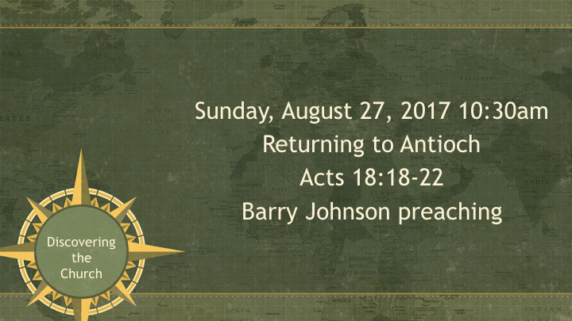

I. God edifies strengthening His people
Isaiah 40:29–31 ESV
²⁹ He gives power to the faint, and to him who has no might he increases strength. ³⁰ Even youths shall faint and be weary, and young men shall fall exhausted; ³¹ but they who wait for the Lord shall renew their strength; they shall mount up with wings like eagles; they shall run and not be weary; they shall walk and not faint.
2 Thessalonians 3:3 ESV
³ But the Lord is faithful. He will establish you and guard you against the evil one.

II. The edification of believers

A. God builds
1 Peter 2:4–5 ESV
⁴ As you come to him, a living stone rejected by men but in the sight of God chosen and precious, ⁵ you yourselves like living stones are being built up as a spiritual house, to be a holy priesthood, to offer spiritual sacrifices acceptable to God through Jesus Christ.

B. Believers build
Jude 20 ESV
²⁰ But you, beloved, building yourselves up in your most holy faith and praying in the Holy Spirit,

C. One another building
Ephesians 4:29 ESV
²⁹ Let no corrupting talk come out of your mouths, but only such as is good for building up, as fits the occasion, that it may give grace to those who hear.
Hebrews 3:13 ESV
¹³ But exhort one another every day, as long as it is called “today,” that none of you may be hardened by the deceitfulness of sin.

III. The means of edification

A. God’s word
Acts 20:32 ESV
³² And now I commend you to God and to the word of his grace, which is able to build you up and to give you the inheritance among all those who are sanctified.

B. The Holy Spirit
Ephesians 3:16 ESV
¹⁶ that according to the riches of his glory he may grant you to be strengthened with power through his Spirit in your inner being,

C. Spiritual gifts
1 Corinthians 14:26 ESV
²⁶ What then, brothers? When you come together, each one has a hymn, a lesson, a revelation, a tongue, or an interpretation. Let all things be done for building up.

D. Ministry
Ephesians 4:11–12 ESV
¹¹ And he gave the apostles, the prophets, the evangelists, the shepherds and teachers, ¹² to equip the saints for the work of ministry, for building up the body of Christ,

E. Love and encouragement
Ephesians 4:15–16 ESV
¹⁵ Rather, speaking the truth in love, we are to grow up in every way into him who is the head, into Christ, ¹⁶ from whom the whole body, joined and held together by every joint with which it is equipped, when each part is working properly, makes the body grow so that it builds itself up in love.
1 Thessalonians 5:11 ESV
¹¹ Therefore encourage one another and build one another up, just as you are doing.

IV. The goal of edification
Ephesians 3:13 ESV
¹³ So I ask you not to lose heart over what I am suffering for you, which is your glory.

Edification results in spiritual discernment:
Ephesians 4:14 ESV
¹⁴ so that we may no longer be children, tossed to and fro by the waves and carried about by every wind of doctrine, by human cunning, by craftiness in deceitful schemes.
Philippians 1:9–10 ESV
⁹ And it is my prayer that your love may abound more and more, with knowledge and all discernment, ¹⁰ so that you may approve what is excellent, and so be pure and blameless for the day of Christ,
HEAR
Romans 10:17 (ESV)
¹⁷ So faith comes from hearing, and hearing through the word of Christ.

BELIEVE
Mark 16:16 (ESV)
¹⁶ Whoever believes and is baptized will be saved, but whoever does not believe will be condemned.

REPENT
Acts 17:30 (ESV)
³⁰ The times of ignorance God overlooked, but now he commands all people everywhere to repent,

CONFESS
1 Timothy 6:12 (ESV)
¹² Fight the good fight of the faith. Take hold of the eternal life to which you were called and about which you made the good confession in the presence of many witnesses.

BE BAPTIZED
Romans 6:4 (ESV)
⁴ We were buried therefore with him by baptism into death, in order that, just as Christ was raised from the dead by the glory of the Father, we too might walk in newness of life.

REMAIN FAITHFUL
Revelation 2:10 (ESV)
¹⁰ Do not fear what you are about to suffer. Behold, the devil is about to throw some of you into prison, that you may be tested, and for ten days you will have tribulation. Be faithful unto death, and I will give you the crown of life.

