Barry G. Johnson, Sr. / www.bgjsr22.com
Questions Asked of Jesus / Question; Doubt; Unbelief / Matthew 11:2–3
Believers may go through periods of doubt and indecision, especially on account of difficulties in trusting God or accepting certain aspects of his will for them.
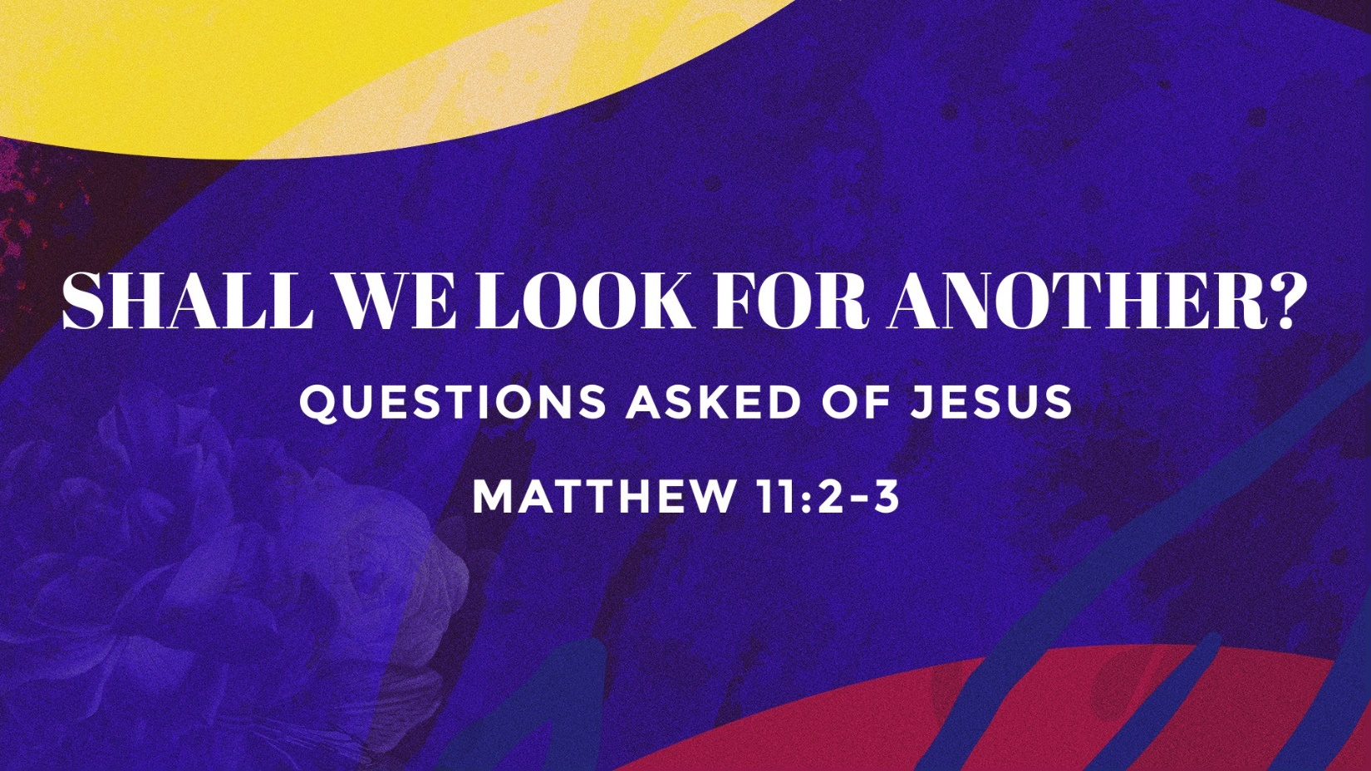

Unbelief of Believers

Abraham
Genesis 17:17 ESV
¹⁷ Then Abraham fell on his face and laughed and said to himself, “Shall a child be born to a man who is a hundred years old? Shall Sarah, who is ninety years old, bear a child?”

Sarah
Genesis 18:13–14 ESV
¹³ The Lord said to Abraham, “Why did Sarah laugh and say, ‘Shall I indeed bear a child, now that I am old?’ ¹⁴ Is anything too hard for the Lord? At the appointed time I will return to you, about this time next year, and Sarah shall have a son.”

Moses
Numbers 11:21–22 ESV
²¹ But Moses said, “The people among whom I am number six hundred thousand on foot, and you have said, ‘I will give them meat, that they may eat a whole month!’ ²² Shall flocks and herds be slaughtered for them, and be enough for them? Or shall all the fish of the sea be gathered together for them, and be enough for them?”

Gideon
Judges 6:12–13 ESV
¹² And the angel of the Lord appeared to him and said to him, “The Lord is with you, O mighty man of valor.” ¹³ And Gideon said to him, “Please, my lord, if the Lord is with us, why then has all this happened to us? And where are all his wonderful deeds that our fathers recounted to us, saying, ‘Did not the Lord bring us up from Egypt?’ But now the Lord has forsaken us and given us into the hand of Midian.”

Elisha’s servant
2 Kings 4:42–44 ESV
⁴² A man came from Baal-shalishah, bringing the man of God bread of the firstfruits, twenty loaves of barley and fresh ears of grain in his sack. And Elisha said, “Give to the men, that they may eat.” ⁴³ But his servant said, “How can I set this before a hundred men?” So he repeated, “Give them to the men, that they may eat, for thus says the Lord, ‘They shall eat and have some left.’ ” ⁴⁴ So he set it before them. And they ate and had some left, according to the word of the Lord.

Zechariah
Luke 1:20 ESV
²⁰ And behold, you will be silent and unable to speak until the day that these things take place, because you did not believe my words, which will be fulfilled in their time.”

John the Baptist
Matthew 11:3 ESV
³ and said to him, “Are you the one who is to come, or shall we look for another?”

Why People Look for Another

Doubt Concerning Jesus Christ’s Power
Matthew 8:24–26 ESV
²⁴ And behold, there arose a great storm on the sea, so that the boat was being swamped by the waves; but he was asleep. ²⁵ And they went and woke him, saying, “Save us, Lord; we are perishing.” ²⁶ And he said to them, “Why are you afraid, O you of little faith?” Then he rose and rebuked the winds and the sea, and there was a great calm.
Matthew 14:26 ESV
²⁶ But when the disciples saw him walking on the sea, they were terrified, and said, “It is a ghost!” and they cried out in fear.
Matthew 14:29–31 ESV
²⁹ He said, “Come.” So Peter got out of the boat and walked on the water and came to Jesus. ³⁰ But when he saw the wind, he was afraid, and beginning to sink he cried out, “Lord, save me.” ³¹ Jesus immediately reached out his hand and took hold of him, saying to him, “O you of little faith, why did you doubt?”
Matthew 16:8–10 ESV
⁸ But Jesus, aware of this, said, “O you of little faith, why are you discussing among yourselves the fact that you have no bread? ⁹ Do you not yet perceive? Do you not remember the five loaves for the five thousand, and how many baskets you gathered? ¹⁰ Or the seven loaves for the four thousand, and how many baskets you gathered?

Doubt Concerning Jesus Christ’s Resurrection
Mark 16:14 ESV
¹⁴ Afterward he appeared to the eleven themselves as they were reclining at table, and he rebuked them for their unbelief and hardness of heart, because they had not believed those who saw him after he had risen.
Luke 24:25 ESV
²⁵ And he said to them, “O foolish ones, and slow of heart to believe all that the prophets have spoken!

Doubt Concerning Jesus Christ’s Claims
Matthew 17:17 ESV
¹⁷ And Jesus answered, “O faithless and twisted generation, how long am I to be with you? How long am I to bear with you? Bring him here to me.”
John 6:60 ESV
⁶⁰ When many of his disciples heard it, they said, “This is a hard saying; who can listen to it?”
John 8:24 ESV
²⁴ I told you that you would die in your sins, for unless you believe that I am he you will die in your sins.”

Encouragements in Overcoming Unbelief
Matthew 11:4–6 ESV
⁴ And Jesus answered them, “Go and tell John what you hear and see: ⁵ the blind receive their sight and the lame walk, lepers are cleansed and the deaf hear, and the dead are raised up, and the poor have good news preached to them. ⁶ And blessed is the one who is not offended by me.”
Romans 4:20 ESV
²⁰ No unbelief made him waver concerning the promise of God, but he grew strong in his faith as he gave glory to God,

God’s Plan of Salvation
