Saul the Basket Case
Saul the Basket Case
Barry G. Johnson, Sr. / General
Discovering the Church / Persecution; Paul; Basket; Ark of Bulrushes / Acts 9:23–25
Saul moves from persecutor to persecuted.

Acts 9:23–25 ESV
²³ When many days had passed, the Jews plotted to kill him, ²⁴ but their plot became known to Saul. They were watching the gates day and night in order to kill him, ²⁵ but his disciples took him by night and let him down through an opening in the wall, lowering him in a basket.
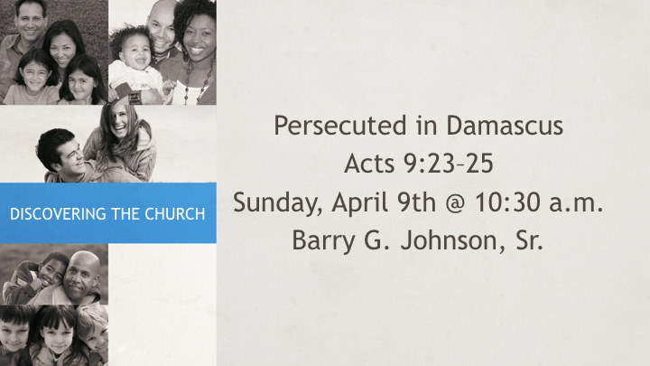

I. Same old plan
Acts 9:23 ESV
²³ When many days had passed, the Jews plotted to kill him,
Acts 9:24 ESV
²⁴ but their plot became known to Saul. They were watching the gates day and night in order to kill him, Remember how they desired to do the same to Jesus...
Matthew 26:3–4 ESV
³ Then the chief priests and the elders of the people gathered in the palace of the high priest, whose name was Caiaphas, ⁴ and plotted together in order to arrest Jesus by stealth and kill him.
John 11:51–53 ESV
⁵¹ He did not say this of his own accord, but being high priest that year he prophesied that Jesus would die for the nation, ⁵² and not for the nation only, but also to gather into one the children of God who are scattered abroad. ⁵³ So from that day on they made plans to put him to death.
Acts 23:12 ESV
¹² When it was day, the Jews made a plot and bound themselves by an oath neither to eat nor drink till they had killed Paul.

II. Enemies to Allies
Acts 9:25 ESV
²⁵ but his disciples took him by night and let him down through an opening in the wall, lowering him in a basket.
Romans 8:7–8 ESV
⁷ For the mind that is set on the flesh is hostile to God, for it does not submit to God’s law; indeed, it cannot. ⁸ Those who are in the flesh cannot please God.
James 4:4 ESV
⁴ You adulterous people! Do you not know that friendship with the world is enmity with God? Therefore whoever wishes to be a friend of the world makes himself an enemy of God.
The enemies of God are _______________ , the allies of God are _______________ .
1 Corinthians 2:14 ESV
¹⁴ The natural person does not accept the things of the Spirit of God, for they are folly to him, and he is not able to understand them because they are spiritually discerned.
A lot of us try to straddle the fence. We try being both natural and spiritual. That is a war going on where you must choose a side.
Matthew 6:24 ESV
²⁴ “No one can serve two masters, for either he will hate the one and love the other, or he will be devoted to the one and despise the other. You cannot serve God and money.

III. Another Basket Deliverance
Acts 9:25 ESV
²⁵ but his disciples took him by night and let him down through an opening in the wall, lowering him in a basket.
What other popular Bible character was saved using a basket? _______________
Genesis 6:14 ESV
¹⁴ Make yourself an ark of gopher wood. Make rooms in the ark, and cover it inside and out with pitch.
Exodus 2:3 ESV
³ When she could hide him no longer, she took for him a basket made of bulrushes and daubed it with bitumen and pitch. She put the child in it and placed it among the reeds by the river bank.
2 Corinthians 11:33 ESV
³³ but I was let down in a basket through a window in the wall and escaped his hands.
1 Peter 3:18–22 ESV
¹⁸ For Christ also suffered once for sins, the righteous for the unrighteous, that he might bring us to God, being put to death in the flesh but made alive in the spirit, ¹⁹ in which he went and proclaimed to the spirits in prison, ²⁰ because they formerly did not obey, when God’s patience waited in the days of Noah, while the ark was being prepared, in which a few, that is, eight persons, were brought safely through water. ²¹ Baptism, which corresponds to this, now saves you, not as a removal of dirt from the body but as an appeal to God for a good conscience, through the resurrection of Jesus Christ, ²² who has gone into heaven and is at the right hand of God, with angels, authorities, and powers having been subjected to him.

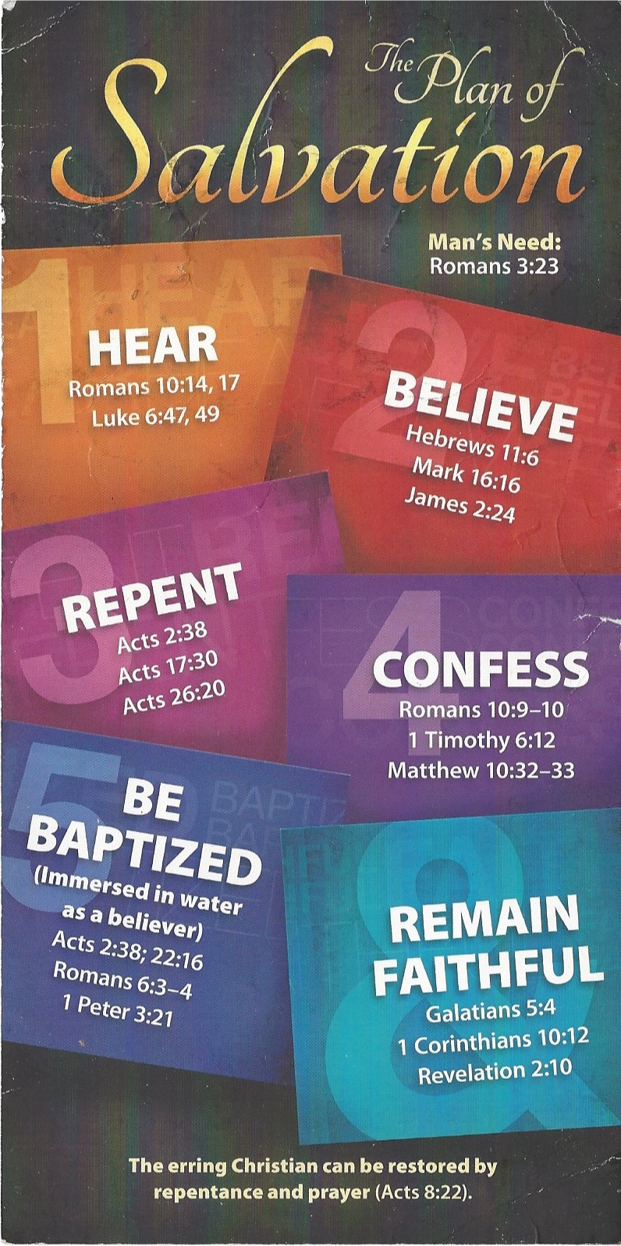
Hear - Romans 10:17 (NIV)
¹⁷ Consequently, faith comes from hearing the message, and the message is heard through the word about Christ.
Believe - Hebrews 11:6 (NIV)
⁶ And without faith it is impossible to please God, because anyone who comes to him must believe that he exists and that he rewards those who earnestly seek him.
Repent - Acts 17:30 (NIV)
³⁰ In the past God overlooked such ignorance, but now he commands all people everywhere to repent.
Confess - 1 Timothy 6:12 (NIV)
¹² Fight the good fight of the faith. Take hold of the eternal life to which you were called when you made your good confession in the presence of many witnesses.
Be Baptized - Acts 2:38 (ESV)
³⁸ And Peter said to them, “Repent and be baptized every one of you in the name of Jesus Christ for the forgiveness of your sins, and you will receive the gift of the Holy Spirit.
Remain Steadfast - Revelation 2:10 (NIV)
¹⁰ Do not be afraid of what you are about to suffer. I tell you, the devil will put some of you in prison to test you, and you will suffer persecution for ten days. Be faithful, even to the point of death, and I will give you life as your victor’s crown.

