Barry G. Johnson, Sr. / www.barrygjohnsonsr.com
Discovering the Church / Safety; Eternal Security; Secure; Assurance / Acts 27:39–44
God promises to keep his people from all lasting spiritual and physical danger; he requires, however, that his people act responsibly.
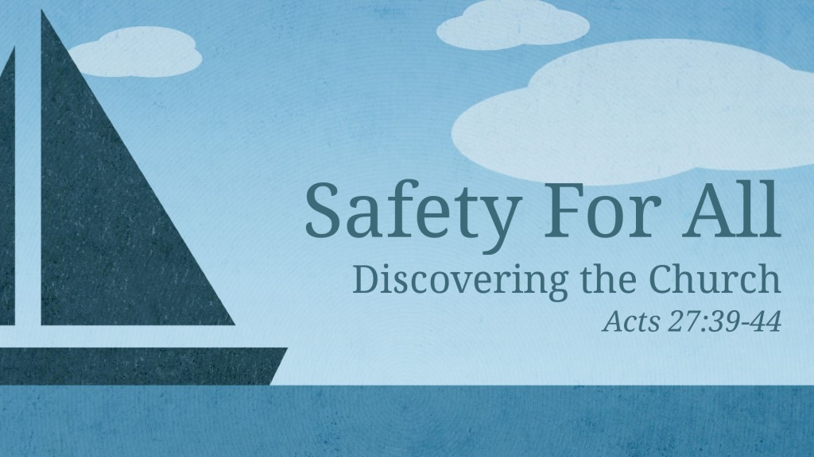
Acts 27:39–44 (ESV)
³⁹ Now when it was day, they did not recognize the land, but they noticed a bay with a beach, on which they planned if possible to run the ship ashore. ⁴⁰ So they cast off the anchors and left them in the sea, at the same time loosening the ropes that tied the rudders. Then hoisting the foresail to the wind they made for the beach. ⁴¹ But striking a reef, they ran the vessel aground. The bow stuck and remained immovable, and the stern was being broken up by the surf. ⁴² The soldiers’ plan was to kill the prisoners, lest any should swim away and escape. ⁴³ But the centurion, wishing to save Paul, kept them from carrying out their plan. He ordered those who could swim to jump overboard first and make for the land, ⁴⁴ and the rest on planks or on pieces of the ship. And so it was that all were brought safely to land.

I. God promises safety

A. To his people
Deuteronomy 12:10 ESV
But when you go over the Jordan and live in the land that the Lord your God is giving you to inherit, and when he gives you rest from all your enemies around, so that you live in safety,
Romans 8:31 ESV
What then shall we say to these things? If God is for us, who can be against us?

B. To those who trust in him
Psalm 37:3 ESV
Trust in the Lord, and do good; dwell in the land and befriend faithfulness.
Proverbs 18:10 ESV
The name of the Lord is a strong tower; the righteous man runs into it and is safe.
Proverbs 29:25 ESV
The fear of man lays a snare, but whoever trusts in the Lord is safe.

C. To those who obey him
Leviticus 25:18–19 ESV
“Therefore you shall do my statutes and keep my rules and perform them, and then you will dwell in the land securely. The land will yield its fruit, and you will eat your fill and dwell in it securely.

D. To those in need
Job 5:11 ESV
he sets on high those who are lowly, and those who mourn are lifted to safety.
Job 5:15 ESV
But he saves the needy from the sword of their mouth and from the hand of the mighty.
Isaiah 14:30 ESV
And the firstborn of the poor will graze, and the needy lie down in safety; but I will kill your root with famine, and your remnant it will slay.

E. But not to the wicked
Proverbs 28:18 ESV
Whoever walks in integrity will be delivered, but he who is crooked in his ways will suddenly fall.

II. Safety from enemies
Hebrews 13:6 ESV
So we can confidently say, “The Lord is my helper; I will not fear; what can man do to me?”

III. Perfect safety in God’s kingdom
Matthew 16:18 ESV
And I tell you, you are Peter, and on this rock I will build my church, and the gates of hell shall not prevail against it.

IV. Spiritual safety
1 John 5:18 ESV
We know that everyone who has been born of God does not keep on sinning, but he who was born of God protects him, and the evil one does not touch him.
2 Timothy 4:18 ESV
The Lord will rescue me from every evil deed and bring me safely into his heavenly kingdom. To him be the glory forever and ever. Amen.
Revelation 2:11 ESV
He who has an ear, let him hear what the Spirit says to the churches. The one who conquers will not be hurt by the second death.’

V. Human responsibility for safety

A. Personal
Matthew 24:15–16 ESV
“So when you see the abomination of desolation spoken of by the prophet Daniel, standing in the holy place (let the reader understand), then let those who are in Judea flee to the mountains.
Acts 2:40 ESV
And with many other words he bore witness and continued to exhort them, saying, “Save yourselves from this crooked generation.”
Acts 27:44 ESV
and the rest on planks or on pieces of the ship. And so it was that all were brought safely to land.

B. Family
Genesis 4:9 ESV
Then the Lord said to Cain, “Where is Abel your brother?” He said, “I do not know; am I my brother’s keeper?”
Genesis 43:9 ESV
I will be a pledge of his safety. From my hand you shall require him. If I do not bring him back to you and set him before you, then let me bear the blame forever.
Matthew 2:13 ESV
Now when they had departed, behold, an angel of the Lord appeared to Joseph in a dream and said, “Rise, take the child and his mother, and flee to Egypt, and remain there until I tell you, for Herod is about to search for the child, to destroy him.”

C. Church Leadership
Hebrews 13:17 ESV
Obey your leaders and submit to them, for they are keeping watch over your souls, as those who will have to give an account. Let them do this with joy and not with groaning, for that would be of no advantage to you.
John 10:11–15 ESV
I am the good shepherd. The good shepherd lays down his life for the sheep. He who is a hired hand and not a shepherd, who does not own the sheep, sees the wolf coming and leaves the sheep and flees, and the wolf snatches them and scatters them. He flees because he is a hired hand and cares nothing for the sheep. I am the good shepherd. I know my own and my own know me, just as the Father knows me and I know the Father; and I lay down my life for the sheep.
Acts 20:28 ESV
Pay careful attention to yourselves and to all the flock, in which the Holy Spirit has made you overseers, to care for the church of God, which he obtained with his own blood.

VI. Dangers inherent in safety

A. False security
1 Thessalonians 5:3 ESV
While people are saying, “There is peace and security,” then sudden destruction will come upon them as labor pains come upon a pregnant woman, and they will not escape.

B. Complacency
Proverbs 1:32 ESV
For the simple are killed by their turning away, and the complacency of fools destroys them;

C. Wickedness
Jeremiah 7:9–10 ESV
Will you steal, murder, commit adultery, swear falsely, make offerings to Baal, and go after other gods that you have not known, and then come and stand before me in this house, which is called by my name, and say, ‘We are delivered!’—only to go on doing all these abominations?

Greatest Safety in God’s Plan of Salvation

Hear
Romans 10:17 ESV
So faith comes from hearing, and hearing through the word of Christ.

Believe
Hebrews 11:6 ESV
And without faith it is impossible to please him, for whoever would draw near to God must believe that he exists and that he rewards those who seek him.

Repent
Luke 13:3 ESV
No, I tell you; but unless you repent, you will all likewise perish.

Confess
Romans 10:9–10 ESV
because, if you confess with your mouth that Jesus is Lord and believe in your heart that God raised him from the dead, you will be saved. For with the heart one believes and is justified, and with the mouth one confesses and is saved.

Be Baptized
Acts 22:10 ESV
And I said, ‘What shall I do, Lord?’ And the Lord said to me, ‘Rise, and go into Damascus, and there you will be told all that is appointed for you to do.’
Acts 22:16 ESV
And now why do you wait? Rise and be baptized and wash away your sins, calling on his name.’

Remain Faithful
Revelation 2:10 ESV
Do not fear what you are about to suffer. Behold, the devil is about to throw some of you into prison, that you may be tested, and for ten days you will have tribulation. Be faithful unto death, and I will give you the crown of life.

