Barry G. Johnson, Sr. / www.barrygjohnsonsr.com
Judges: A Modern-Day Cycle? / Admonish; Rebuke; Training; Teaching; Counseling / Judges 6:7–10
A loving attempt to correct another’s attitude or behavior.
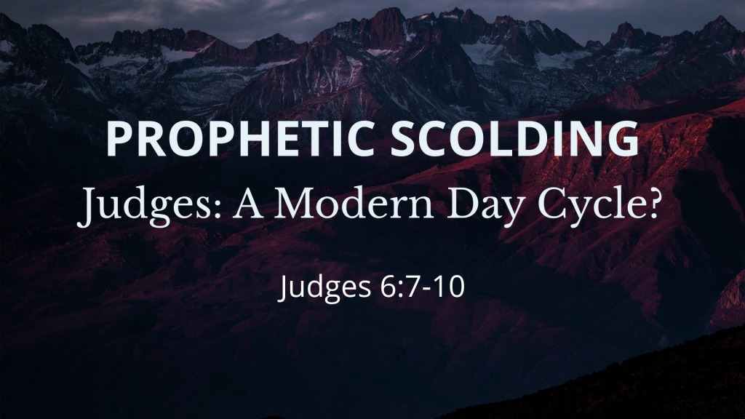

The prophets admonished Israel
2 Kings 17:13 ESV
¹³ Yet the Lord warned Israel and Judah by every prophet and every seer, saying, “Turn from your evil ways and keep my commandments and my statutes, in accordance with all the Law that I commanded your fathers, and that I sent to you by my servants the prophets.”
Nehemiah 9:29–30 ESV
²⁹ And you warned them in order to turn them back to your law. Yet they acted presumptuously and did not obey your commandments, but sinned against your rules, which if a person does them, he shall live by them, and they turned a stubborn shoulder and stiffened their neck and would not obey. ³⁰ Many years you bore with them and warned them by your Spirit through your prophets. Yet they would not give ear. Therefore you gave them into the hand of the peoples of the lands.

Parents are to admonish their children
Proverbs 22:6 ESV
⁶ Train up a child in the way he should go;
even when he is old he will not depart from it.
Ephesians 6:4 ESV
⁴ Fathers, do not provoke your children to anger, but bring them up in the discipline and instruction of the Lord.

Leaders are to admonish those in their care
2 Timothy 4:2 ESV
² preach the word; be ready in season and out of season; reprove, rebuke, and exhort, with complete patience and teaching.

Christians are to admonish fellow believers
Colossians 3:16 ESV
¹⁶ Let the word of Christ dwell in you richly, teaching and admonishing one another in all wisdom, singing psalms and hymns and spiritual songs, with thankfulness in your hearts to God.

It is wise to accept legitimate admonition
Proverbs 13:18 ESV
¹⁸ Poverty and disgrace come to him who ignores instruction,
but whoever heeds reproof is honored.
Ecclesiastes 7:5 ESV
⁵ It is better for a man to hear the rebuke of the wise
than to hear the song of fools.
Jeremiah 7:28 ESV
²⁸ And you shall say to them, ‘This is the nation that did not obey the voice of the Lord their God, and did not accept discipline; truth has perished; it is cut off from their lips.
Zephaniah 3:1–2 ESV
¹ Woe to her who is rebellious and defiled,
the oppressing city!
² She listens to no voice;
she accepts no correction.
She does not trust in the Lord;
she does not draw near to her God.

The Instruction of the Beginning of Salvation

To Hear - To Believe - To Repent - To Confess - To Be Baptized - To Remain Faithful
1 Thessalonians 2:13 ESV
¹³ And we also thank God constantly for this, that when you received the word of God, which you heard from us, you accepted it not as the word of men but as what it really is, the word of God, which is at work in you believers.
Matthew 21:32 ESV
³² For John came to you in the way of righteousness, and you did not believe him, but the tax collectors and the prostitutes believed him. And even when you saw it, you did not afterward change your minds and believe him.
Luke 13:3 ESV
³ No, I tell you; but unless you repent, you will all likewise perish.
1 John 2:23 ESV
²³ No one who denies the Son has the Father. Whoever confesses the Son has the Father also.
Acts 22:16 ESV
¹⁶ And now why do you wait? Rise and be baptized and wash away your sins, calling on his name.’
Acts 11:23 ESV
²³ When he came and saw the grace of God, he was glad, and he exhorted them all to remain faithful to the Lord with steadfast purpose,

