Barry G. Johnson, Sr. / www.barrygjohnsonsr.com
Natural Evangelism: Words of Encouragement / Evangelism; Labor; Work; A Worker / Matthew 9:35–38
God has done His part by preparing the field. Let's do ours by doing the work of a faithful laborer.
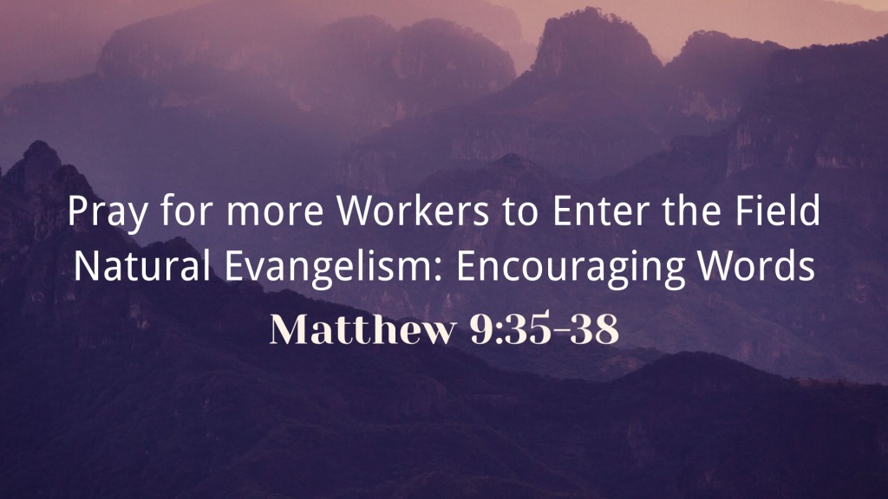
Matthew 9:35–38 ESV
³⁵ And Jesus went throughout all the cities and villages, teaching in their synagogues and proclaiming the gospel of the kingdom and healing every disease and every affliction. ³⁶ When he saw the crowds, he had compassion for them, because they were harassed and helpless, like sheep without a shepherd. ³⁷ Then he said to his disciples, “The harvest is plentiful, but the laborers are few; ³⁸ therefore pray earnestly to the Lord of the harvest to send out laborers into his harvest.”

The need for laborers
Romans 10:14–15 ESV
¹⁴ How then will they call on him in whom they have not believed? And how are they to believe in him of whom they have never heard? And how are they to hear without someone preaching? ¹⁵ And how are they to preach unless they are sent? As it is written, “How beautiful are the feet of those who preach the good news!”
Isaiah 52:7 ESV
⁷ How beautiful upon the mountains
are the feet of him who brings good news,
who publishes peace, who brings good news of happiness,
who publishes salvation,
who says to Zion, “Your God reigns.”

The work of laborers

Proclaim the Good News
Acts 8:12 ESV
¹² But when they believed Philip as he preached good news about the kingdom of God and the name of Jesus Christ, they were baptized, both men and women.
Be sure to read my blog on May 17th entitled “What is Evil?”
www.barrygjohnsonsr.com/blog

Calling people to turn to God
2 Corinthians 5:19–20 ESV
¹⁹ that is, in Christ God was reconciling the world to himself, not counting their trespasses against them, and entrusting to us the message of reconciliation. ²⁰ Therefore, we are ambassadors for Christ, God making his appeal through us. We implore you on behalf of Christ, be reconciled to God.

Announce judgement
Acts 10:42 ESV
⁴² And he commanded us to preach to the people and to testify that he is the one appointed by God to be judge of the living and the dead.

Teaching and Baptizing new believers
Matthew 28:19–20 ESV
¹⁹ Go therefore and make disciples of all nations, baptizing them in the name of the Father and of the Son and of the Holy Spirit, ²⁰ teaching them to observe all that I have commanded you. And behold, I am with you always, to the end of the age.”

Expanding the Mission field
2 Corinthians 10:15–16 ESV
¹⁵ We do not boast beyond limit in the labors of others. But our hope is that as your faith increases, our area of influence among you may be greatly enlarged, ¹⁶ so that we may preach the gospel in lands beyond you, without boasting of work already done in another’s area of influence.

Strengthening one another
Acts 18:23 ESV
²³ After spending some time there, he departed and went from one place to the next through the region of Galatia and Phrygia, strengthening all the disciples.
Join us for our next Book Club Topic Saturday, June 29th at 12:00 p.m.
Lunch will be served

God’s Salvation Invitation

Hear - Believe - Confess - Repent - Be Baptized - Be Faithful
‌Matthew 7:24 ESV24 “Everyone then who hears these words of mine and does them will be like a wise man who built his house on the rock.
‌John 1:12 ESV12 But to all who did receive him, who believed in his name, he gave the right to become children of God,
‌1 John 2:23 ESV23 No one who denies the Son has the Father. Whoever confesses the Son has the Father also.
‌Luke 13:3 ESV3 No, I tell you; but unless you repent, you will all likewise perish.
‌Galatians 3:27 ESV27 For as many of you as were baptized into Christ have put on Christ.
‌James 1:3–4 ESV3 for you know that the testing of your faith produces steadfastness. 4 And let steadfastness have its full effect, that you may be perfect and complete, lacking in nothing.

