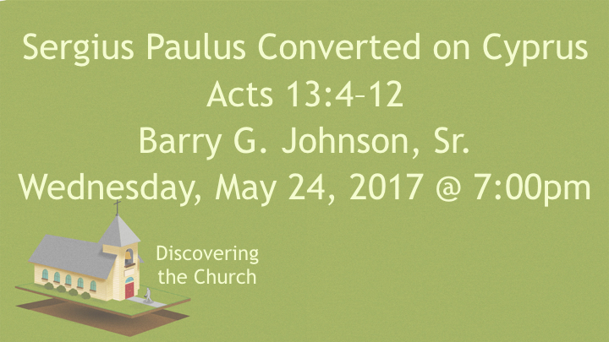
Barry G. Johnson, Sr. / General
Discovering the Church / Cyprus; Sergius Paulus; Bar-Jesus; Paul; Barnabas; John Mark; False Prophet; Divination / Acts 13:4–12

Not even the darkness of false prophecy and prophets will impede the Word of God.

Sailing to Cyprus
ref. Acts 13:4; 11:19-20
Who is behind this missionary journey?

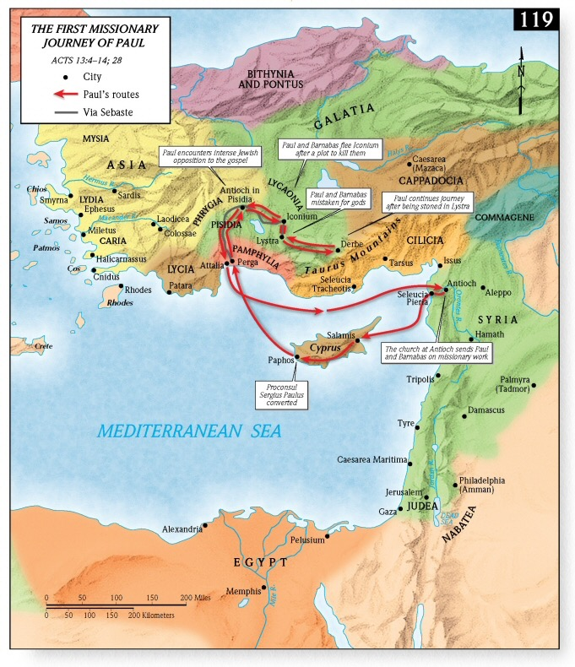

Proclaiming the Word of God
ref. Acts 13:5
What was Paul’s practice when he came to a new place?

Sought to hear the Word of God
ref. Acts 13:6-7; Dt. 18:9-12; Lev. 20:6; Rev. 21:8; Gal. 5:19-21; 1 Chr. 10:13-14
What type of prophet does the Bible call Bar-Jesus?

What kind of man does the Bible call Sergius Paulus?

Is it ok for Christians to consult Diviners such as Witches; Sorcerers; Horoscopes; etc.?

Son of the Devil
ref. Acts 13:8-10
What are some motives of Elymas to turn the Proconsul from the faith?

Darkness fell upon him
ref. Acts 13:11
Who else had experienced blindness as the result of defying God?

The teaching of the Lord
ref. Acts 13:12
What converted the Proconsul to the faith? Was it the miracle or the Word?

Barnabas and Saul on Cyprus (Acts 13:4–12)

