Is There Another Cure for Mans Most Serious Disease?
Barry G. Johnson, Sr. / www.barrygjohnsonsr.com
Has Man Outgrown the Gospel? / Gospel; Balm; Disease; Medicine / Isaiah 1:1–6
The only antidote for the greatest disease of man has Gospel written all over it.
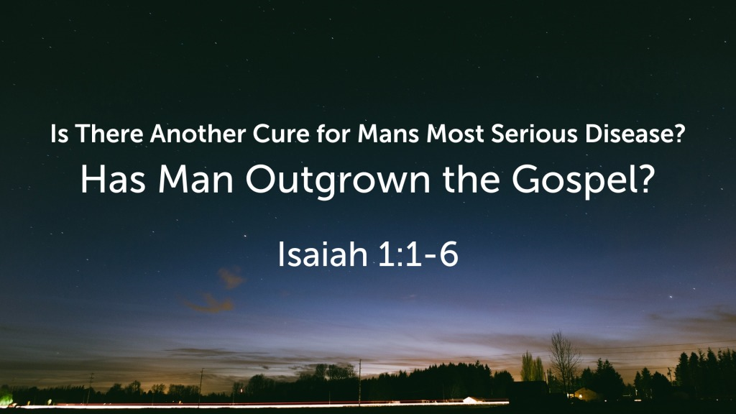
Isaiah 1:1–6 ESV

¹ The vision of Isaiah the son of Amoz, which he saw concerning Judah and Jerusalem in the days of Uzziah, Jotham, Ahaz, and Hezekiah, kings of Judah.
² Hear, O heavens, and give ear, O earth;
for the Lord has spoken:
“Children have I reared and brought up,
but they have rebelled against me.
³ The ox knows its owner,
and the donkey its master’s crib,
but Israel does not know,
my people do not understand.”
⁴ Ah, sinful nation,
a people laden with iniquity,
offspring of evildoers,
children who deal corruptly!
They have forsaken the Lord,
they have despised the Holy One of Israel,
they are utterly estranged.
⁵ Why will you still be struck down?
Why will you continue to rebel?
The whole head is sick,
and the whole heart faint.
⁶ From the sole of the foot even to the head,
there is no soundness in it,
but bruises and sores
and raw wounds;
they are not pressed out or bound up
or softened with oil.

Has Man Outgrown the Gospel?

NOT UNLESS HE HAS FOUND ANOTHER CURE FOR MAN'S MOST SERIOUS DISEASE
I. A cure for sin (forgiveness) is still man's most basic spiritual need
Romans 3:23 ESV
²³ for all have sinned and fall short of the glory of God,
Romans 6:23 ESV
²³ For the wages of sin is death, but the free gift of God is eternal life in Christ Jesus our Lord.
Isaiah 1:6 ESV
⁶ From the sole of the foot even to the head,
there is no soundness in it,
but bruises and sores
and raw wounds;
they are not pressed out or bound up
or softened with oil.
Jeremiah 8:22 ESV
²² Is there no balm in Gilead?
Is there no physician there?
Why then has the health of the daughter of my people
not been restored?
Jeremiah 46:11 ESV
¹¹ Go up to Gilead, and take balm,
O virgin daughter of Egypt!
In vain you have used many medicines;
there is no healing for you.
II. The only antidote has "Gospel" on the label
Romans 1:16 ESV
¹⁶ For I am not ashamed of the gospel, for it is the power of God for salvation to everyone who believes, to the Jew first and also to the Greek.
Romans 3:23 ESV
²³ for all have sinned and fall short of the glory of God,
1 John 2:15 ESV
¹⁵ Do not love the world or the things in the world. If anyone loves the world, the love of the Father is not in him.
Hebrews 4:12 ESV
¹² For the word of God is living and active, sharper than any two-edged sword, piercing to the division of soul and of spirit, of joints and of marrow, and discerning the thoughts and intentions of the heart.
1 Timothy 1:18 ESV
¹⁸ This charge I entrust to you, Timothy, my child, in accordance with the prophecies previously made about you, that by them you may wage the good warfare,
Ephesians 6:17 ESV
¹⁷ and take the helmet of salvation, and the sword of the Spirit, which is the word of God,
III. The Reality of Sin has not Changed
Isaiah 5:20 ESV
²⁰ Woe to those who call evil good
and good evil,
who put darkness for light
and light for darkness,
who put bitter for sweet
and sweet for bitter!
1 John 2:4 ESV
⁴ Whoever says “I know him” but does not keep his commandments is a liar, and the truth is not in him,
Romans 14:23 ESV
²³ But whoever has doubts is condemned if he eats, because the eating is not from faith. For whatever does not proceed from faith is sin.
James 4:17 ESV
¹⁷ So whoever knows the right thing to do and fails to do it, for him it is sin.
1 John 5:17 ESV
¹⁷ All wrongdoing is sin, but there is sin that does not lead to death.

We all need the cure that only the Gospel can give
Galatians 1:6–7 ESV
⁶ I am astonished that you are so quickly deserting him who called you in the grace of Christ and are turning to a different gospel— ⁷ not that there is another one, but there are some who trouble you and want to distort the gospel of Christ.
Plan of Salvation
Romans 10:17 ESV
¹⁷ So faith comes from hearing, and hearing through the word of Christ.
Hebrews 11:6 ESV
⁶ And without faith it is impossible to please him, for whoever would draw near to God must believe that he exists and that he rewards those who seek him.
Matthew 10:32–33 ESV
³² So everyone who acknowledges me before men, I also will acknowledge before my Father who is in heaven, ³³ but whoever denies me before men, I also will deny before my Father who is in heaven.
Acts 17:30 ESV
³⁰ The times of ignorance God overlooked, but now he commands all people everywhere to repent,
Romans 6:3 ESV
³ Do you not know that all of us who have been baptized into Christ Jesus were baptized into his death?
1 Corinthians 15:58 ESV
⁵⁸ Therefore, my beloved brothers, be steadfast, immovable, always abounding in the work of the Lord, knowing that in the Lord your labor is not in vain.

