Barry G. Johnson, Sr. / www.barrygjohnsonsr.com
Discovering the Church / Conviction; Convict; Sin; Guilt / Acts 26:9–11
The proving of a person guilty of sin. Scripture stresses that God has declared the guilt, together with its consequences, of sinful humanity. The term can also refer to a state of being convinced; i.e., the holding of a strong belief, especially a conscious awareness of one’s guilt and the atoning death of Jesus Christ as the means of remission of that guilt.
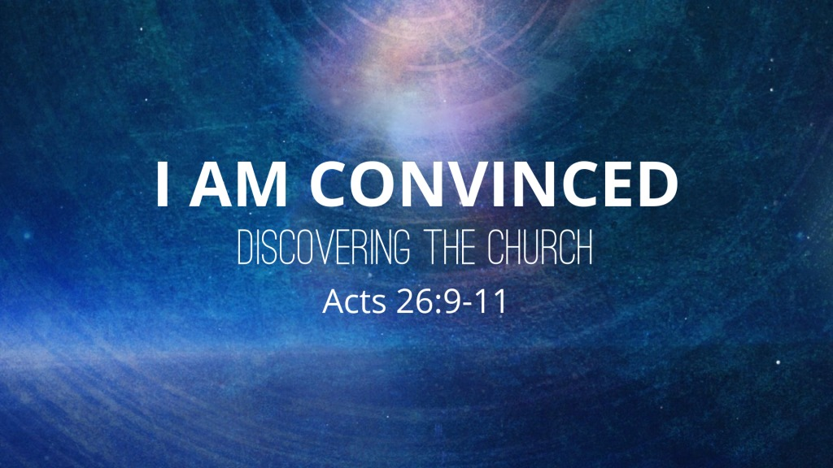
Acts 26:9–11 ESV
⁹ “I myself was convinced that I ought to do many things in opposing the name of Jesus of Nazareth. ¹⁰ And I did so in Jerusalem. I not only locked up many of the saints in prison after receiving authority from the chief priests, but when they were put to death I cast my vote against them. ¹¹ And I punished them often in all the synagogues and tried to make them blaspheme, and in raging fury against them I persecuted them even to foreign cities.

I. Conviction is proving a person guilty of sin
John 8:46 ESV
⁴⁶ Which one of you convicts me of sin? If I tell the truth, why do you not believe me?
1 Corinthians 14:24 ESV
²⁴ But if all prophesy, and an unbeliever or outsider enters, he is convicted by all, he is called to account by all,

II. God’s conviction of sinful humanity

A. He declares them to be guilty
Romans 3:19–20 ESV
¹⁹ Now we know that whatever the law says it speaks to those who are under the law, so that every mouth may be stopped, and the whole world may be held accountable to God. ²⁰ For by works of the law no human being will be justified in his sight, since through the law comes knowledge of sin.
Psalm 14:1–3 ESV
¹ The fool says in his heart, “There is no God.” They are corrupt, they do abominable deeds; there is none who does good. ² The Lord looks down from heaven on the children of man, to see if there are any who understand, who seek after God. ³ They have all turned aside; together they have become corrupt; there is none who does good, not even one.
Ecclesiastes 7:20 ESV
²⁰ Surely there is not a righteous man on earth who does good and never sins.
Isaiah 59:7–8 ESV
⁷ Their feet run to evil, and they are swift to shed innocent blood; their thoughts are thoughts of iniquity; desolation and destruction are in their highways. ⁸ The way of peace they do not know, and there is no justice in their paths; they have made their roads crooked; no one who treads on them knows peace.

B. He also declares the consequences of their guilt
1 Corinthians 15:22 ESV
²² For as in Adam all die, so also in Christ shall all be made alive.

III. Conviction as holding a strong belief
Romans 14:5 ESV
⁵ One person esteems one day as better than another, while another esteems all days alike. Each one should be fully convinced in his own mind.
Matthew 17:20 ESV
²⁰ He said to them, “Because of your little faith. For truly, I say to you, if you have faith like a grain of mustard seed, you will say to this mountain, ‘Move from here to there,’ and it will move, and nothing will be impossible for you.”
Colossians 2:2 ESV
² that their hearts may be encouraged, being knit together in love, to reach all the riches of full assurance of understanding and the knowledge of God’s mystery, which is Christ,
1 Thessalonians 1:5 ESV
⁵ because our gospel came to you not only in word, but also in power and in the Holy Spirit and with full conviction. You know what kind of men we proved to be among you for your sake.
Hebrews 6:11 ESV
¹¹ And we desire each one of you to show the same earnestness to have the full assurance of hope until the end,
Hebrews 10:22 ESV
²² let us draw near with a true heart in full assurance of faith, with our hearts sprinkled clean from an evil conscience and our bodies washed with pure water.

IV. Conviction as the conscious awareness of one’s guilt

A. Examples of conviction not resulting in repentance
Exodus 9:27 ESV
²⁷ Then Pharaoh sent and called Moses and Aaron and said to them, “This time I have sinned; the Lord is in the right, and I and my people are in the wrong.

Saul:
1 Samuel 26:21 ESV
²¹ Then Saul said, “I have sinned. Return, my son David, for I will no more do you harm, because my life was precious in your eyes this day. Behold, I have acted foolishly, and have made a great mistake.”

Judas Iscariot
Matthew 27:3–4 ESV
³ Then when Judas, his betrayer, saw that Jesus was condemned, he changed his mind and brought back the thirty pieces of silver to the chief priests and the elders, ⁴ saying, “I have sinned by betraying innocent blood.” They said, “What is that to us? See to it yourself.”

Governor Felix
Acts 24:25 ESV
²⁵ And as he reasoned about righteousness and self-control and the coming judgment, Felix was alarmed and said, “Go away for the present. When I get an opportunity I will summon you.”

B. Examples of conviction leading to repentance
Acts 2:37 ESV
³⁷ Now when they heard this they were cut to the heart, and said to Peter and the rest of the apostles, “Brothers, what shall we do?”

David:
2 Samuel 12:13 ESV
¹³ David said to Nathan, “I have sinned against the Lord.” And Nathan said to David, “The Lord also has put away your sin; you shall not die.
Psalm 51:3–4 ESV
³ For I know my transgressions, and my sin is ever before me. ⁴ Against you, you only, have I sinned and done what is evil in your sight, so that you may be justified in your words and blameless in your judgment.

The prodigal son:
Luke 15:17–18 ESV
¹⁷ “But when he came to himself, he said, ‘How many of my father’s hired servants have more than enough bread, but I perish here with hunger! ¹⁸ I will arise and go to my father, and I will say to him, “Father, I have sinned against heaven and before you.

Philippian jailer
Acts 16:30 ESV
³⁰ Then he brought them out and said, “Sirs, what must I do to be saved?”

God’s Plan of Redemption

Hear the Word about Jesus
Romans 10:17 ESV
¹⁷ So faith comes from hearing, and hearing through the word of Christ.

Believe the Word about Jesus
John 8:46 ESV
⁴⁶ Which one of you convicts me of sin? If I tell the truth, why do you not believe me?

Adjust your Convictions and Repent
Romans 2:4 ESV
⁴ Or do you presume on the riches of his kindness and forbearance and patience, not knowing that God’s kindness is meant to lead you to repentance?

Confess Jesus before men
1 Timothy 6:12 ESV
¹² Fight the good fight of the faith. Take hold of the eternal life to which you were called and about which you made the good confession in the presence of many witnesses.

Be Baptized in this New Conviction
Acts 2:38 ESV
³⁸ And Peter said to them, “Repent and be baptized every one of you in the name of Jesus Christ for the forgiveness of your sins, and you will receive the gift of the Holy Spirit.

Remain Steadfast in this Conviction
Revelation 2:10 ESV
¹⁰ Do not fear what you are about to suffer. Behold, the devil is about to throw some of you into prison, that you may be tested, and for ten days you will have tribulation. Be faithful unto death, and I will give you the crown of life.

