Barry G. Johnson, Sr. / www.barrygjohnsonsr.com
Christian Character / Faith; Hope; Love; Word; Earth; Heaven; Spiritual growth / Colossians 1:4–5
The Word of God gives believers Hope Here on Earth and Hope for Heaven to come.
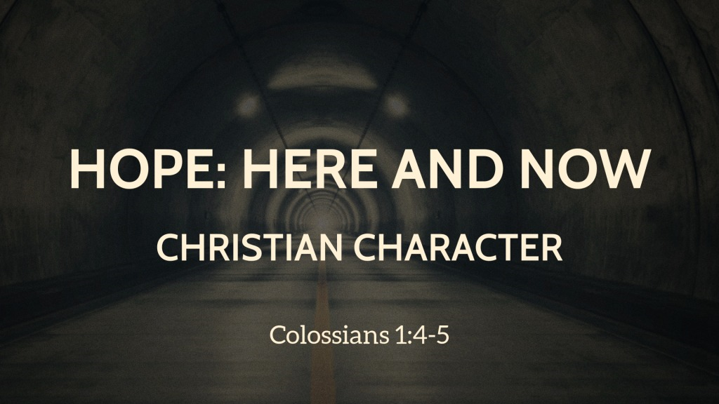
Colossians 1:4–5 ESV
⁴ since we heard of your faith in Christ Jesus and of the love that you have for all the saints, ⁵ because of the hope laid up for you in heaven. Of this you have heard before in the word of the truth, the gospel,

I. Hope in Heaven

A. Christians have a strong Hope in a destiny in Heaven
Acts 23:6; 1 Corinthians 15:19

B. Christians live here and now in a Hope for Heaven
Matthew 6:19-20; 2 Timothy 4:8

II. Hope on Earth

A. Spiritual Wisdom and Thanksgiving grows Hope Here and Now
Colossians 1:9; 2 Thessalonians 1:3

B. The Born Again are obedient to Truth and serve One Another due to the Hope in God Here on Earth
1 Peter 1:21-23; Hebrews 6:10

III. Hope in the Word

A. God’s Word brings Hope closer and closer
Romans 10:8; 2 Corinthians 5:19; Ephesians 1:13

B. It is not an Ordinary Word that gives us Hope and we Hunger for it
1 Thessalonians 2:13; 1 Peter 2:2

God’s Invitation and Plan of Salvation

Hear - Romans 10:17

Believe and Confess - Romans 10:9-10

Repent - Luke 13:3

Be Baptized - Romans 6:3-4

Remain Faithful - Revelation 2:10

New to the Faith
• First Principles
Have you fallen away from Faith?
• Need to be Restored
My Decision Today
• I would like to be baptized today
• I would like to renew my life to Christ
• I would like to learn more about Jesus and the Bible

Questions: What are my next steps?
• Come forward to be baptized
• Request a Bible Study to learn more
• Attend Bible Class to grow and mature
• Find a place to serve others
• Apply today’s lesson to my life

