Barry G. Johnson, Sr. / www.Barrygjohnsonsr.com
The Way of Wisdom / Wisdom / Proverbs 1:20–33
Solomon personifies wisdom as a woman, one who is virtuous at first and foolish later in Proverbs.
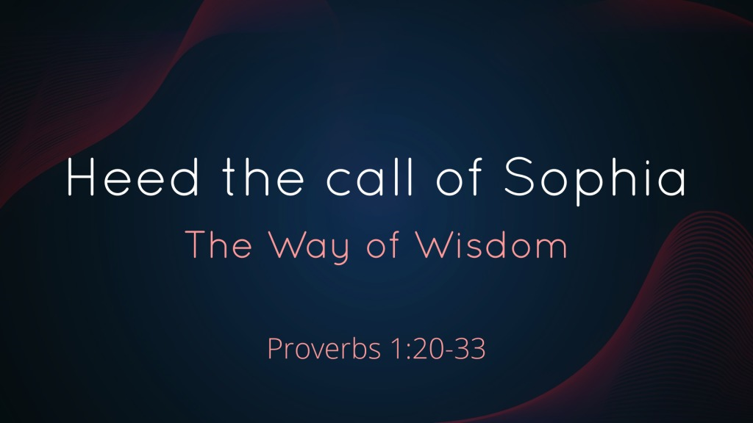

I. SOPHIA'S PLEA

A. MADE PUBLICLY... (1:20-21)
Proverbs 1:20–21 ESV
²⁰ Wisdom cries aloud in the street, in the markets she raises her voice; ²¹ at the head of the noisy streets she cries out; at the entrance of the city gates she speaks:

B. TO THOSE WHO NEED HER... (1:22)
Proverbs 1:22 ESV
²² “How long, O simple ones, will you love being simple? How long will scoffers delight in their scoffing and fools hate knowledge?

C. BE FILLED WITH HER WISDOM... (1:23)
Proverbs 1:23 ESV
²³ If you turn at my reproof, behold, I will pour out my spirit to you; I will make my words known to you.

II. SOPHIA'S WARNING

A. DIRECTED TO THOSE WHO REFUSED TO HEAR... (1:24-25)
Proverbs 1:24–25 ESV
²⁴ Because I have called and you refused to listen, have stretched out my hand and no one has heeded, ²⁵ because you have ignored all my counsel and would have none of my reproof,

B. THERE WILL BE NO HELP WHEN CALAMITY COMES... (1:26-30)
Proverbs 1:26–30 ESV
²⁶ I also will laugh at your calamity; I will mock when terror strikes you, ²⁷ when terror strikes you like a storm and your calamity comes like a whirlwind, when distress and anguish come upon you. ²⁸ Then they will call upon me, but I will not answer; they will seek me diligently but will not find me. ²⁹ Because they hated knowledge and did not choose the fear of the Lord, ³⁰ would have none of my counsel and despised all my reproof,

C. THEY WILL SUFFER THE FATE OF THEIR FOLLY... (1:31)
Proverbs 1:31 ESV
³¹ therefore they shall eat the fruit of their way, and have their fill of their own devices.

III. SOPHIA'S SUMMARY

A. DESTRUCTION COMES UPON THE SIMPLE AND FOOLS... (1:32)
Proverbs 1:32 ESV
³² For the simple are killed by their turning away, and the complacency of fools destroys them;

B. SAFETY AND SECURITY ARE FOR THOSE WILLING TO HEAR... (1:33)
Proverbs 1:33 ESV
³³ but whoever listens to me will dwell secure and will be at ease, without dread of disaster.”

