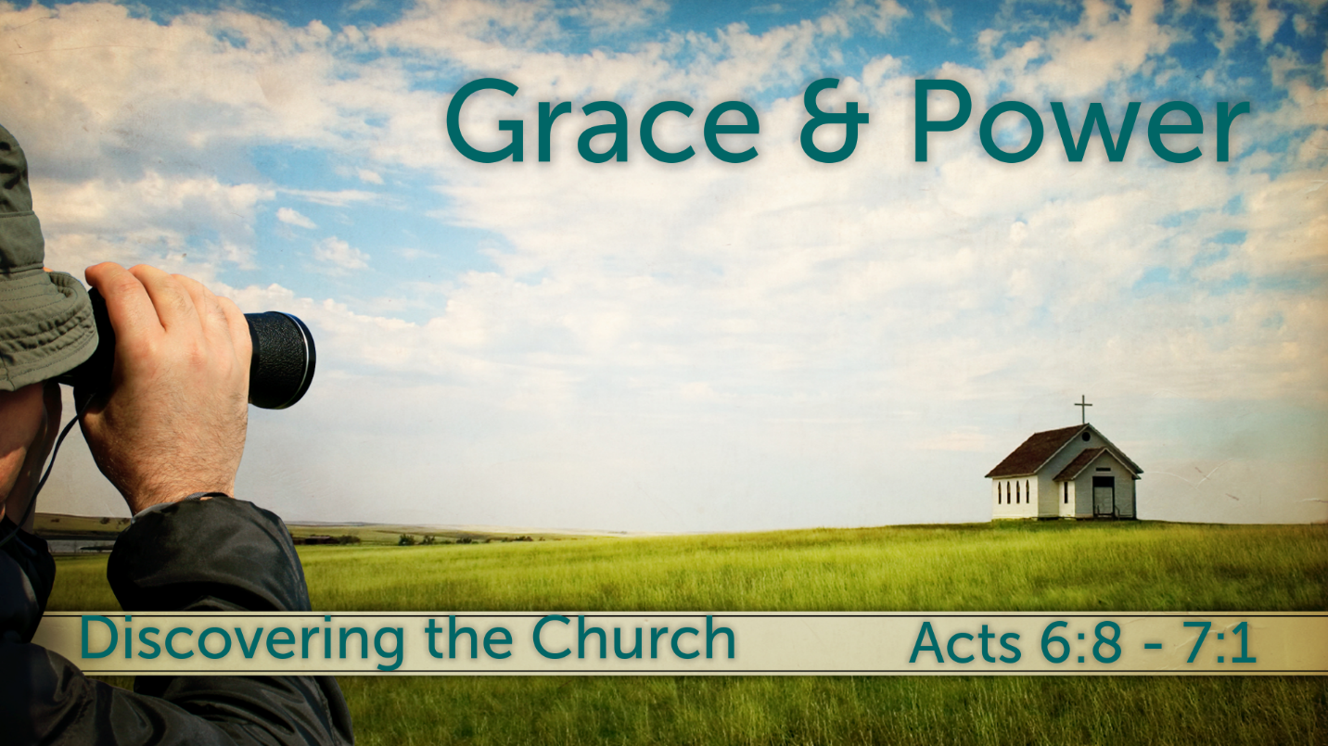
Thesis/ Central Idea:
The Holy Spirit equips and empowers believers so that the reign and reality of God is revealed through them in the world.
Questions:
- How should we define grace?
- How should we define power?
- How can we be full of grace and power?

What is this Grace?

Grace best example…
John 1:14 (ESV)
¹⁴ And the Word became flesh and dwelt among us, and we have seen his glory, glory as of the only Son from the Father, full of grace and truth.

Grace available for you and me…
Romans 3:24 (ESV)
²⁴ and are justified by his grace as a gift, through the redemption that is in Christ Jesus,

Grace is not works…
Romans 11:5–6 (ESV)
⁵ So too at the present time there is a remnant, chosen by grace. ⁶ But if it is by grace, it is no longer on the basis of works; otherwise grace would no longer be grace.

What is this Power?

Power’s best example
Romans 1:16 (ESV)
¹⁶ For I am not ashamed of the gospel, for it is the power of God for salvation to everyone who believes, to the Jew first and also to the Greek.

Power available for you and me
1 Corinthians 1:18 (ESV)
¹⁸ For the word of the cross is folly to those who are perishing, but to us who are being saved it is the power of God.

Power is Christ
2 Peter 1:3 (ESV)
³ His divine power has granted to us all things that pertain to life and godliness, through the knowledge of him who called us to his own glory and excellence,

Why was Stephen full of God’s grace and power?

He was familiar with the righteous acts of Jesus
Acts 6:10 (ESV)
¹⁰ But they could not withstand the wisdom and the Spirit with which he was speaking.

He operated under the grace of Jesus
2 Timothy 1:9 (ESV)
⁹ who saved us and called us to a holy calling, not because of our works but because of his own purpose and grace, which he gave us in Christ Jesus before the ages began,

Conviction and knowledge of Jesus showed Stephen and us how to live our life
Acts 6:15 (ESV)
¹⁵ And gazing at him, all who sat in the council saw that his face was like the face of an angel.

Power builds Christian character
Romans 15:13 ESV
May the God of hope fill you with all joy and peace in believing, so that by the power of the Holy Spirit you may abound in hope.
See also 2 Ti 1:7

Power strengthens the church
Ephesians 3:16 ESV
that according to the riches of his glory he may grant you to be strengthened with power through his Spirit in your inner being,
See also Ro 1:11; 1 Co 1:7–8
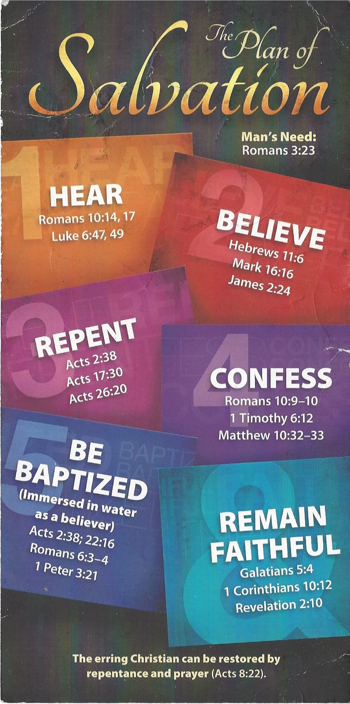
Hear - Romans 10:17 (NIV)
¹⁷ Consequently, faith comes from hearing the message, and the message is heard through the word about Christ.
Believe - Hebrews 11:6 (NIV)
⁶ And without faith it is impossible to please God, because anyone who comes to him must believe that he exists and that he rewards those who earnestly seek him.
Repent - Acts 17:30 (NIV)
³⁰ In the past God overlooked such ignorance, but now he commands all people everywhere to repent.
Confess - 1 Timothy 6:12 (NIV)
¹² Fight the good fight of the faith. Take hold of the eternal life to which you were called when you made your good confession in the presence of many witnesses.
Be Baptized - Acts 2:38 (ESV)
³⁸ And Peter said to them, “Repent and be baptized every one of you in the name of Jesus Christ for the forgiveness of your sins, and you will receive the gift of the Holy Spirit.
Remain Steadfast - Revelation 2:10 (NIV)
¹⁰ Do not be afraid of what you are about to suffer. I tell you, the devil will put some of you in prison to test you, and you will suffer persecution for ten days. Be faithful, even to the point of death, and I will give you life as your victor’s crown.

