Barry G. Johnson, Sr. / www.barrygjohnsonsr.com
Christian Character / Love; Character; God: Love; Steadfast Love; God’s Love / 1 John 4:16
The deepest possible expression of God’s character. Though God loves all people, he is especially committed to sacrificial, loyal relationships with his people.
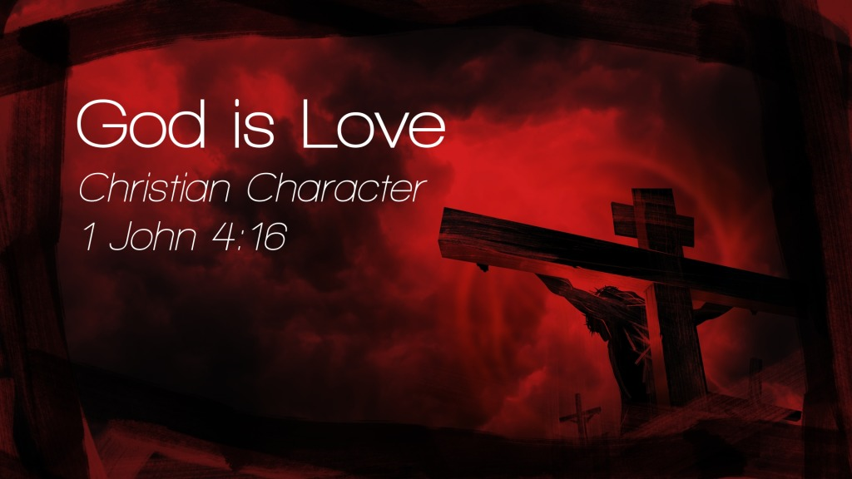

I. God’s nature is love
1 Jn 4:8
Mk 1:10-11
See also Jn 5:20; Jn 10:17; Jn 14:23; Eph 1:6; Col 1:13

II. Characteristics of God’s love

A. It is eternal
Je 31:3
See also Ps 103:17; Ps 136:1–26; Is 49:15–16; Is 54:8; Is 54:10

B. It is a covenant love
Dt 7:9
See also Ex 20:6; Dt 7:12; 1 Ki 8:23; Ps 106:45; Da 9:4

C. It is lavish
Ex 34:6-7

D. It is holy and just
Ps 33:5
See also Ps 37:28; Ps 99:4; Is 61:8

III. Images of God’s love

A. God as a father:
Dt 1:31; Ho 11:1–4; Lk 15:11–32; Heb 12:6; Pr 3:12

B. God as a husband:
Je 31:32; Ho 2:14–20; Re 21:2

IV. God’s loving actions

A. The gift of God’s Son is a unique act of love
1 Jn 4:9-10
See also Jn 3:16; Jn 15:13; Ro 5:7–8

B. God sets his love on the unlovely
Dt 7:7-8
See also Eze 16:1–14; Ro 5:8; Eph 2:4–5

C. God always acts in love towards believers
Ro 8:38-39
See also 2 Co 13:14; 2 Jn 3

V. God’s love transforms human love

A. Human love must respond to God’s love
1 Jn 4:19
See also Dt 6:5; Dt 30:6; Eph 5:1; Col 3:12–14

B. Human love must be modelled on God’s love
Mt 5:44-45
See also Ho 3:1; 1 Jn 2:15; 1 Jn 4:7–8; 1 Jn 4:11–12

God’s Invitation and Plan of Salvation

Hear - Romans 10:17

Believe and Confess - Romans 10:9-10

Repent - Luke 13:3

Be Baptized - Acts 2:38

Remain Faithful - Revelation 2:10

New to the Faith?
- First Principles

Have you fallen away from Faith
- Need to be Restored

My Decision Today
- I would like to be baptized today
- I would like to renew my life to Christ
- I would like to learn more about Jesus and the Bible

Questions: What are my next steps?
- Come forward to be baptized
- Request a Bible Study to learn more
- Attend Bible Class to grow and mature
- Find a place to serve others
- Apply today’s lesson to my life

